Technology-based Eye Care Services (TECS) Fact Sheet
- What is it?
- Comprehensive eye screening program based in the primary care clinic.

- What does it do?
- Bring specialty eye care services to the underserved medical communities, such as rural, homeless, indigent populations.

- How does it work?
- Primary care providers or patients who desire an eye exam, can refer patients to the program.
- A trained ophthalmology technician is stationed in a primary care clinic.
- The technician works up the patient by checking history, vision, glasses, eye pressure, and takes pictures of the back of the patients’ eyes. These pictures are the same as the VA diabetic teleretinal photographs.
- Photos and clinical information transferred to a remote reading physician who generates a report and result letter for the patient.
- Those requiring additional tests are referred in for a face-to-face exam.
- Reader orders an eyeglass prescription for those patients who need it and the technician can measure the patient for eyeglasses at the CBOC.

- Set up
- Providers are practicing store and forward telemedicine using a single consult process.
- Results are visible on the patient side CPRS.
- Stop code 407 or 408 as primary, secondary as 694/695

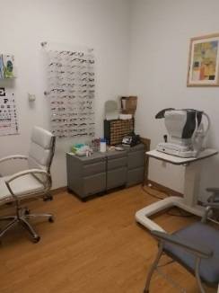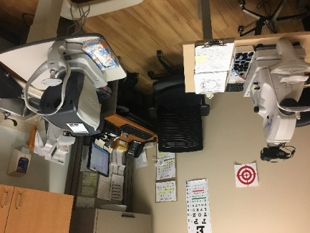

- Benefits
- Comprehensive National QA/QI program run by third party data team, HEROIC (Charleston Center of Innovation in Health Services and Development), which includes an epidemiologist, statistician, and health economist.
- One of the VA Office of Rural Health Enterprise Wide Initiatives since 2017.
- Improved access (>95% in 28 days)
- High patient satisfaction, 4.8 out of 5 for “High quality service” and “Would refer another Veteran”.
- Saved travel beneficiary time and travel distance/time for Veteran.
- Multiple peer reviewed published papers in medical literature verifying quality of care,
- Realign eye care delivery in the VA system – only send patients who truly need in person exams to your eye providers. Also provide access to vulnerable populations and reduce healthcare disparities.

