How do I know if Falls Boot Camp is right for me?
- Have you ever fallen or are you concerned you might fall?
- Do you have a neurological condition?
- Do you want to improve your balance, gait, and cognition?
- Do you like achieving goals in a team setting?

What are the benefits of exercise?

Exercise plays a key role in preventing falls through the improvement of

- Safe walking
- Strength
- Stamina
- Balance
- Coordination
- Power output
- Multi-tasking
- Memory
- Reaction time

And so much more!

What do people say about Falls Boot Camp?

I have not had any falls since attending Falls Boot Camp. I’ve learned so much more here than anywhere else about how to manage my Parkinson’s.

- Veteran testimonial about Falls Boot Camp

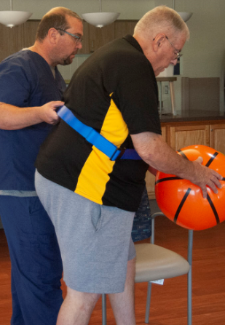

FALLS BOOT CAMP

Come join our team and prevent falls with us today!
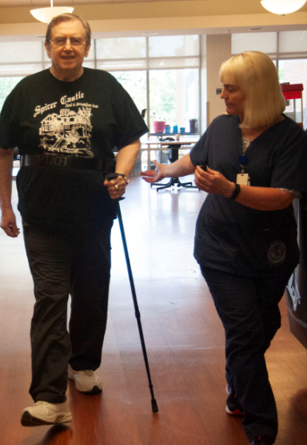
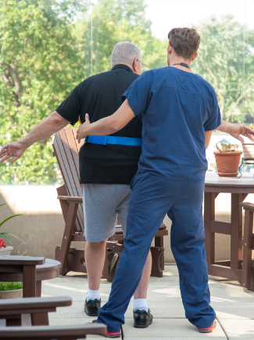
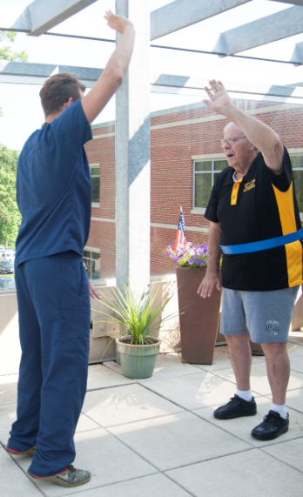

Why Should I Be Concerned?
Over 800,000 patients a year are hospitalized because of a fall injury. A fall can negatively impact aspects of your daily routine. A fall, especially a serious one, might make it difficult for you to get around or live on your own.
Falls lead to…
- Depression
- Limited Activity
- Broken Bones
- Loss of Independence

It is important to work towards preventing fall injuries because falls harm everyone.

I’m worried I might be at risk for falling. What can I do to prevent a fall?
Join our Falls Boot Camp! This is an 8-week long session designed to help Veterans who are at-risk of falling. Each class during the Boot Camp has stations where you will perform:

Boxing
Wii, Obstacle Course, Tai Chi
Cognitive Function and Multi-tasking
Walking to the Rhythm of Music

Each session is one-hour, and the group size is kept small so that Veterans receive personal attention from the staff.

After class, each Falls Boot Camp participant receives a home program to continue to work towards personal goals.

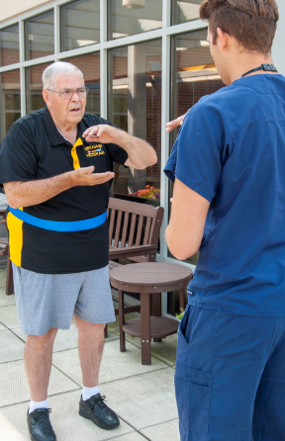
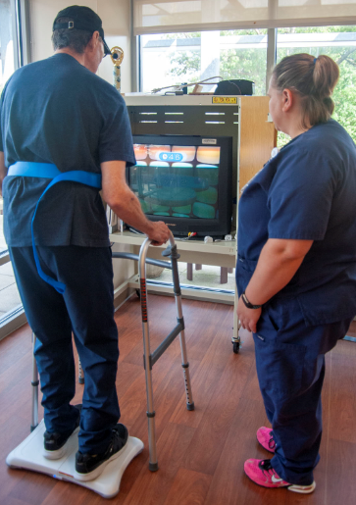

Does my facility offer Falls Boot Camp?
Yes! Please join us!
Class Schedule:

Contact:

Talk to your doctor to see if you would benefit from Falls Boot Camp!

