The Surgical Pause
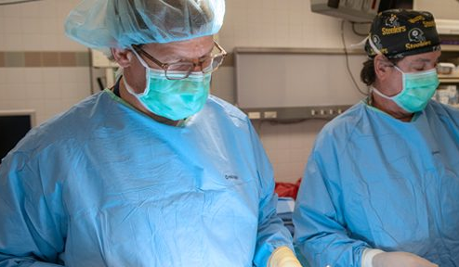

  - Implementation Guide
Date of Last Revision: September 2021

ACKNOWLEDGEMENTS
The following individuals were instrumental in the development and replication of the Surgical Pause Promising Practice:

Jason Johanning | Andrew Bilderback
Mark Wilson | Jacob Hodges
Shipra Arya | Jeff Borrebach
Ricky Shinall | Mary K. Wisniewski
Kelly Allsup | Bob Arnold
Kayla Kennedy | Johanna Bellon
Nadar Massarweh | Dan Forman
Patrick Varley | Joel Nelson
Jonas Johnson | Steve Shapiro
Tamra Minnier | Tom Lynch
Rupen Shah | Tom Edes
Ada Youk | Diffusion of Excellence Support Team

CONTENTS
ACKNOWLEDGEMENTS 2
CONTENTS 3
EXECUTIVE SUMMARY 5
WELCOME 6
What is the Surgical Pause? 7
The Surgical Pause Origin 9
ORGANIZATIONAL READINESS ASSESSMENT 11
IMPLEMENTATION ROADMAP 12
IMPLEMENTATION PHASES 13
Pre-Implementation Phase: Plan and Design 13
Step 1: Identify Practice Champions 13
Step 2: Select a Pilot Surgical Service Line 14
Step 3: Begin Administering the RAI 15
Step 4: Set Project Scope and Develop Project Charter 17
Step 5: Define Practice Intervention 18
Step 6: Engage Relevant Stakeholders 20
Step 7: Present Initial RAI Dataset 21
Implementation Phase: Operationalize and Execute 21
Step 8: Implementation Launch 21
Step 9: Collect and Analyze Data 22
Metrics 22
Data Collection and Analysis 23
Post-Implementation Phase: Evaluate and Iterate 30
Step 10: Quality Improvement 30
Step 11: Expansion to Additional Surgical Service Lines 31
Step 12: Share Outcomes with Implementation Staff, Stakeholders, and Facility Leadership 32
Step 13: Celebrate! (Optional) 32
QUESTIONS 33
REFRENCES 34
SUPPLEMENTARY MATERIALS/APPENDIX 36
A. Organizational Readiness Assessment Worksheet 36
B. National Surgery Office Signed Memorandum for RAI CPRS Template 39
C. Risk Analysis Index Patient Handout 40
D. Adding the RAI Health Factor Reminder Dialogue Template to CPRS 41
E. Project Charter Template 43
F. Stakeholder Analysis Template 44
G. Implementation Launch Plan 45
H. Patient Decision Regret Survey 47
I. Patient Centeredness Survey 48
J. Human Flourishing 50
K. Accessing Bereaved Family Survey Data 52

EXECUTIVE SUMMARY

Frail patients suffer disproportionately high rates of adverse post-operative complications, including death. Patient frailty is not routinely assessed despite the fact it predicts post-operative outcomes better than age or comorbidity alone. Surgeons have always paid attention to perioperative risks, but evidence indicates that the traditional foot-of-the-bed ‘eyeball test’ is not sufficiently reliable or sensitive. Moreover, surgical risk stratification typically focuses on high-risk surgeries (e.g., aortic aneurism, pancreatectomy) even though it has been shown that there is no such thing as low-risk surgery for high-risk, frail patients¹. There is a need for an easy-to-administer, standardized screening tool to better inform the selection of high-risk patients considering elective surgery.

To address this need, the Risk Analysis Index (RAI) was developed and validated to assess frailty among patients considering elective surgery. In addition to demonstrated success in reducing post-operative mortality, RAI assessment equips patients and surgeons with reliable data necessary to inform surgical decision-making, optimize perioperative care, and reduce the need for long-term services and support following surgery. To be clear, the goal is not to withhold needed surgery or tell surgeons what they should do. Rather, the goal is to identify the highest risk patients and provide access to additional resources designed to facilitate patient-centered decision making and optimize perioperative care.

The primary objective of this Implementation Guide is to provide the tools and resources necessary to facilitate the successful implementation of the Surgical Pause practice.

Please direct any questions to VASurgicalPause@va.gov with any questions.

WELCOME
Welcome and thank you for participating in the implementation of the Surgical Pause Practice within your surgical service line. This Implementation Guide is intended for the identified Facility Champion and Surgical Champion leading implementation at your facility.

The goals of this Implementation Guide are to provide:
- Background on the Surgical Pause Practice

- Instructions and Resources necessary to implement this practice at your facility
Refer to the information ahead to learn how you can implement this Practice and enhance the Veteran experience at your facility!

What is the Surgical Pause?
The Surgical Pause involves assessing patient frailty using the Risk Analysis Index (RAI) and providing patients with intervention options designed to improve post-operative outcomes. The RAI consists of 14 variables scored on a weighted scale. In addition to age and sex, it includes questions assessing weight loss, appetite, cognitive impairment, and activities of daily living, as well as comorbidities of the lungs, heart, and kidneys.
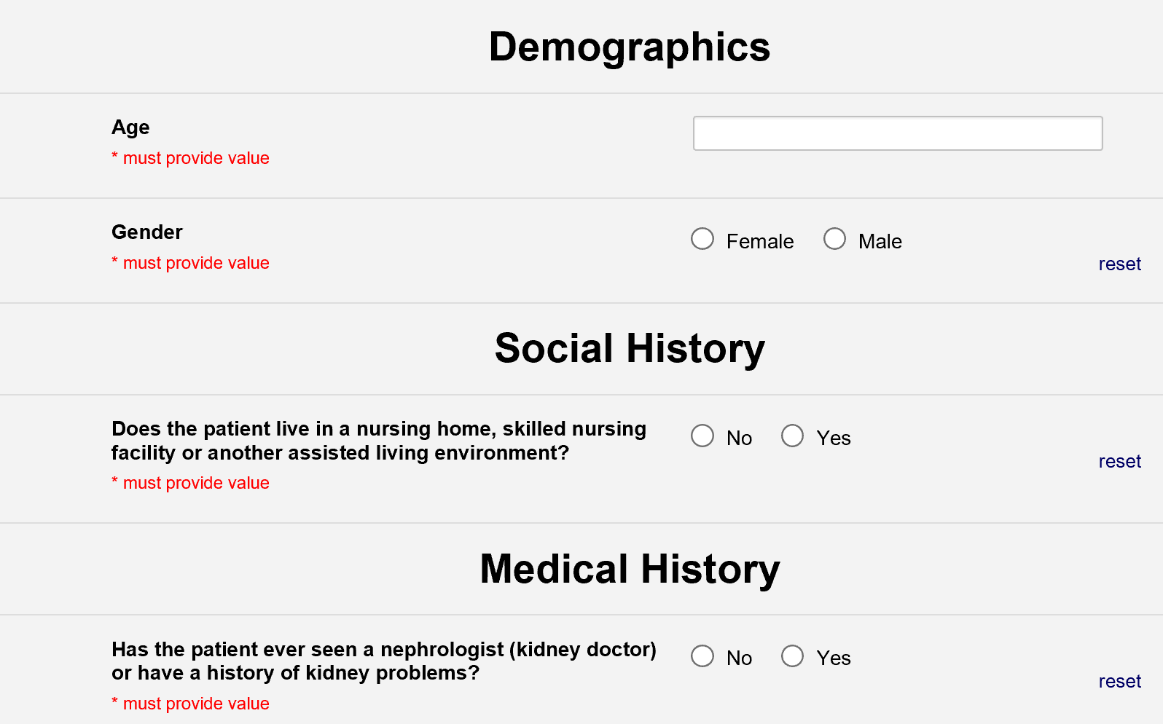
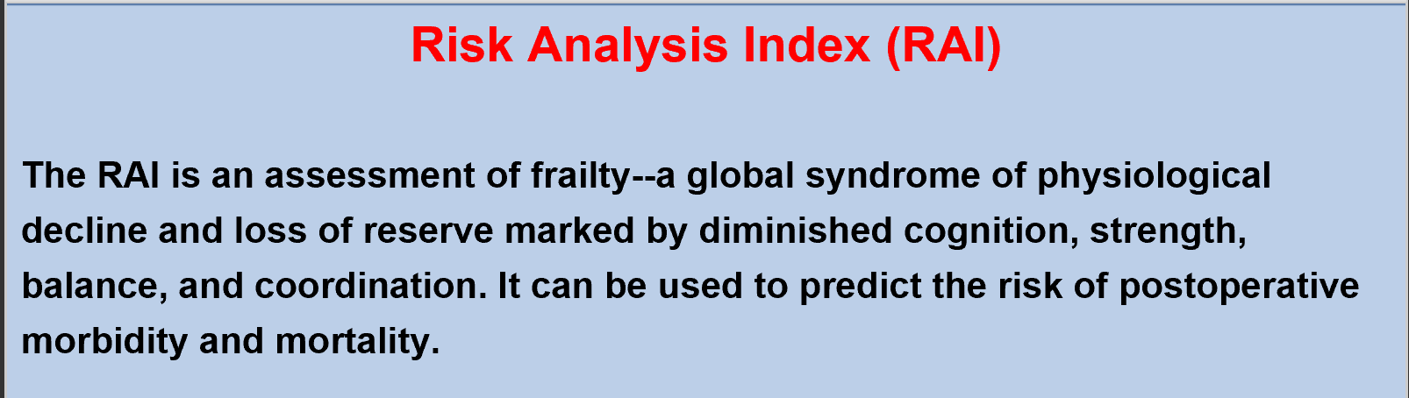
Administered at the initial clinical visit, the RAI triggers a ‘surgical pause’, providing the opportunity to revise surgical plans as needed. Patients with a RAI score ≥ 37 are reviewed by a Surgeon Champion and, if indicated, referred for enhanced perioperative care. Recommended interventions are summarized below in order of ease of implementation:
- Administrative case review performed by a Multidisciplinary Review Board consisting of clinicians from surgery, anesthesia, and palliative care

- Referral to palliative care consult to clarify goals and document Advance Directive
Figure 1. Snapshot of the online RAI scoring tool in REDCap

- Site-specific referral to existing clinical services designed to improve the physical performance of frail patients who elect to proceed with surgery (e.g., physical therapy, nutritional optimization, home-based respiratory training, etc.)
Calibrated in a nationally representative sample of more than 480,000 Veteran patients and externally validated in >1,000,000 patients from the American College of Surgeons National Surgical Quality Improvement Program, the RAI is the most thoroughly validated measure of surgical frailty.² It is also the only one proven feasible for system-wide screening, taking less than 30 seconds to administer^{3,4}.
In addition to demonstrated success in reducing post-operative mortality, RAI assessment equips patients and surgeons with reliable data necessary to inform surgical decision-making, optimize perioperative care, and reduce the need for long-term services and support
- To reduce observed to expected (O/E) post-operative mortality rates
- To reduce instances of patient regret
- To reduce the number of patients requiring long-term services and support following surgery
Why should I Implement
Pre-Operative Frailty Screening and Prehabilitation?
following surgery. Figure 2 illustrates the integration of RAI screening into the surgical decision-making process flow.

Figure 2. Integration of RAI screening into the surgical decision-making process

Risk Stratify by Assessing Frailty
Non-Operative Management
Prehabilitation
SURGICAL PAUSE
(Make No Promises)
- Further Risk Assessment & Mitigation
- Risk-informed Shared Decision-making process
Surgery
Usual Care
Patient Presents to Outpatient Surgical Clinic

The Surgical Pause Origin
The Surgical Pause originated out of the Omaha VA Medical Center in response to the facility’s desire to improve their observed to expected (O/E) post-operative mortality rate. The facility’s Chief of Surgery, Dr. Jason Johanning, mandated RAI administration to schedule surgery. Patients with RAI scores indicating significant frailty were reviewed by Dr. Johanning or his designee. Based on this review, clinicians from surgery, anesthesia, critical care, and palliative care were notified of the patient’s frailty and associated surgical risks. If indicated, perioperative plans were modified based on team input. The effect of the RAI Frailty Screening Initiative (RAI-FSI) on mortality was examined in a cohort of 9,153 surgical patients treated before and after implementation. The 180-day post-operative mortality rate among the frail fell from 23.9% to 7.7% (p<0.001).⁵ This corresponds to a nearly three-fold survival advantage after controlling for age, frailty, and comorbidity (AOR 2.87 [95% CI 1.98-4.16]).⁵ In addition the RAI-FSI was associated with:
The effect of this initiative on mortality was examined in a cohort of 9,153 surgical patients from Omaha VAMC treated before and after implementation. The 180-day post-operative mortality rate fell from 23.9% to 7.7%.
- 20% reduction of per-case costs.
- Doubling the rate of palliative care consultation in surgical patients
  - More often ordered by surgeons
  - More often ordered before surgery
  - Reducing the risk of death controlling for age, frailty, and whether the patient had surgery (AOR 0.27[95% CI 0.11-068], p=0.006)⁶

Omaha VAMC Mortality Observed / Expected
Red markers indicate >90% confidence interval

Frailty Screening
Initiative Implemented
Figure 3. Changes in the Observed to Expected (O/E) Mortality Ratio at Omaha VA Medical Center between 2008 to 2014
These results support the feasibility of screening pre-operative patients for frailty and the efficacy of system-level initiatives to improve surgical outcomes for frail patients. Since its initial implementation at Omaha VA medical center in 2012, the RAI has been implemented at five VA Medical Centers and five private hospitals within the University of Pittsburgh Medical Center (UPMC) Healthcare System^{3,4}.

In 2019, Dr. Daniel Hall submitted the Surgical Pause to the Fifth Veterans Health Administration (VHA) Shark Tank Competition, a Diffusion of Excellence Initiative competition for sourcing clinical and operational Promising Practices that originate at VA facilities. After several rounds of rigorous evaluation from Subject Matter Experts (SMEs) and program office representatives, the Surgical Pause was pitched in the Fifth VHA Shark Tank and designated as Promising after its selection to be replicated at Iowa City VA Health Care System.
The Surgical Pause is 1 of 12 Promising Practices to emerge from the Fifth VHA Shark Tank Competition, selected from a total pool of 591 practice submissions

The Surgical Pause is also one of four evidence-based practices that will be implemented across VISN 4 as part of the SAGE QUERI-Program (Safer Ageing through Geriatric-informed Evidence-based practices).⁷ Led by Core Investigators from the VA Center for Health Equity Research and Promotion (CHERP), this initiative seeks to provide consistent, high quality care to Veterans 65 and older by:
- Attending to Veteran healthcare goals and preferences,
- Avoiding harms related to medication,
- Preventing, identifying, treating, and managing cognitive impairment, and
- Promoting safe movement to maintain function and independence
The Surgical Pause will ensure the goals of surgery are aligned with the personal goals of frail older patients with the objective of reducing inappropriate surgeries, serious complications, and perioperative mortality. It will also increase access to underutilized palliative care services, improving satisfaction with end-of-life care when mortality occurs.

In addition, HSR&D recently funded the PAUSE trial, a randomized, stepped wedge, multi-center, hybrid type 1 comparative effectiveness-implementation trial examining the impact of preoperative frailty screening followed by a multidisciplinary care intervention on mortality and functional status after surgery.

ORGANIZATIONAL READINESS ASSESSMENT
To ensure maximum success in implementing the Surgical Pause, consider conducting an Organizational Readiness Assessment. Assessing organizational readiness will help you take stock of your site’s existing processes – a key step in preparing to fit a new intervention into your facility’s culture and work systems. One way of doing this is through the Consolidated Framework for Implementation Research (CFIR), which is an implementation science model that offers guidelines for change management that prepare your organization for a successful implementation. While any number of the CFIR considerations may be useful, we recommend evaluating your facility’s barriers and facilitators, and developing a plan to proceed within the following seven considerations:

Figure 4. Seven considerations when evaluating facility-level barriers and facilitators.

Available
Resources
Learning
Climate
Tension for
Change
Network and
Communication
Leadership
Engagement
Relative
Priority
Culture
Refer to Appendix A for an Organizational Readiness worksheet to assist your team in conducting this assessment. This exercise could shed valuable light on the existing work systems within your facility. Identifying and planning for potential barriers, as well as understanding ways to leverage stakeholders, may allow you and your team to increase the likelihood of successful implementation.

IMPLEMENTATION ROADMAP
From start to finish, you can expect implementation of the Surgical Pause to take approximately 10 to 12 months. This may differ slightly due to leadership, training, and buy-in. Target deadlines can be used to hold practice stakeholders accountable and improve the likelihood of successful and timely implementation.

Figure 5. High-level implementation road map for the Surgical Pause
Month 1
Identify Facility Champion and Surgeon Champion
Present Initial RAI Dataset
Expand to Additional Surgical Service Lines
Collect and Analyze Outcome Data
Begin Administering the RAI
Refine and Sustain Intervention
Evaluate Process Implementation Metrics
Implementation Launch
Engage Relevant Stakeholders
Define Intervention
Month 10
Month 6
Month 3
Month 2

IMPLEMENTATION PHASES

Pre-Implementation Phase: Plan and Design
As you will see in the preceding steps, most of the work involved in implementing the Surgical Pause occurs on the front end. Once you coordinate with the appropriate stakeholders and make the necessary workflow changes, implementation, sustainment, and expansion to additional surgical service lines can follow seamlessly.

In 2021, The National Surgery Office endorsed this practice and allows each VA Medical Center to utilize the tools that have been developed to support the evaluation, identification, and intervention associated with the Surgical Pause. Implementation is not mandatory, but at the discretion of each local VAMC. Sites may wish to formalize their implementation as a quality improvement project not constituting research, especially if they envision disseminating details of their local experience. Details on distinguishing operations activities that may (or may not) constitute research can be found in Program Guide 1200-21, conveniently located on the Surgical Pause VHA Marketplace Site. If questions persist on how to handle data from the Surgical Pause implementation, site leaders are encouraged to consult with their local IRB and/or Research Office in determining whether research regulations apply.

Step 1: Identify Practice Champions
Identify a Facility Champion and Surgeon Champion, who together will engage with surgical clinic staff and facility leadership as the leaders of practice implementation. The Facility Champion should be someone in a leadership position who can educate, advocate for, and address challenges associated with the implementation of this practice. The Surgeon Champion should be the facility Chief of Surgery or a Surgeon associated with the initial surgical service line implementing the practice. Additional champions may include leaders from nursing who can facilitate frailty screening in outpatient clinics, anesthesiologists who can develop frailty-specific anesthetic pathways, critical care physicians who can develop strategies for optimizing postoperative recovery, and palliative care practitioners who can assist with goal clarification. Building the practice requires investment from these human resources. More time is needed at the beginning of implementation to socialize the practice and build out the associated processes, but eventually it can be maintained by the Surgeon Champion dedicating as little as one to two hours per week. If possible, the responsibilities of the Facility and Surgeon Champions should be explicitly written into their job description and/or tour of duty.

The primary responsibilities of the Facility Champion include:
- Oversee practice implementation and evaluation

- Promote the value of the practice among clinic staff and facility leadership

- Engage with nursing leadership to integrate RAI administration into clinic workflows

- Work with facility leadership to designate protected time for other practice champions to succeed in their work

The primary responsibilities of the Surgeon Champion include:
- Mandate RAI administration as part of perioperative workflow

  - This may include requiring screening with the RAI prior to reserving block time, as was done at the Omaha VAMC, but can be adapted as local culture requires. The key is to systematically assess frailty in the target population using the RAI.

- Weekly review of all patients with an RAI≥37 with selected referral to the chosen intervention. Experience suggests this takes only one to two hours per week for large centers

- Promote the value of the practice among clinic staff and facility leadership

- Engage anesthesia, primary care, palliative care, and other necessary care teams

Step 2: Select a Pilot Surgical Service Line
Select a pilot surgical service line within which to begin screening for frailty and calculating RAI scores. There are two main factors to consider when selecting a pilot surgical service line:
- Patient Volume
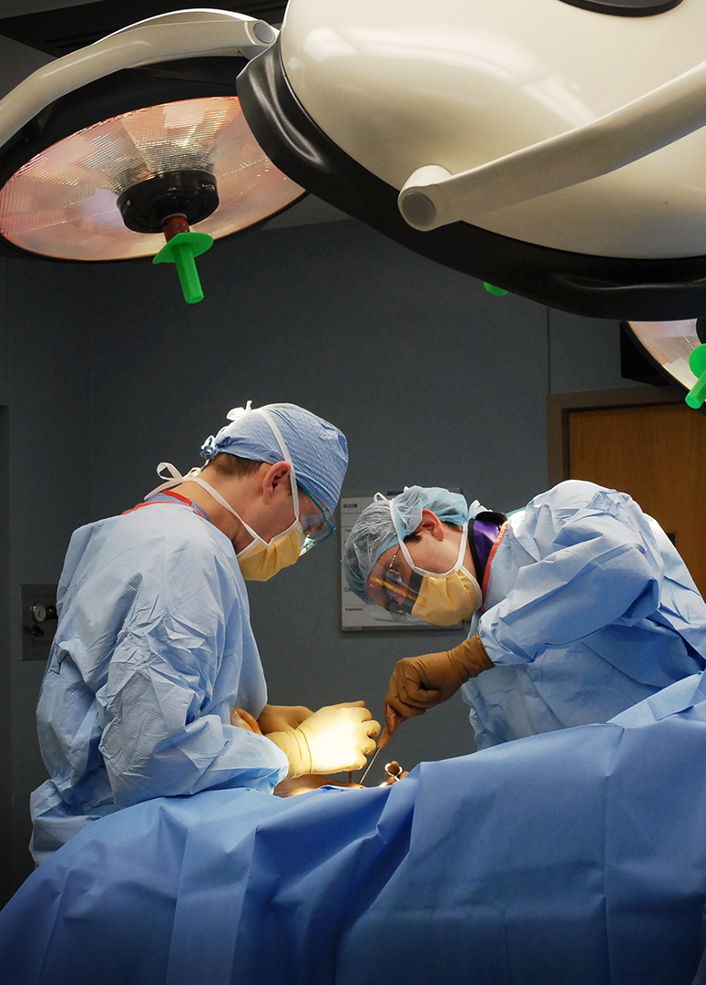
  - Establishing a process requires repetition to build experience. If patient volume is too low, too few patients will flag for frailty and personnel will not get timely experience after training. A service line should be selected such that one to five patients may screen as frail in each week, affording a reliable and manageable stream of patients to build experience

- Prevalence of Frailty in the Service Line
  - RAI scores vary by surgical specialty. For example, the prevalence of frailty in orthopedic, general, and vascular surgical service lines is approximately 5%, 10%, and 20%, respectively⁸. Patient volume and frailty prevalence within the selected service line should allow for the growth of the program without overwhelming available resources

- Post-Operative Morbidity and Mortality Rates
  - Although evidence suggests that frailty screening improves outcomes generally, Practice Champions may wish to target service lines with comparatively elevated rates of morbidity and mortality to focus the impact where there is the greatest need and the highest likelihood of success.

Step 3: Begin Administering the RAI
Administering the RAI within a pilot surgical service line three months prior to launch allows for the generation of an initial RAI score dataset that can be shared with surgical staff and facility leadership. The initial pilot data will demonstrate the value of the RAI, facilitating buy-in and support prior to implementation. This section outlines a recommended approach to RAI administration that has been found to be effective and efficient. However, this approach can be adjusted as needed to better align with existing workflows or the availability of staff within your surgical clinic.
- Review the RAI FRAILTY TOOL CPRS Reminder Dialogue Template
Released nationally on 9/13/2021 in all instances of CPRS, the RAI FRAILTY TOOL is a reminder dialogue template that facilitates the calculation of the RAI and the recording of RAI values in the patient chart as a “health factor”, thereby facilitating data retrieval and reporting. Details about the RAI FRAITLY TOOL and its use can be found in the linked slide deck. This tool is supported by the National Surgery Office (see Appendix B to view signed Memorandum).

- Identify Staff to Administer the RAI
It is recommended that outpatient nurses within the surgical clinic administer the RAI. However, other staff within the clinic, such as medical assistants, residents, and clinicians, may also be utilized. If you choose to use staff that experience repeated turnover, such as residents, training efforts will likely need to be more frequent and rigorous to ensure that new staff are aware of the RAI and the administration process.

- Train Staff to Administer the RAI
RAI administration training should take no more than 30-minutes and can be integrated into existing staff meetings (e.g., weekly nursing huddle). Recommended training components are outlined below.

Q&A
Leave adequate time to field questions and concerns, as well as discuss any staff-proposed changes to the administration process
Value Case
Introduce the RAI and its’ value in reducing O/E post-operative morbidity and mortality
Process Walkthrough
Walkthrough the administration process, including how to input RAI item responses into REDCap, calculate the score, and record it in CPRS
Workflow Documentation
Document how the workflow of staff involved in the administration process will change.

- Distribute the RAI
Patients and/or caregivers receive the single-page RAI handout when they check-in to the surgical clinic, to be completed prior to rooming. A PDF version of the RAI handout can be found in Appendix C.

- Review Responses
Nursing staff responsible for rooming the patient briefly review the responses to each item and engage with the patient and/or caregiver to complete any items that were left blank or answered incorrectly.
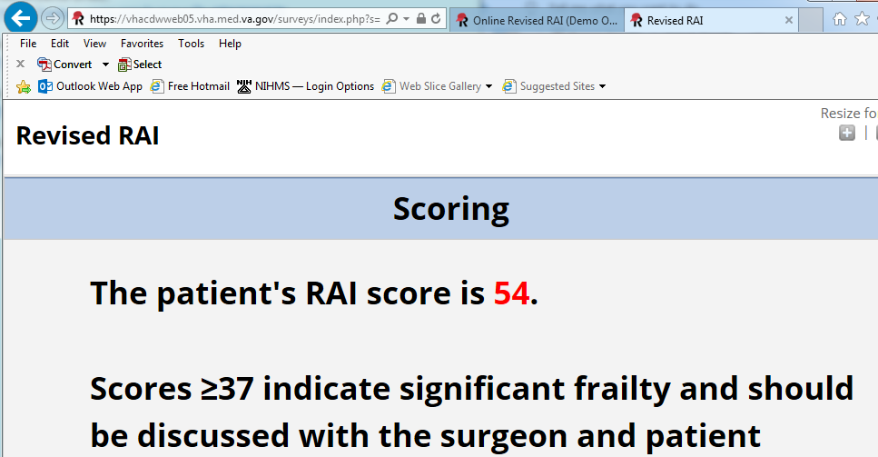
- Input Responses and Calculate the RAI Score
Nursing staff utilize the REDCap link embedded in the CPRS VA RAI FRAILTY TOOL Reminder Dialogue to access the online RAI scoring tool, key-in patient responses, and calculate the RAI score.

- Record the RAI Score
The RAI score is written directly on the completed handout - to follow the patient throughout the remainder of the clinic visit - and keyed into the patient chart. The RAI score should be recorded as a Health Factor to permit retrieval from the Corporate Data Warehouse (CDW). To facilitate the process, a RAI Reminder Dialogue has been generated called “VA RAI FRAILTY TOOL” that can be added to existing note templates. For instructions on how to access the RAI Health Factor Reminder Dialogue Template, please see Appendix D.

Communicate with staff responsible for check-in to the surgical clinic about the RAI so they can address any patient-specific questions. For example, if a patient is unsure how to respond to a particular item, check-in staff would let them know that a member of the clinical team will review the handout with them once they are roomed.

Step 4: Set Project Scope and Develop Project Charter
As with many Promising Practices identified through the Diffusion of Excellence Initiative, the Surgical Pause can be modified to fit the unique characteristics of your facility. Certain aspects of the practice, such as selecting the type of intervention, defining a RAI score threshold, and outlining metrics should be discussed among the implementation team and documented in the Project Charter. The Project Charter will serve as a guide for implementing the practice and should include:
- Problem statement
- Implementation scope, goal(s), and timeline
- Resources needed to implement
- Any other information gathered from initial discussions with your implementation team
Another major component of the Project Charter is identifying stakeholders and leadership who will support implementation. Recommended stakeholders, and their associated roles and responsibilities, are outlined in Table 1 located on page 20.

Refer to Appendix E for a template Project Charter to get you started!

Figure 6. Recommended project charter components

Problem Statement
Resources Needed to Implement
Implementation Goals
Stakeholder Support
Implementation Timeline
Scope of Implementation

Step 5: Define Practice Intervention
The Surgical Pause consists of two central components:
Assess patient frailty using the RAI

Provide intervention options designed to improve post-operative outcomes

It is recommended that patients with a RAI score greater than or equal to 37 are reviewed by the Surgeon Champion and, if necessary, referred for enhanced perioperative care. A RAI ≥37 corresponds to the highest risk 10% of surgery patients who experience at least twice the typical rate of morbidity, mortality, readmission, and long-term ICU stays ≥5 days. Recommended prehabilitation interventions are listed below in order of ease of implementation.
Referral to a Multidisciplinary Review Board
Much like a tumor board for cancer patients, at-risk frail patients with RAI scores ≥37 should be discussed by a Multidisciplinary Review Board. In addition to clinicians from surgery and anesthesia, the board may include representation from palliative care, primary care, geriatrics, physical medicine, and physical or occupational therapy. The interdisciplinary review process, board members, and meeting cadence will vary by facility based on:
- Availability of staff and clinical resources

- Surgical service lines implementing the practice

- Volume of patient cases tied to implementing service lines
For example, board members at one facility may choose a synchronous review process where they come together in-person or via conference call to discuss high-risk patient cases. Alternatively, board members at another facility may choose an asynchronous process of review, providing feedback via email, Microsoft Teams, or other suitable technology. Whatever the approach, it is imperative that the review process, meeting cadence, and board member responsibilities are well-defined and sustainable, such that a comprehensive review of high-risk patient cases can be conducted consistently.
The RAI score threshold of 37 is calibrated to flag the highest risk 10% of patients. However, if this threshold yields too few or too many patients, it can be adjusted to yield a more manageable and clinically meaningful patient population.

Clarifying Goals and Documenting Advance Directives
Older patients often receive care that can be burdensome and may not align with their health priorities. It is important to recognize that, when faced with tradeoffs, older adults differ in terms of what matters most to them. As such, it is imperative that healthcare providers gain an understanding of patient health priorities and facilitate patient engagement in the healthcare decision-making process.
For higher risk patients considering operative management, it is imperative to describe available options along with the best, worst, and most likely scenarios associated with each option. Telling stories about the variety of possible future outcomes can serve as a springboard for goal clarification. Some surgeons may have the interest, time, and communication skills to do this themselves. Others, however, can request assistance from colleagues with this training through a formal consult. Most palliative care physicians and some geriatricians have these skills and can work with the surgeon to establish the options and likely outcomes before discussing and clarifying surgical goals, including the patients hopes and fears. This information can then be shared with the patient and incorporated into the shared decision-making process. Palliative care consults also allow for the generation of an Advance Directive – a legal form that helps doctors and caregivers understand patient preferences as it relates to medical and mental health care and make decisions about their care. An Advance Directive is the best way to ensure that the future medical care patients receive, including surgical care, reflects their wishes.
Site-Specific Referral to Existing Clinical Services Designed to Improve Physical Performance
If indicated, frail patients who elect to proceed with surgery may be referred to existing clinical services designed to improve aspects of their physical performance, and subsequently enhance perioperative outcomes. These referrals could include, but are not limited to:
- Physical therapy
- Nutritional optimization
- Pre-operative strength training
- Home-based respiratory muscle training
Ultimately, referrals will be site-specific, based on operational imperatives and available clinical resources.
The Michigan Surgical Health Optimization Program (MSHOP) is an example of a formal prehabilitation initiative that engages patients in activities designed to prepare them for surgery (e.g., physical activity, pulmonary rehabilitation, nutritional optimization, and stress reduction). Although not specific to frail patients, this program has been found to reduce post-operative complications and associated care costs^{10,11}.

Step 6: Engage Relevant Stakeholders
Refer to the following table for a list of stakeholders typically involved in the implementation of the Surgical Pause. When you initially engage these groups, consider what you will be asking of them, and how you can best communicate to get the support you need.
Table 1. Stakeholders involved in the implementation of the Surgical Pause
Core Stakeholders | Roles and Responsibilities
Leadership  (at the facility- and surgical service line-level) | - General support and buy-in  - Approval to proceed with implementation  - Assigning FTE  - Assistance with procurement of resources (if needed)
Surgeons | - General support and buy-in  - Participation in development of the Multidisciplinary Review Board and integration of a “surgical pause”  - Help to facilitate culture change
Nursing | - General support and buy-in  - Administration of the RAI  - Assist with Decision Regret Survey and Patient Centeredness of Care Survey (optional)
Anesthesia | - General support and buy-in  - Multidisciplinary Review Board member  - Assist with the evaluation of high-risk patients and, if necessary, the development of alternative care plans
Palliative Care
Primary Care
Geriatrics
Physical Medicine & Rehabilitation (PM&R)

A more formal way to think about engaging local stakeholders is to complete a Stakeholder Analysis, which prompts you to think about those that might be influential in your facility’s implementation. See Appendix F for a Stakeholder Analysis Template to get started.
Once you determine the stakeholders to engage, it is recommended that you host a kick-off meeting to provide background on the practice, outline stakeholder roles and responsibilities, and address any questions or comments. Practice creator Dr. Daniel Hall developed a presentation designed to introduce the Surgical Pause:
- The Surgical Pause: Preoperative Frailty Screening and Prehabilitation is a 45-minute, grand rounds style presentation aimed at clinicians that presents the evidence supporting the RAI and the practice of frailty screening and prehabilitation.
This presentation is available through VA’s Talent Management System (TMS) and can be viewed for CME credit. When thinking about how to structure initial meetings with stakeholders, these presentations are a good place to start. You may elect to show the recordings as part of the meeting and then solicit questions or use them as a springboard for your own presentation. To view this presentation, login to TMS and search for the course number listed above. Additionally, this course is available on YouTube; however, in order to obtain CME credit it must be viewed through TMS.
The Surgical Pause: Preoperative Frailty Screening and Prehabilitation
Course No. 43441
Click to view on YouTube
Additionally, a PowerPoint Presentation is available for those who will be completing the CPRS RAI Frailty Tool Template in Appendix D.

Step 7: Present Initial RAI Dataset
It is recommended that you present the initial RAI dataset collected in the three months prior to implementation launch to staff within participating surgical service lines and relevant stakeholders. In addition to illustrating the value of the RAI, this presentation provides an opportunity to introduce the practice to facility leadership. After three months, you will have data from your own site to demonstrate the RAI’s feasibility, ease, and validity in risk stratifying patients. Presenting local data on postoperative mortality and readmission stratified by frailty demonstrates how observed mortality increases with RAI score, builds confidence in the tool, and establishes the clinical need to intervene and improve outcomes among those with elevated RAI scores.

Implementation Phase: Operationalize and Execute
Once you have completed the Pre-Implementation Phase steps, you are ready to launch!

Step 8: Implementation Launch
Implementation launch signals the transition from simply assessing patient frailty using the RAI to employing the intervention option(s) your site has selected.

A formal launch plan with timelines offers the most successful approach for implementation. The Surgical Pause Launch Plan located in Appendix G provides a checklist of key questions to consider and plan for during the following phases:
- Program Build Out
- Leadership and Stakeholder Buy-In
- Timeline Development
- Implementation Team Identification and Training
- Program Evaluation
- Expansion to Additional Surgical Service Lines
The document serves as a planning tool to foster collaboration, leverage stakeholder insights, and establish key programmatic benchmarks to customize and optimize implementation at your facility.

Step 9: Collect and Analyze Data
Implementing a new clinical practice can be challenging. Therefore, data collection and analysis are critical to:
- Ensure the practice is consistently implemented

- Identify problems during implementation

- Promote an opportunity for continuous Quality Improvement (QI)

- Evaluate the impact/effectiveness of practice implementation

Metrics
The implementation of the Surgical Pause can be assessed utilizing a variety of process and outcome measures. Establishing process metrics at each step allows you to monitor the degree to which frailty screening is effectively executed. The flow chart below depicts a series of recommended process metrics.

Number of Patients who present to a surgical clinic implementing Frailty Screening (n)

Presenting patients for which a RAI score is calculated (n, %)

Presenting patients with a RAI score ≥37 (n, %)

Description of what happened to patients with a RAI score ≥37

*Management Plan
(n, %)
Referral to Prehabilitation
Services
(n, %)
Referral to Palliative Care Consult
(n, %)
Evaluation by
Multidisciplinary Review Board
(n, %)

*Non-operative Management, Lesser Surgery, or Surgery as Initially Planned
Establishing outcome metrics allows you to assess the impact of practice implementation on Veteran patient health. The recommended outcome measures outlined below include what can be defined as traditional surgical outcomes and patient reported outcomes.
- Traditional Surgical Outcomes

  - Post-Operative Mortality
  - Post-Operative Complications
  - Length of Stay (LOS)
  - Post-Operative Readmission
  - Non-Operative Management
  - Less-invasive surgery

- Patient-Reported Outcomes

  - Decision Regret
  - Patient Centeredness of Care
  - Human Flourishing
  - Bereaved Family Survey

Data Collection and Analysis
Step 1. Determine who will be responsible for collecting and/or analyzing data
Please consider the following when selecting staff member(s) to collect and analyze data:
- Where the data is housed (e.g., CDW, CPRS, VASQIP, VISTA Surgery Package)
With the skills needed to abstract, manage, and analyze data, Surgical Quality Nurses may be a good choice for this role.
- The skills needed to abstract, merge, and manage the data
- The skills needed to analyze the data
Once a team member is identified, it is critical to involve them early in the implementation process to ensure that data is abstracted and managed in such a way that expedites analysis. It may also be beneficial to designate additional staff members within the participating service lines who possess the necessary data management and analytic skills to augment – or eventually assume – these responsibilities.

Step 2. Determine what process and outcome metrics you will assess

This section provides more detailed descriptions of the process and outcome measures outlined above, as well as recommendations on how to extract and assess these measures.

Process Measures
- Patients Engaging in the Frailty Screening Initiative
  - Defined as the number of patients who present to a surgical clinic implementing frailty screening
  - Assessment method will vary by facility (e.g., abstraction of data using clinical software, tracking data manually, etc.)
  - Pulled Quarterly

- RAI Screening Compliance
  - Defined as presenting patients for which a RAI score is calculated (n, %)
  - The goal is to screen and calculate a RAI score for at least 80% of presenting patients
  - Assessment method will vary by facility depending on:
    - Where the RAI score is recorded in CPRS
    - How the RAI score is extracted from CPRS
  - Pulled Quarterly

- Proportion of Frail Patients
  - Defined as presenting patients with a RAI score ≥ 37 (n, %)
  - Assessed in real-time on a per patient basis
  - Abstracted and analyzed weekly or biweekly for the first quarter to ensure that screening is being done properly. Once the screening process becomes more established, abstraction and analysis can be done on a less frequent basis (e.g., monthly, quarterly)
More frequent abstraction and analysis in the early stages of implementation allows for the identification of barriers or bottlenecks in the screening process and can inform the development of solutions to resolve them.

- Intervention Description
  - Defined as a description of what happened to patients with a RAI score ≥ 37 (n, %)
    - Patients reviewed by the Surgeon Champion (n, %)
    - Patients reviewed by the Multidisciplinary Review Board (n, %)
    - Patients referred for goal clarification (n, %)
    - Patients referred for prehabilitation (n, %)
    - Management Plan
      - Patient undergoes surgery as originally planned (n, %)
      - Surgery is delayed for medical optimization/prehabilitation (n, %)
        - Duration of the delay
        - Description of what was achieved during the delay (e.g., improvements in physical performance)
      - Alteration of surgical plans (n, %)
        - Description of what was different (e.g., patient undergoes less invasive surgery, revision of anesthetic plan)
  - Outcomes of operative decision-making and the associated management plan can be determined through a chart review of patients identified as frail or it can be prospectively recorded by members of the Multidisciplinary Review Board during the review of at-risk patient cases
    - If indicated, a data entry sheet or form can be generated using Excel, Microsoft Access, or other comparable software to record the instance of various pre-operative interventions and management plans (Figure 7). Columns A-F in the example table below can be generated by a data pull from CPRS if the RAI is recorded as a Health Factor. See Appendix D for details on Health Factors.
Figure 7. Example Excel data entry sheet designed to record the instance of different pre-operative interventions and management plans (Full file embedded in Appendix D).
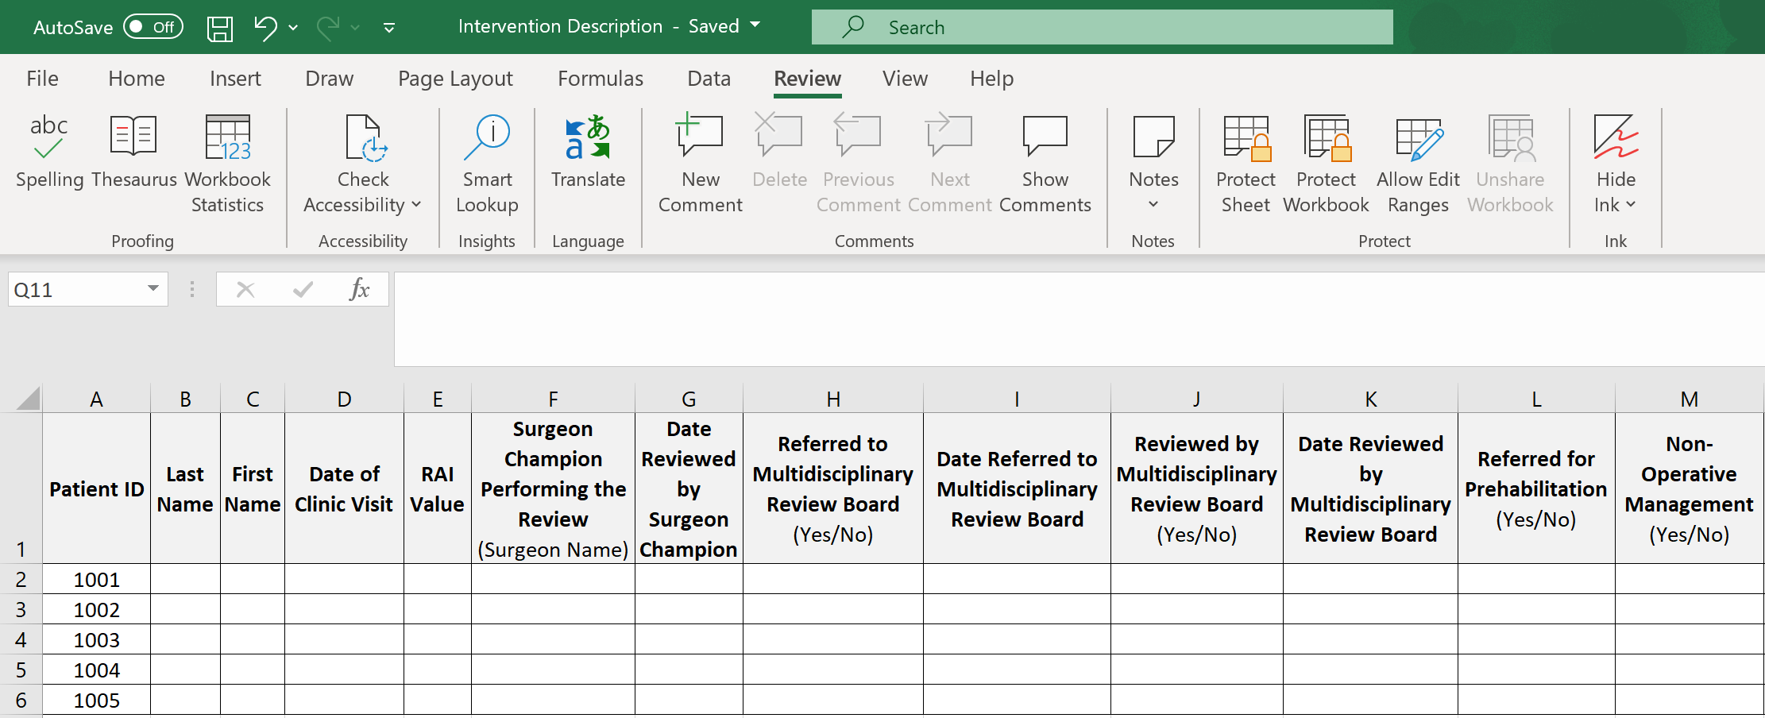

Traditional Surgical Outcomes
Length of Stay (LOS)
Tracked by linking data from VISTA Surgery Package, including date of surgery, date of admission, and date of discharge
Post-Operative Mortality
Assessed at 30, 180, and 365 days after surgery. Tracked by linking data from Vital Status file in the Corporate Data Warehouse (CDW) and the dates of surgery recorded in the VISTA Surgery Package.
Post-Operative Readmission
Tracked by linking data from VISTA Surgery Package, including date of surgery, date of admission, and date of discharge
Post-Operative Complications
Assessed at 30, 180, and 365 days after surgery. Tracked by linking data from VASQIP. For patients not included in VASQIP, a Surgical Quality Nurse will be needed to abstract the necessary post-operative complications data.

Non-Operative Management
Determined through Surgeon Champion chart review of patients identified as frail or prospectively recorded by members of the Multidisciplinary Review Board during the review of at-risk patient cases

Patient-Reported Outcomes (Optional)

- Patient Decision Regret
Conceptualized as “distress or remorse after a health care decision,”¹² patient decision regret is assessed using a 5-item survey instrument that takes approximately 30 seconds to complete.¹² The Survey is administered to patients in the week prior to surgery and at 90 days after surgery, or at 14 and 90 days after the decision to elect non-operative management. The administration approach will likely vary by facility, adjusted to fit site-specific workflows, but the key is to identify clear owners of this process and outline a plan to ensure the process is executed consistently.
It is recommended that surgical clinic staff assess patient baseline decision regret at the initial clinical encounter. For those patients who elect to proceed with surgery, the follow-up survey can be administered at the surgical follow-up. If the patient is not scheduled for a follow-up appointment, or if they choose not to undergo surgery, the follow-up survey can be administered over the phone. A copy of the Patient Decision Regret survey instrument can be found in Appendix H.

- Patient Centeredness of Care
Patient Centeredness is conceptualized as the extent to which patients feel involved in the healthcare decision-making process and the degree to which the resulting decision(s) reflect their preferences, needs, and values. It is assessed using the 12-item Patient-Perceived Patient-Centeredness of Care scale (PPPC)¹³, which assesses perceptions in three domains:

Treating the patient as a whole person

Focusing on the patient’s experience of disease and illness

Negotiating a treatment plan that shares common ground between physician and patient priorities

It takes approximately 2 minutes to complete¹⁴. The scale is administered to patients in the week prior to surgery and at 90 days after surgery, or at 14 and 90 days after the decision to elect non-operative management. A copy of the Patient Centeredness survey instrument can be found in Appendix I.

- Human Flourishing
Human flourishing is conceptualized as a broader assessment of patient well-being beyond physical and mental health, assessed utilizing a 12-item survey instrument comprised of six domains¹⁵:
Meaning and Purpose
Mental and Physical Health
Happiness and Life Satisfaction
Character and Virtue
Financial and Material Stability

Close Social Relationships

Human flourishing is assessed at 90 days after surgery or 90 days after the decision to elect non-operative management. A copy of the Human Flourishing survey instrument can be found in Appendix J.

- Bereaved Family Survey
The Bereaved Family Survey (BFS) is a product of the PROMISE project designed to “identify and reduce unwanted variation in the quality of end-of-life care throughout VA and to define and disseminate process of care best practices that contribute to improved outcomes for Veterans near the end of life [and their families].”
The BFS is administered to the families of Veterans who have died in a VA facility for the purpose of examining their perceptions of the care that their deceased loved one received during the last month of life. The components of the BFS are as follows:
Sixteen multiple choice items evaluating performance in areas of care including communication, emotional and spiritual support, pain management, and personal care needs
A single Likert-scale item, the BFS performance measure, asking respondents to provide a global rating of care during the last month of life (i.e., Excellent, Very Good, Good, Fair, Poor)
Two open-ended questions soliciting comments about positive and negative aspects of care (e.g., how could the care be improved, what else would you like to share about the Veteran’s care during the last month of life?)

If desired, BFS data can be abstracted for frail patients who die at your facility before and after the surgical pause is initiated. For instructions on how to access BFS data, please see Appendix K.
Step 3. Build out a tracking methodology
It is imperative that you establish a methodology to consistently track the process and outcome metrics needed to assess the impact and value of practice implementation. This can be accomplished by creating a spreadsheet in Excel, Microsoft Access, or other comparable software package.

Step 4. Conduct statistical analyses
Defer to the individual(s) responsible for collecting, managing, and analyzing practice data to define variables of interest and determine the appropriate statistical analyses to conduct. A brief description of the recommended analyses are outlined below:

2

Model Outcomes with Regression Analyses
Generate regression models to assess outcomes of interest. Ideally, data collected after the intervention is implemented can be compared to pre-intervention data to make inferences about the impact of the intervention.
Calculate Descriptive Statistics
Caclulate descriptive statistics for the applicable process and surgical outcome metrics. This includes total numbers, proportions, means, standard deviations, interquartile ranges, etc.
Perform Simple Comparisons
Using appropriate statistical tests, compare post-operative mortality rates and readmission rates three months prior to, and three months after, implementation.

Post-Implementation Phase: Evaluate and Iterate
It may be helpful to convene a ‘lessons learned’ meeting with your local implementation team to review the results of the pilot phase and discuss if any modifications or changes should be made prior to implementing the Surgical Pause across additional surgical service lines.

Step 10: Quality Improvement
QI entails continuous efforts to achieve stable and predictable results, reduce process variation, and improve outcomes for patients and providers. When deciding how best to approach continuous QI, consider the following:

- Utilization of a Formal QI Model
Figure 8. The Plan-Do-Study-Act Cycle
Although not required, pulling from an established model can provide some much-needed structure and direction to QI activities. One such model is the Plan-Do-Study-Act (PDSA) Cycle ¹⁷ (Figure 8), which involves identifying the need for improvement, generating ideas for change, and developing ways to measure improvement.
What change can we make that will result in an improvement?
What are we trying to accomplish?
- Implementation Team Resources Consider whether your implementation team has the time or available resources to engage in more extensive form of QI, like conducting statistical analyses or collecting and reviewing large amounts of qualitative data. Don’t discount the value of engaging in informal QI discussions with implementing staff to ascertain lessons learned on what went well, what didn’t, and what should be changed going forward.
PDSA
How will we know a change is an improvement?
- Feedback from Implementing Staff Feedback from staff participating in the implementation process can be used to improve and evolve the practice. “Early adopters” are particularly valuable in that they believe in the value of the practice and are eager to provide constructive feedback and suggestions. By the same token, it is important to recognize that there will be individuals who criticize the practice. Acknowledge these individuals and their concerns, but do not be paralyzed by them.
Do
Plan
Study
Act

Step 11: Expansion to Additional Surgical Service Lines
Based on initial outcomes and lessons learned from your pilot phase, you may want to expand the practice to additional surgical service lines.

Factors to consider when selecting additional surgical service lines include:
- Patient Volume

- Morbidity and Mortality

- Clinician Interest

A review of your facility’s most recent National Surgery Office (NSO) Quarterly Report can be used to determine which service lines are likely to meet the criteria, as it relates to patient volume and morbidity/mortality. If you aren’t planning to implement the practice across all service lines, focus expansion efforts where clinicians are most interested, the greatest volume of at-risk patients are located, and the clinical conditions being addressed present the greatest risk. Discussions of expanding the RAI can be incorporated into existing meetings that include surgical staff from multiple service lines. These discussions will also help you determine what aspects of the process, if any, need to be modified to fit the unique needs of a particular service line. For example, whether recalibration of the RAI score threshold is needed to yield a more manageable and clinically significant patient population.

With regards to the utilization of frailty screening for low-risk procedures (e.g., cataract surgery), data demonstrate that even for low stress procedures, frail patients suffer significant mortality, often 10 times greater than typical patients¹. However, it is unlikely that surgery is the cause of death in these patients, whereas moderate (e.g., cholecystectomy) or high stress (e.g., colectomy) surgery may occasion the death of frail patients. Sites may choose to focus on higher stress procedures, but the identification of frailty, even among patients considering low stress surgery presents an opportunity for goal clarification that may be beneficial beyond the discrete decision about surgery.

Step 12: Share Outcomes with Implementation Staff, Stakeholders, and Facility Leadership

Share outcomes with the implementing staff, stakeholders, and facility leadership every chance you get. Share the process before you start, share updates during the journey, and share the successes when accomplished.

You can schedule meetings exclusively for the purpose of sharing implementation outcomes or utilize existing meetings with facility staff and leadership.

Step 13: Celebrate! (Optional)
After successfully launching the Surgical Pause at your facility, you and your implementation team deserve some recognition! Regardless of the format you choose, it is important to celebrate the hard work put forth and the outcomes accomplished, because this is a practice directly enhancing the quality of care Veterans receive at your facility.

Take note of Veteran feedback that is particularly positive or encouraging and make a note to share them with implementing staff regularly. It can be a very effective tool in boosting morale and sustaining practice momentum.

QUESTIONS

Do you have questions or need advice about implementing the Surgical Pause at your facility?

Check out the Diffusion Marketplace Site:
https://marketplace.va.gov/practices/preoperative-frailty-screening-prehabilitation

Or contact the team:
VHASurgicalPause@va.gov

REFRENCES

- Shinall MC, Jr., et al. Association of Preoperative Patient Frailty and Operative Stress with
Postoperative Mortality. JAMA Surg. 10.1001/jamasurg.2019.4620. 2019.
- Arya S., Varley P., Youk A., Borrebach J.A., Perez S., Massarweh N.N., Johanning J.M., Hall D.E.
Recalibration and External Validation of the Risk Analysis Index: A Surgical Frailty
Assessment Tool. Ann Surg. 2019 Mar 19. [Epub ahead of print] https://www.ncbi.nlm.n

- Varley PR, Borrebach JD, Arya S, Massarweh NN, Bilderback AL, Wisniewski MK, Nelson JB,
Johnson JT, Johanning JM, Hall DE. Clinical Utility of the Risk Analysis Index as a Prospective Frailty Screening Tool within a Multi-practice, Multi-hospital Integrated Healthcare System. Ann Surg. 2020. 10.1097/SLA.0000000000003808

- Shah R, Borrebach JD, Hodges JC, Varley PR, Wisniewski MK, Shinall MC, Jr., Arya S, Johnson J,
Nelson JB, Youk A, Massarweh NN, Johanning JM, Hall DE. Validation of the Risk Analysis Index for Evaluating Frailty in Ambulatory Patients. J Am Geriatr Soc. 2020;68(8):1818-1824.
- Hall DE, Arya S, Schmid KK, et. al. Association of a Frailty Screening Initiative with Postoperative
Survival at 30, 180, and 365 Days. JAMA Surg. 2017 Mar 1;152(3):233-240.
- Ernst KF, Hall DE, Schmid KK, Seever G, Lavedan P, Lynch TG, Johanning JM. Surgical palliative care
consultations over time in relationship to systemwide frailty screening. JAMA Surg. 2014;149(11):1121-1126.

- VA Center for Health Equity Research and Promotion. (2020, May 01). VA.gov: Veterans Affairs.
Retrieved August 13, 2020 from https://www.cherp.research.va.gov/features/‌Major_new_project_led_by_CHERP_INVestigators.asp

- George EL, Hall DE, Youk A, Chen R, Kashikar A, Trickey AW, Varley PR, Shireman PK, Shinall MC,
Massarweh NN, Johanning JM, Arya S. Patient frailty and postoperative mortality after noncardiac surgery—does specialty matter? JAMA Surgery (in press).

- Anaya DA, Johanning J, Spector SA, Katlic MR, Perrino AC, Feinleib J, Rosenthal RA. Summary of
the Panel Session at the 38th Annual Surgical Symposium of the Association of VA Surgeons: What Is the Big Deal About Frailty? JAMA Surg. 2014;149(11):1191-1197.

- Howard, Ryan, et al. “Taking control of your surgery: impact of a prehabilitation program on
major abdominal surgery.” Journal of the American College of Surgeons 228.1 (2019): 72-80.
- University of Michigan. (n.d.). Morphomics®. Retrieved October 28, 2020, from
http://www.med.umich.edu/surgery/morphomics/mshop.html
- Brehaut JC, O’Conner AM, Wood TJ, et al. Validation of a decision regret scale. Medical decision
making: an international journal of the Society for Medical Decision Making. Jul-Aug 2003; 23(4):281-292.
- Stewart M, Brown JB, Donner A, et al. The impact of patient-centered care on outcomes. J Fam
Pract. Sep 2000; 49(9):796-804.
- Hudon C, Fortin M, Haggerty JL, et al. Measuring patients' perceptions of patient-centered care:
a systematic review of tools for family medicine. Ann Fam Med. Mar-Apr 2011;9(2):155-164.
- VanderWeele TJ. On the promotion of human flourishing. Proc Natl Acad Sci U S A. 2017;114(31):8148-
8156.
- Health Services Research and Development (2014). Improving End-of-Life Care for Veterans: PROMISE.
U.S. Department of Veteran Affairs. Retrieved October 28, 2020 from https://www.hsrd.research.va.gov/impacts/promise.cfm

- Langley, G. J. (1996). The improvement guide: A practical approach to enhancing organizational
performance.

SUPPLEMENTARY MATERIALS/APPENDIX

Organizational Readiness Assessment Worksheet
Prior to implementation, we suggest assessing your organization’s readiness to implement the Pre-Operative Frailty Screening and Prehabilitation Promising Practice. To do so, you may consider the Consolidated Framework for Implementation Research (CFIR), which is an implementation science model that offers several considerations, formally called constructs, to prepare your organization for a successful implementation. For more information on the CFIR model, you can visit: https://cfirguide.org/. While any number of the CFIR considerations may be useful, we recommend using the following seven considerations:
- Networks and Communications: The nature and quality of social networks, and the nature and quality of formal and informal communications within an organization
- Culture: Norms, values, and basic assumptions of a given organization
- Tension for Change: The degree to which stakeholders perceive the current situation as intolerable or needing change
- Relative Priority: Individuals’ shared perception of the importance of the implementation within the organization
- Learning Climate: A climate in which: a) leaders express their own fallibility and need for team members’ assistance and input; b) team members feel that they are essential, valued, and knowledgeable partners in the change process; c) individuals feel psychologically safe to try new methods; and d) there is sufficient time and space for reflective thinking and evaluation
- Leadership Engagement: Commitment, involvement, and accountability of leaders and managers with the implementation
- Available Resources: The level of resources dedicated for implementation and on-going operations, including finances, training, education, physical space, and time
To assess readiness, evaluate the barriers and facilitators associated with the seven considerations above using the table on the next page.

 | Questions to Consider | Barriers | Facilitators
Network and Communications
- What are working relationships like in the context of perioperative care?
- Between colleagues?
- With leaders?
- With influential stakeholders?
- Do teams meet formally or informally?
- Are staff meetings held regularly?
- How do you typically find out about new information in your surgical service line? In your facility?
- When you need to get something done or solve a problem, who are the “go-to” people?
Culture
- How would you describe the culture of your organization? Of your surgical service line?
- How do you think your organization’s culture will affect the implementation of this project?
- To what extent are new ideas embraced and used to make improvements in your surgical service line?
Tension for Change
- What needs will this project serve?
- How essential is this to meet the needs of your patients?
- How do people feel about current programs, practices, or processes that are available?

 | Questions to Consider | Barriers |  |  | Facilitators
Relative Priority
- What kinds of high-priority initiatives are already happening in your surgical service line/facility?
- What initiatives have, or appear to have, the highest priority for your organization/unit?
- To what extent might this project take a backseat to other current high-priority initiatives?
- How will you and your colleagues juggle competing priorities in your own work?
Learning Climate
- If you saw a problem in your service line, what would you do?
- To what extent do you feel like you can try new things to improve your work processes?
Leadership Engagement
- What level of endorsement or support have you seen or heard from leaders?
- What level of involvement has leadership at your organization had so far with this process?
- What kind of support or actions can you expect from leaders in your organization to make this initiative successful?
Available Resources
- Do you expect to have sufficient resources to implement?
- How do you expect to procure necessary resources?

National Surgery Office Signed Memorandum for RAI CPRS Template

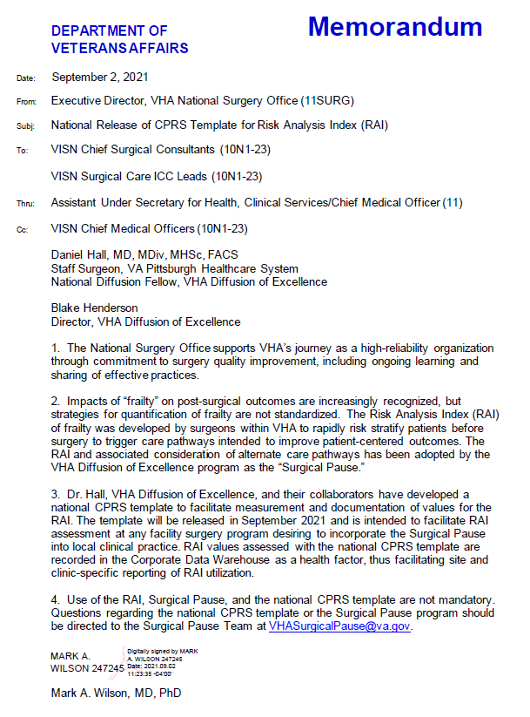

Risk Analysis Index Patient Handout
Two versions of the single-page RAI patient handout, with and without scoring, are included below. Either version of the handout can be distributed to patients and/or caregivers when they check-in to the outpatient surgical clinic, to be completed prior to rooming. The version without the scoring system is preferred unless extenuating circumstances require the score to be calculated manually or if clinicians require the scores to interpret the findings.

Adding the RAI Health Factor Reminder Dialogue Template to CPRS
After using the online RAI to assess frailty, it is critical that the value of the RAI score is entered into the patient chart. To facilitate the process, we developed a RAI FRAILTY TOOL Reminder Dialogue Template that can serve as a model for your own notes, or simply be added to existing note templates (e.g., Outpatient Surgery Clinic Consults or Surgery Request Template to book OR time in the VISTA Surgical Package). One advantage of this tool is that it records the RAI value as a Health Factor, facilitating retrieval from the Corporate Data Warehouse (CDW) using a SQL query.

The user can click on this hyperlink for the online RAI in REDCap and enter all the information that the Veteran recorded on their RAI Worksheet. After entering all information, the RAI will generate a score that can be recorded in the VA RAI FRAILTY TOOL Template in CPRS.

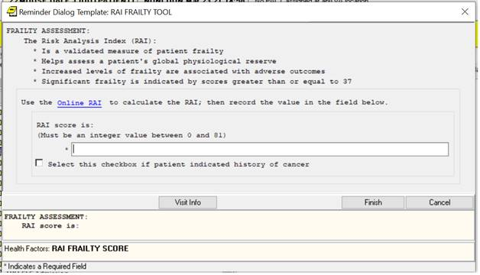

* If the Cancer question is answered in the negative, the REDCap tool renders a single score called “RAI Score” that the user inputs into the empty field and presses “Finish” and which point the value is written into the Health Factor called “RAI FRAILTY SCORE”
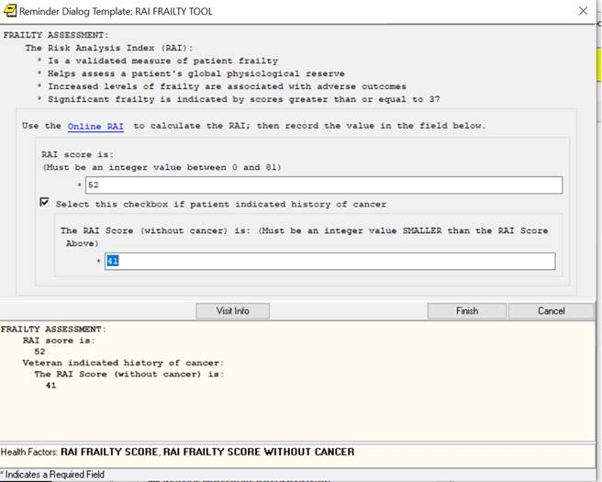

*If the cancer score is answered in the affirmative, the REDCap tool renders 2 scores, instructing the user to select the toggle box in CPRS and enter the “RAI Score (without cancer)”. If the toggle box is selected, a new entry field appears into which the non-cancer score can be inscribed and on finishing this is written to the RAI FRAILTY SCORE WITHOUT CANCER health factor.

The steps for using this reminder dialogue are outlined in the attached PowerPoint below:

Note that the Health Factor associated with this tool is called VA RAI Frailty Score. Every time a value is recorded in this field, an entry is written into the Health Factor file giving the identity of the patient, the value of the RAI and the date of recording. This facilitates post-hoc data abstraction, allowing data to be retrieved directly from CDW. For example, your CAC or other data manager could periodically download the identities, dates, and values of every recorded RAI at your facility. This could form the root dataset for tracking process and outcome metrics. The Template Data Tracker spreadsheet included below can be modified and used to collect data at your facility.

Project Charter Template
[INSERT FACILITY NAME] PROJECT CHARTER
[Project Title]
General Project Information
Facility Champion | Person who will promote the value of the practice among facility leadership and oversee practice implementation and evaluation.
Surgeon Champion | Person who will promote the value of the practice among surgical staff, and engage stakeholders from anesthesia, primary care, palliative care, and other necessary care teams.
Project Scope | Defines what is included and what is not included in the project. Lists what the project will and will not address.
Problem/Opportunity Statement  What problem will you solve, or what is the opportunity for improvement? Quantify the size of the problem or opportunity if you can.  E.g., reduce observed to expected post-operative mortality rates and/or rates of post-operative complications |  | Resources  What resources are required for this project? What resources does your facility need?  E.g., 10-20% FTE from Surgeon Champion, Facility Champion, and data analyst
Goal Statement  How will your facility benefit from participating in this project, and when? Specify the targeted improvement that is desired by stating a SMART goal (i.e., a goal that is specific, measurable, achievable, results-focused, and time-bound).  E.g., reduction in post-operative mortality rates; (2) increase in non-operative management; (3) reduction in patient decision regret  SMART Goal Example: Reduce the 180-day postoperative mortality rate among the frail from X% to Y% in 12 months. |  | Timeline  How and when are you going to get this project done? Highlight the project’s key activities and milestones in your timeline.  E.g., 10-12 months. Begin administering the RAI; Identify Facility Champion and Surgeon Champion; Define practice intervention; Identify relevant stakeholders; Present initial RAI dataset; Go live; Collect and analyze data; Evaluate implementation process and outcomes; Expand to additional surgical service lines
Team Members  Who will actively participate in this project team and what is each participant’s time commitment?  E.g., Facility Champion, Surgeon Champion, representatives from anesthesia and palliative care, outpatient surgical clinic nursing staff, surgical service line chiefs, etc. Additional care teams, depending on interventions are pursued (e.g., PT/OT, primary care) |  | Leadership  Who do you need to obtain buy-in from to support your project?  E.g., Facility leadership, Surgical Service Line Leadership (e.g., Service Chiefs), Nursing Leadership who oversee outpatient surgical nursing staff

Stakeholder Analysis Template

Stakeholder Category | Questions to Consider | Name/Position | How will they support implementation? | What is the engagement plan? What training is needed?
Opinion  Leaders | - Who are the key individuals to get on board?  - What are these individuals saying about this project?
Formally Appointed  Implementation  Leaders | - Who will lead the intervention?  - Why is this individual best suited to lead the implementation?
Champions | - Besides the formal leader, who may go above and beyond to champion the intervention?  - What are people’s perception of this individual?  - What kinds of behaviors/actions will this individual exhibit?

Implementation Launch Plan
Planning Tasks | Key Considerations | Completion Status | Comments
Process Buildout | - Which surgical service line(s) will serve as the pilot?  - Who will administer the RAI?  - What resources are needed to implement the RAI?  - What needs to be done to gain access to REDCap?  - What intervention option(s) will your facility pursue?
Leadership and Stakeholder Buy-In Support | - Who are your key stakeholders?  - When will you engage these key stakeholders?  - What do these key stakeholders need to know to buy-in to this practice?  - Who in a leadership position can support and champion implementation?  - What are your asks of facility leadership (e.g., allocation of FTE, resources for RAI administration)?
Timeline Development | - What is the preferred start date for administering the RAI within the pilot surgical service line?  - When will you select intervention option(s)?  - What preparatory work and training must be done prior to implementation launch?  - When will you present the initial RAI dataset to stakeholders and facility leadership?  - What milestones and benchmarks should your team work towards and track?
Implementation Team Identification and Training | - Who will serve as the Facility Champion?  - Who will serve as the Surgeon Champion?  - What surgical clinic staff will be involved in the administration of the RAI?  - What surgical clinic staff will be involved in the administration of the Decision Regret Survey?  - What facility staff will be involved in the intervention option(s) selected?  - What facility staff will be responsible for collecting and analyzing data?  - How will each staff member be identified? What are their roles and responsibilities?  - What training and communication materials should be provided?
Program Evaluation | - How will you evaluate this practice?  - What process and outcome metrics will you collect and analyze?  - Where will you obtain process and outcome data from (e.g., REDCap, CPRS, CDW)?  - What tracking methodology will you utilize (e.g., Excel, Microsoft Access)?  - What statistical analyses will you conduct?  - How will you obtain and incorporate staff feedback into process improvement efforts?
Expansion to Additional Surgical Service Lines | - What additional service lines would benefit from this practice?  - Who do you need to engage with from within those service lines to jumpstart expansion?  - Will any aspects of the implementation process need to be adjusted for these additional service lines?

Patient Decision Regret Survey

Record ID: __________________

Please reflect on your decision about whether or not to have [specific] surgery. Please show how strongly you agree or disagree with the following statements by checking the number from “strongly agree” to “strongly disagree” that best fits your views about your decision.

 | Strongly agree | Agree | Neither agree nor disagree | Disagree | Strongly disagree
- It was the right decision | ○ | ○ | ○ | ○ | ○
- I regret the choice that was made | ○ | ○ | ○ | ○ | ○
- I would make the same choice if I had to do it over again | ○ | ○ | ○ | ○ | ○
- The choice did me a lot of harm | ○ | ○ | ○ | ○ | ○
- The decision was a wise one | ○ | ○ | ○ | ○ | ○

Patient Centeredness Survey

Record ID: __________________

You recently made the decision [to have/to decline] recommended surgery. Your decision may have been informed and supported by your surgeon, anesthesiologist, nurse, palliative care physician, or providers in the preoperative evaluation clinic. Please tell me how you feel the entire healthcare team supported your decision about surgery. The answer choices will vary from item to item, so I will provide you with choices after I read each item.

How well do you think the healthcare team understood your needs as you considered whether to have surgery? | Very well  ○ | Well  ○ | Somewhat  ○ | Not at all  ○ | Do not know  ○

To what extent did the healthcare team discuss your decision whether to have surgery? | Completely  ○ | Mostly  ○ | A little  ○ | Not at all  ○ | Do not know  ○

How satisfied were you with the discussions with the healthcare team as you considered whether to have surgery? | Very satisfied  ○ | Satisfied  ○ | Somewhat satisfied  ○ | Not satisfied  ○ | Do not know  ○

To what extent did the healthcare team explain your medical problems to you? | Completely  ○ | Mostly  ○ | A little  ○ | Not at all  ○ | Do not know  ○
To what extent did you agree with the surgeon’s opinion about how to treat your medical problem? | ○ | ○ | ○ | ○ | ○

How much opportunity did you have to ask your questions? | Much opportunity  ○ | Some  opportunity  ○ | A little  opportunity  ○ | No  opportunity  ○ | Do not know  ○

To what extent did the healthcare team ask about your goals/preferences for treatment? | Completely  ○ | Mostly  ○ | A little  ○ | Not at all  ○ | Do not know  ○
To what extent did the doctor explain the treatment options? | ○ | ○ | ○ | ○ | ○
To what extent did the healthcare team discuss with you how you might manage your treatment | ○ | ○ | ○ | ○ | ○

To what extent did you and the healthcare team discuss your respective role in making decisions about your healthcare? | Completely  ○ | Mostly  ○ | A little  ○ | Not at all  ○ | Do not know  ○
To what extent did the healthcare team support you in your referred role in making decisions about your healthcare? | ○ | ○ | ○ | ○ | ○

How much would you say that the healthcare team cares about you as a person? | Very much  ○ | A fair amount  ○ | A little  ○ | Not at all  ○ | Do not know  ○

Human Flourishing

The “Flourish” measure is obtained by summing the scores from each of the first five domains. The “Secure Flourish” measure is obtained by summing the scores from all six domains, including the financial and material stability domain. Each of the questions is assessed on a scale of 0 – 10.

Domain 1:
Happiness and Life Satisfaction
Overall, how satisfied are you with life as a whole these days? | 0  Not satisfied at all | 1 | 2 | 3 | 4 | 5 | 6 | 7 | 8 | 9 | 10  Completely satisfied
In general, how happy, or unhappy do you usually feel? | 0  Extremely unhappy | 1 | 2 | 3 | 4 | 5 | 6 | 7 | 8 | 9 | 10  Extremely happy
Domain 2:
Mental and Physical Health
In general, how would you rate your physical health? | 0  Poor | 1 | 2 | 3 | 4 | 5 | 6 | 7 | 8 | 9 | 10  Excellent
In general, how would you rate your overall mental health? | 0  Poor | 1 | 2 | 3 | 4 | 5 | 6 | 7 | 8 | 9 | 10  Excellent
Domain 3:
Meaning and Purpose
Overall, to what extent do you feel the things you do in your life are worthwhile? | 0  Not at all  worthwhile | 1 | 2 | 3 | 4 | 5 | 6 | 7 | 8 | 9 | 10  Completely worthwhile
I understand my purpose in life. | 0  Strongly disagree | 1 | 2 | 3 | 4 | 5 | 6 | 7 | 8 | 9 | 10  Strongly agree
Domain 4:
Character and Virtue
I always act to promote good in all circumstances, even in difficult and challenging situations. | 0  Not true of me | 1 | 2 | 3 | 4 | 5 | 6 | 7 | 8 | 9 | 10  Completely true of me
I am always able to give up some happiness now for greater happiness later. | 0  Not true of me | 1 | 2 | 3 | 4 | 5 | 6 | 7 | 8 | 9 | 10  Completely true of me
Domain 5:
Close Social Relationships
I am content with my friendships and relationships. | 0  Strongly disagree | 1 | 2 | 3 | 4 | 5 | 6 | 7 | 8 | 9 | 10  Strongly agree
My relationships are as satisfying as I would want them to be. | 0  Strongly disagree | 1 | 2 | 3 | 4 | 5 | 6 | 7 | 8 | 9 | 10  Strongly agree
Domain 6:
Financial and Material Stability
How often do you worry about being able to meet normal monthly living expenses? | 0  Worry all of the  time | 1 | 2 | 3 | 4 | 5 | 6 | 7 | 8 | 9 | 10  Do not ever  worry
How often do you worry about safety, food, or housing? | 0  Worry all of the  time | 1 | 2 | 3 | 4 | 5 | 6 | 7 | 8 | 9 | 10  Do not ever  worry

Accessing Bereaved Family Survey Data
To access Bereaved Family Survey (BFS) data, facility personnel need to be added to the BFS IRB Protocol managed by Francis Nelson. Facility personnel seeking access should be familiar with accessing data through the Data Access Request Tracker (DART). To be added to the BFS IRB Protocol, personnel should email Francis Nelson (Francis.Nelson@va.gov):
- A signed copy of the “Rules of Behavior (ROB) for Access and Use of Data from VHA Vital Status Files” form

- Certificates of completion for the following trainings:

  - TMS VA Privacy and Information Security Awareness and Rules of Behavior
  - TMS Privacy and HIPAA
  - CITI Program VA Human Subjects Protection and Good Clinical Practices

Once these items are submitted, access will be granted to the BFS folder on the Data Access Request Tracker (DART). From that point forward, the designated personnel will be able to download BFS data as needed, refreshing quarterly if appropriate.

The BFS Variable Codebook linked below can assist in the interpretation of BFS data.

