VA Insider 10/1/18
Rapid Naloxone Initiative Program Saves Lives

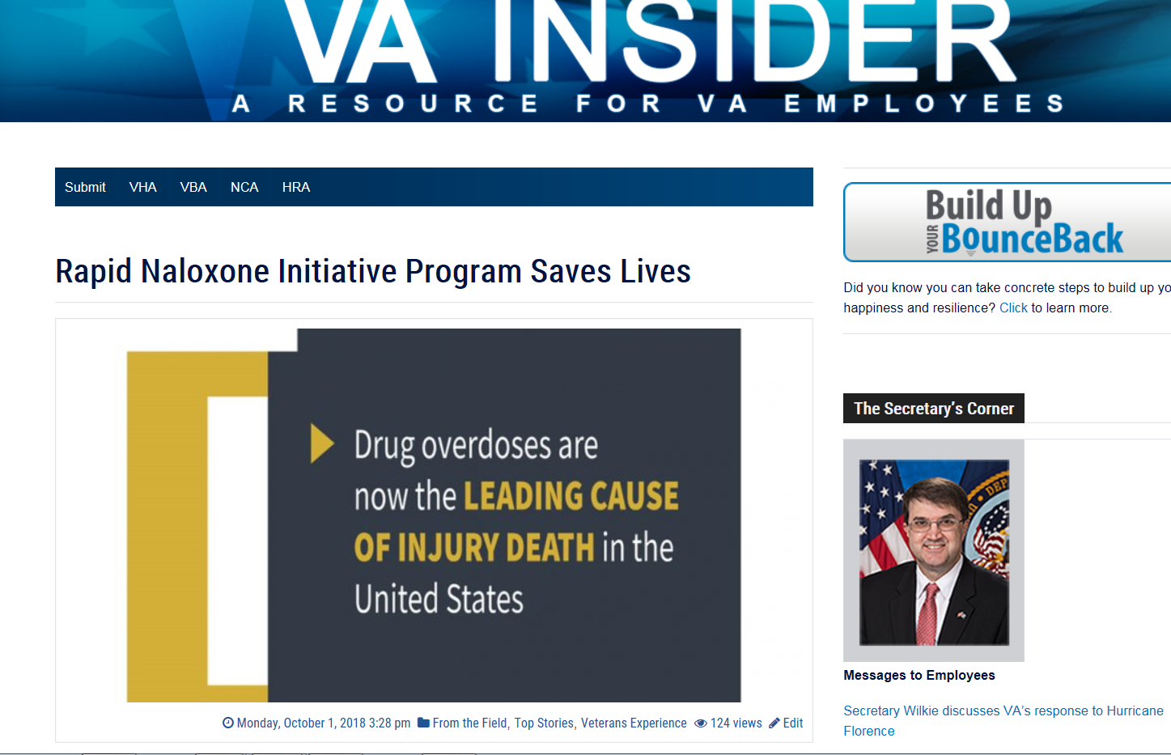
Photo:
At VA Boston Healthcare System (Boston HCS), the Rapid Naloxone Initiative program is saving lives. Patient Safety Manager, Pam Bellino, is the driving force behind the program. Bellino introduced the life-saving program and since its implementation there have been 132 successful opioid overdose reversals for both Veterans and non-Veterans at Boston HCS. This ground-breaking program is modernizing how the VA cares for Veterans and civilians alike.
Naloxone is a narcotic blocker. It is used to treat opioid drug overdoses and is also known as Narcan. Boston HCS’s Public Affairs Officer, Pallas Wahl explained, “We give and train at-risk Veterans on the use and positive results of Naloxone. We train family members and caregivers of at-risk Veterans as well.”
Boston HCS equipped their VA Police and one police dog with nasal Naloxone and have equipped 43 of 51 automated external defibrillator (AED) cabinets with two doses of naloxone, gloves, mask and directions for administering the drug. Not all first responders (police, fire, and healthcare) are equipped with Naloxone. This innovative program allows for immediate response by any trained person as, Bellino notes, “…every second counts and equipping our facilities and staff with naloxone, the drug that reverses opioid overdoses, is saving lives.”
What should you do if you find an unresponsive person with a suspected opioid overdose? Call 911 first. But did you know that the 10 or so minutes it would take for the ambulance to arrive are the most crucial for saving the life of a person who overdosed? Unfortunately, many will not survive the wait.
That is why the naloxone initiative program is imperative. With naloxone stored in every AED kit, the first dose can be administered within a minute, with a second dose just minutes later. By the time the help arrives a third dose can be delivered and a life can be saved.
Our country is amid an opioid epidemic. In 2016, an average of 116 people died every day from opioid-related drug overdoses. “Veterans are twice as likely to die from a drug overdose than non-Veterans. But we can change the number by implementing the rapid naloxone initiative throughout all of VA and throughout the country,” said Bellino during a VA ted-style talk accessed here (through Google chrome).
“For every minute that goes by, the Veteran’s likelihood of survival diminishes.” Bellino stated. “The saving of lives at VA Boston speaks to eventually modernizing not only all VA’s but all community first responders, healthcare professionals, teachers, parents – the list is endless.”
As a result of Boston HCS’s success, the Naloxone program is being rolled out to all VA Medical Centers by December 2, 2018. For more information on how the Veterans Health Administration will implement this practice, see Automated External Defibrillator (AED) Cabinet Naloxone Program.

