**TCR ASPIRE-VA**

# Chapter One

## Getting Set for Success



*During this session you will:*

* Gain motivation by identifying your reasons “Why”
* Define a low carbohydrate diet and explore potential benefits
* Understand the TCR Aspire approach

#### W

Welcome to Therapeutic Carbohydrate Restricted ASPIRE! program.

# **Welcome!**

This program was developed for Veterans with insulin resistance who want to obtain the benefits that come from leading a healthier lifestyle.

Insulin resistance is when cells in your muscles, fat, and liver don’t respond well to insulin and can’t use glucose form your blood for energy. To make up for it, your pancreas makes more insulin. Over time, your blood sugar levels go up.

The TCR ASPIRE program will provide you with guidance and support as you increase your physical activity, explore, and maintain motivation to make healthy changes, and adopt a lower carbohydrate diet.

***************************************************************************  
Before we get started learning about TCR Aspire, we need to take a moment to make sure you have the tools needed for success.

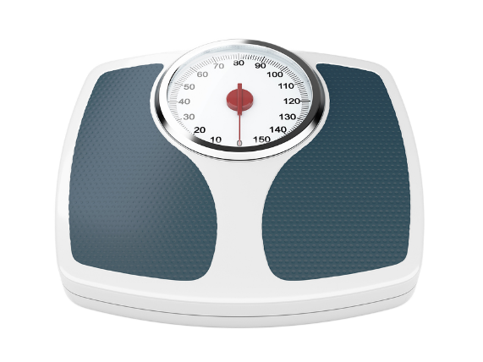 **You Will Need:**

* TCR Aspire Workbook
* TCR Aspire Food + Activity Log
* Resistance Band
* Weight Scale
* Pedometer
* Video Compatible Device

What tools are you missing? ________________________________________________________________________________________________________

# **Exploring Your Reasons**

Before you start your weight-loss journey, it is important to find your reasons for change. Over time, people motivated by their own needs and desires find it easier to maintain change.

Why is weight loss a priority for you now?

________________________________________________________________________________________________________

____________________________________________________

What will better health mean for you?

____________________________________________________________________________________________________________________________________________________________

What is your Mission, Aspiration & Purpose “MAP” in life?

____________________________________________________  
____________________________________________________  
  
What is in your Bucket List: What dreams will be possible for you to achieve if you lose weight?   
________________________________________________________________________________________________________



# **TCR ASPIRE Overview**

**What You Can Expect Over the Next 16-Weeks**

Weekly sessions for 90minutes each.

The six main goals of this program are to:

1. **Improve nutrition.** We will work to improve what and how much you eat to help you feel better physically. We will focus on decreasing calories from highly starchy and sugary foods. You will learn how to eat more non-starchy vegetables, heart healthy fats and lean proteins.

Therapeutic Carbohydrate Restricted diets can be done in several ways, we will help you find a way to healthfully reduce your carbohydrate intake without turning to processed foods that can have negative impacts on your overall wellbeing.

1. **Increase physical activity.** We will provide you with a pedometer, a device you wear every day that counts all the steps you take in a day. This device will help you identify ways to increase your daily physical activity levels by about 30 minutes a day (about **3,000 steps**). We will help you explore ways other than walking to move your body and to overcome barriers such as chronic pain and arthritis.
2. **Manage weight.** A realistic goal is to lose approximately 5-8% of your current weight during the 16-week program.
3. **Improve quality of life.** Other topics we’ll focus on are stress management, well-being, and life satisfaction, which all have a significant impact on health.
4. **Monitor your blood sugar and/or blood pressure.** If you are taking blood sugar or blood pressure medications, it is important that you monitor your numbers during TCR Aspire. If your blood sugar or blood pressure goes low often, you may need to reduce your medications.
5. **Deprescribe Medications.** You will have the support of a Clinical Pharmacist who will help you to identify if you need to reduce medications for blood sugar and blood pressure. If needed, the Clinical Pharmacist will work with you and your Primary Care Provider to appropriately de-prescribe medications.

# **What is a Therapeutic Carbohydrate Restricted Diet?**

  
With a Therapeutic Carbohydrate Restricted (TCR) diet, you will eat fewer carbohydrates and a higher amount of protein, fiber, and fat.

TCR diet plans are often called low-carbohydrate diets. You may also have heard them referred to as “Keto” diets. A Ketogenic or “Keto” diet is the most restrictive type of low carbohydrate diet. You will not be starting out with a ketogenic or very low carbohydrate diet.

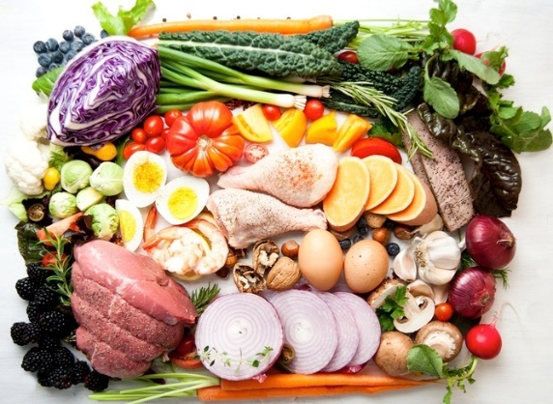In TCR Aspire, you will work with your team to reduce carbohydrates to an amount that works for your specific needs and preferences. You will also learn how to fill your plate with carbohydrates that are loaded with fiber and other nutrition, and you will learn which carbohydrate foods you should minimize in your diet.

You **WILL EAT MORE**:

* Non-starchy vegetables
* Fats from animal foods as well as plants such as avocado, heart-healthy oils, nuts, and seeds
* Protein from meat, fish, shellfish, nuts, seeds, eggs and cheese

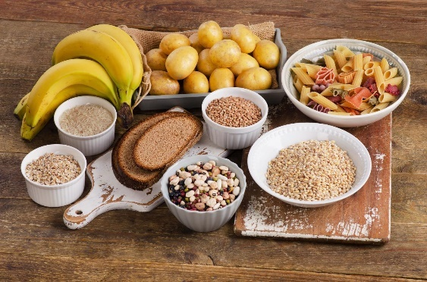

You **WILL EAT LESS:**

* Starchy foods
* Sugary foods
* Refined carbohydrates

**Many of you have already started on the journey to move your body more and improve your nutrition.**

What are some eating, and nutrition changes you have made before joining TCR Aspire?

___________________________________

___________________________________  
___________________________________

**Potential Benefits to a Low Carbohydrate Diet:**

The American Diabetes Association (ADA) in their Guidance Statement reports: “Reducing overall carbohydrate intake for individuals with diabetes has demonstrated the most evidence for improving glycemia and maybe applied to a variety of eating patterns that meet individual needs and preferences (Evert, et. al; 2019).”

Possible Benefits to a Lower Carbohydrate Diet:

* Lose Weight
* Improve Blood Sugars
* Reduce Insulin Resistance
* Improve Blood Pressure
* Reduce Triglycerides
* Increase HDL (Good Cholesterol)
* Reduce Medications



# Is TCR Aspire Right for Me? (Siverhus; 2022)

**Factors Predictive of Success:**

* Excessive hunger is the main reason why you have not been successful with other approaches.
* Carbohydrate intake significantly raises your blood glucose (blood sugar) after eating/drinking or throughout the day.
* You have cravings for fruits, sweets, and/or starchy foods and you are willing to avoid these foods to eventually diminish these cravings.
* You enjoy vegetables, high protein, and high fat foods.
* You have a willingness to try new meal ideas and enjoy cooking.
* You eat out frequently.
* You’re interested, motivated, and open-minded toward the intervention.
* Health issues associated with your weight and/or blood sugar motivate you.
* You have insulin resistance, edema (excess water weight), and/or chronic heart failure.
* You have a strong support system.

**Factors Predictive of Challenges:**

* You eat a lot of fruits and/or starchy foods and would feel “deprived” of these foods.
* You follow a vegan diet.
* You have a history of yo/yo dieting, setting unrealistic goals, blaming, or shaming yourself for your weight, and/or an eating disorder.
* You have competing priorities example: External stressors that would make participation too difficult for you.

*Take a moment to consider the factors that promote success and those that make it harder to succeed.*

**What makes you a good candidate for TLC Aspire? ____________________________________________________________________________________________________________________________________________________________**

**What will make TLC Aspire challenging for you?**   
____________________________________________________________________________________________________________________________________________________________

**Program Requirements:**

* Complete lab work prior to session 3
* Complete pre-class survey (emailed through survey monkey)
* Attend all sessions or notify your team prior to class if you need to miss a session
* Keep a log of your food and activity
* Text Annie your weekly weight
* Make changes to your eating and physical activity
* Monitor your blood sugars (if you are on blood sugar medications)
* Monitor your blood pressure (if you are on blood pressure medications)
* Notify your team of low blood sugars and/or low blood pressure
* Meet with a Clinical Pharmacist to adjust your medications as needed

The TCR Aspire approach is not the right fit for everyone. There are other ways to improve your health and promote weight loss. Let your team know if you would prefer to explore alternative programming to help you meet your wellness goals.

# Summary

This program will help you make healthy lifestyle changes to lose weight and improve your chronic disease(s). The key to successful weight loss is balancing small changes in what you eat with small changes in physical activity. Throughout this program, you’ll learn about your nutrition and activity patterns to make these small but meaningful changes.

Unlike other weight-loss programs, TCR Aspire will focus on helping you reduce your intake of sweet and starchy foods, while increasing your intake of healthy fats, protein, and non-starchy vegetables. These nutritional changes can result in changes to your blood sugar and/or blood pressure. It is critical that you are willing to closely monitor your blood sugar and blood pressure and that you let us know when either of these occur.

We look forward to partnering with you as you work to improve your well-being and live the life of your dreams. To get started, there are a few things you will need to do before our next meeting.   
  
**TO DO:**

* Reply to text message from Annie and send your weight when asked
* Complete survey (found in your email)
* Complete lab work if you have not already done so
* Begin to take notice of what you eat, how much you eat and how that food impacts you.

# This Week’s Goals



**Nutrition & Physical Activity Goals**

**Do not change your eating and physical activity behaviors this week!**

* Use Annie to text over your weight

Things I will do to meet this goal:

* Complete the Weight Management Survey
* Complete any needed laboratory work
* Read through Session One
* Notify your Weight Management Team if you think TCR Aspire is not the right fit so we can help you find a program that will work best for you.
* Begin to take notice of what you eat, when you eat, how much you eat, and how that food impacts you.

**CONFIDENCE:** How confident, on a scale from 0-10, are you that you can succeed in achieving this health goal?

**0......1…. 2…. 3…. 4…...5…. 6…. 7……8……9……10**

**Not at all**   **Very**

**Confident Confident**

|  |
| --- |
| ***NOTES*** |
|  |
|  |
|  |
|  |
|  |
|  |
|  |
|  |
|  |
|  |
|  |
|  |
|  |
|  |
|  |
|  |
|  |
|  |
|  |
|  |
|  |
|  |

]

*What to eat more of and what to limit!*

**

*During this session you will:*

* Learn about a low carbohydrate diet
* Use the TCR Aspire Stop Light to identify foods to increase, foods to limit and foods to minimize.
* Begin reading food labels for carbohydrates and sugars.
* Record what you eat and drink.

# Chapter Two

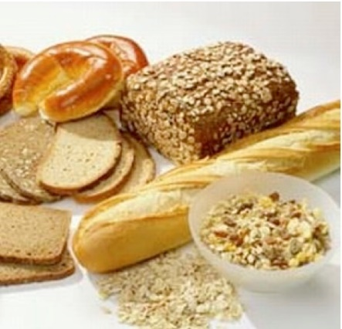

*Low Carbohydrate Diet:*

Welcome Back to TCR Aspire!  
  
Last session we learned what makes the TCR Aspire program unique. Over the past 7 days, you have worked on getting set-up for success.

You will get the most out of TCR aspire if you have:

* Completed any needed laboratory tests
* Answered the weight management survey
* Completed Session 1 in your Aspire Patient Handbook

Let your TCR Aspire team know if you need help.

# **Low Carbohydrate Diet**

TCR Aspire is based on a reduced carbohydrate diet. You will eat fewer carbohydrates and fill more of your plate with low carbohydrate vegetables, healthy fats, and high protein foods.

There are different types or levels of low carbohydrate diets.

**Level 1: Low Carbohydrate Diet:**

26-45% of calories from carbohydrates or

No more than 130 grams of total carbohydrates a day  
 No more than 2 servings of yellow or red foods at a meal  
 (30grams carbohydrates)  
 No more than 1 serving of yellow or red foods at a snack  
 (15grams carbohydrates)

**Level 2: Very Low Carbohydrate Diet (Ketogenic Diet):**

Less than 26% of calories from carbohydrates  
 No more than 75 grams of total carbohydrates a day  
 0-1 serving of yellow foods at a meal   
 (15grams of carbohydrates)  
 0-1 serving of yellow foods at a snack  
 (15 grams of carbohydrates)  
 0-1 serving of red foods a day

In this Chapter, you will learn how to follow a level 1 low carbohydrate diet. After mastering a moderately low carbohydrate diet, you may choose to try a level 2 or very low carbohydrate diet. Chapter 8 will introduce very low carbohydrate diets and will teach those interested how to further restrict carbohydrates.

A healthy low carbohydrate diet limits the total quantity of carbohydrates AND focuses on choosing high quality carbohydrates. High quality carbohydrates are also referred to as complex carbohydrates.

|  |  |
| --- | --- |
| Complex Carbohydrates | Refined Carbohydrates |
| Contain fiber slowing digestion and making them less likely to cause a rapid spike in blood sugar. | Do not contain fiber leading to rapid digestion making them more likely to cause a spike in blood sugar. |
| Naturally high in vitamins and minerals. | Low in vitamins and minerals as they are removed during processing |

Examples of refined carbohydrate foods: ________________________________________________________________________________________________________

Examples of complex carbohydrate foods:

____________________________________________________

____________________________________________________

The STOPLIGHT Program is a method that has proven simple and effective in helping people categorize foods into the colors of a stoplight that make it easier to follow healthy eating habits.

* **Go to the next page to learn more about the Stoplight Program**



**The Stoplight Program Colors**

In this program there are three types of foods: *Green foods, Yellow foods, and Red foods.* You already know a lot about these colors because they are just like the colors you see on a stoplight.

In this program these colors have nothing to do with how the food looks. Instead, these colors tell you how healthy a food is for you.  
  
  


***GREEN FOODS***

Just like the color Green on a stoplight tells you to go, Green in this program means “***GO***.” That means you can eat almost as many Green foods as you want. This is because Green foods are **very healthy.** They give you lots of vitamins and energy. They also do not have many calories or carbohydrates.

Here are some examples of ***Green Foods***.

Circle those you like to eat or drink:

Asparagus Carrots Lettuce Spinach

Peppers Tomatoes Cauliflower Sirloin Steak  
  
Chicken Thighs Avocados Olive Oil Almonds  
  
Salmon Canned Tuna Sunflower Seeds Mustard Greens

Broccoli Mushrooms Snow Peas Cauliflower

***YELLOW FOODS***

Yellow foodsare very important. These foods *give you energy, vitamins, and fiber.* You just need to be *a little more cautious* eating them. These foods have a lot of nutrients, but they also contain more carbohydrates than green foods.

Just like yellow on a stoplight tells you to ***go slow and be cautious***, in this program Yellow means to be careful. ***When you eat a Yellow food, you need to slow down and think about limiting your portions and being careful not to overeat.***

When following a low carbohydrate diet, you should limit each meal to no more than 2 servings of yellow foods. Each snack should have no more than 1 serving of yellow foods.

Here are some examples. Circle your favorite ***Yellow Foods***.

Pinto Beans Sour Cream Lentil Pasta

Brown Rice Oatmeal Milk, 2%

High Fiber Wrap Popcorn (air popped) Berries  
  
Sweet Potatoes Multi-Grain Bread Quinoa



***RED FOODS***

Just like when you see a Red light on a stoplight, when you see a Red food you should *“stop.”*

Foods in the Red food group are *very* fattening, that means they give you a great deal of calories or sugar. By eating *too many* Red foods, you give your body *too much* energy; more energy than your body needs. When this happens, your body stores the extra energy as fat. These foods are high in carbohydrates and fats that promote inflammation and heart disease.

**You should try to limit the number and amount of Red foods you eat.**

Here are some examples of ***Red Foods***.

Donuts Soda or Soft Drinks

Brownies French Fries Fried Foods

Cake Ice Cream Candy

Pizza Cookies Potato Chips

Sweet Tea Chocolate Bar Fruit Pie

Juice

Bottom-line: **ALL CALORIES ARE NOT CREATED EQUAL!** There can be a BIG difference in the quality of the calories.

###### **\*\*\*\*\*\*\*\*\*\*\*\*\*\*\*\*\*CAUTION\*\*\*\*\*\*\*\*\*\*\*\*\*\*\*\*\***

###### Let’s include one more thing that really affects what color a food is: **Spoilers.**

###### Spoilers can happen when a food is prepared or served in a way that lessens its health value and increases the amount of carbohydrates in the food. For example, if you have cabbage and add a sugary dressing to make it into coleslaw, you will be adding a red food to a green food.

What’s an example of a few spoilers that you may use?

Original Food Original Color Spoiler Color

____________ __________ __________ __________

________ ____ ________ __ ________ __ ________ __

*Example:*

Cabbage Green Sugar Red

How can you modify the way you prepare these foods to be healthier?

________________________________________________________________________________________________________

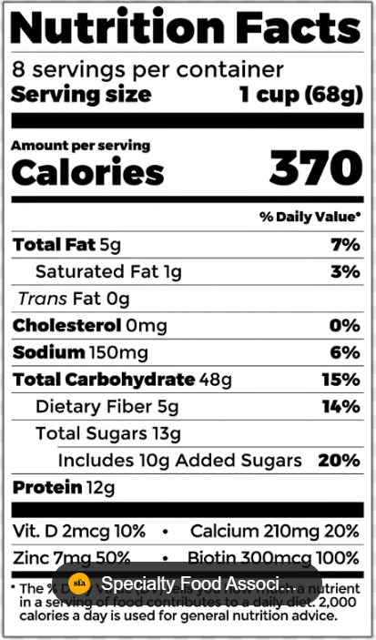**Reading Labels and Dinning Out:**If you don’t prepare your own meals, then you will need to ask how they are prepared and read food labels.  
  
Take a moment to look at this food label. You will see that this processed food item is very high in carbohydrates.   
  
  
What is one serving of this food item? _________

How many grams of carbohydrates are in one serving of this food item? ____________

How many grams of added sugar are in this food item? ________

# **Taking the First Step**

The first and most important step in making permanent lifestyle changes is to understand your ***current*** habits. The best way to do this is to keep detailed records of your current eating and activity habits in your Keeping Track log.

**Food Records**

Keeping a food record will help you look at what types of foods you eat, how much you eat, and you’re eating patterns (for example, you might always have a snack before bed or eat when you watch TV). Here are a few tips for keeping accurate food records:

* Write down the name and amount of everything you eat and drink. Don’t forget the extras, like butter on toast.
* Write down how food was prepared (baked, broiled, fried, etc.)
* Write down the type of food or drink (for example, fat-free or whole milk).
* Write down where you were and what you were doing when you ate (e.g., at the table, in front of the TV, on the road).
* Fill out your record right after you eat. The longer you wait, the more likely you are to forget something.

**Physical Activity Records**

Using a pedometer is an easy way to find out your current activity level and check your progress in this program. The pedometer keeps track of the number of steps you take each day. Simply write them at the bottom of your food/activity log each day.

Each morning, put the pedometer on your waist right above your hipbone. Leave it on all day. Remember, the pedometers aren’t waterproof – so don’t wear it in the shower!

# Summary

This program will help you make healthy lifestyle changes to lose weight. The key to successful weight loss is balancing small changes in what you eat with small changes in physical activity. Throughout this program, you’ll learn about your nutrition and activity patterns to make these small but meaningful changes.

Each week, you’ll set specific goals for healthy eating and physical activity. The changes you’ll make will be gradual, healthy, and will fit your lifestyle.

The first and most important step in making lifestyle changes is to find out what you are doing now. This means ***not*** making any changes in your current eating and activity patterns.

Over the next week, keep detailed records in your Keeping Track log. Remember, this week should reflect your regular, everyday patterns, so **hold off** on starting any new activity or nutritional changes!



# This Week’s Goals

**Nutrition & Physical Activity Goals**

**Do not change your eating and physical activity behaviors this week!**

* Write down everything you eat and drink in your Food & Activity log. Spelling is not important. What is important is to:
* Be honest (write down what you really eat).

Things I will do to meet this goal:

* Be accurate (record the number of servings you ate).
* Be complete (include all food, drinks, and extras added to food
* Try to stick to your typical routine.

**CONFIDENCE:** How confident, on a scale from 0-10, are you that you can succeed in achieving this health goal?

**0......1…. 2…. 3…. 4…...5…. 6…. 7……8……9……10**

**Not at all**  **Very Confident Confident** 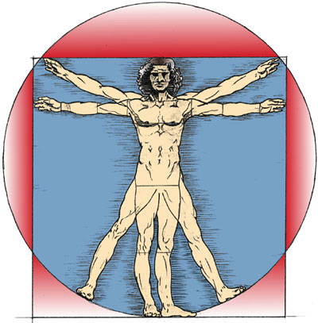

*Food is Medicine:*

]

*Follow a Low Carbohydrate Diet Safely*

**

*During this session you will:*

* Understand the potential side effects of low carbohydrate diets
* Learn how to identify low blood sugar and low blood pressure
* Develop a plan for treating low blood sugars and adjusting medications when needed
* Set your nutrition goal.

# Chapter Three

# The First Step

#### WO

hile recording what you eat, and drink is one of the most important parts involved in making permanent changes in lifestyle, we also know how difficult it can be. That is why we want to check in:

How did your first week of self-monitoring go for you? ____________________________________________________

________________________________________________________________________________________________________

What is something that went well for you this week? ____________________________________________________

____________________________________________________

____________________________________________________

What was a challenge that you encountered this week? What made it difficult for you? ____________________________________________________________________________________________________________________________________________________________

 Don’t worry – your efforts will be rewarded! Today we will be using your baseline food and activity records to better understand your current patterns. This will help us determine your first small change goal for this week regarding your nutritional routines.

Look over your records – what did you learn about your nutrition patterns this past week?

Circle any responses that apply to you. Please add anything you learned not listed here in the blank place below.

1. I was eating more than I realized. Tracking the number and size of my food portions was eye opening!
2. I ate when I wasn’t hungry.
3. I had no idea how many calories were in certain foods.
4. I skip meals a lot! (If so, which ones) _______________________
5. I tend to overeat when I eat out.
6. I eat a lot of prepackaged high-calorie foods (like frozen pizza).
7. _____________________________________________________________________________________________________________________________________________________________________________
8. ________________________________________________

It is also important to learn what situations lead you to eat. Think about your eating habits and look at your baseline food record.



***Do you eat more than you planned in each of these situations?***

Put a “**√**” if Yes

Put an “X” if No

______ When happy

______ While alone

______ When bored

______ When lonely ______ While on the phone

______ At social gatherings ______ While working

______ When depressed ______ When nervous

______ At restaurants ______ While doing housework

______ When frustrated ______ While drinking alcohol

______ While watching TV ______ While smoking cigarettes

______ When celebrating ______ At the movies

______ While on vacation ______ After physical activity

______ While away from home______ While reading

______ While preparing meals ______ While eating mea

# TCR Aspire Medication Management

In 2019, the American Diabetes Association published a report noting that:

* Implementing a “very” low carbohydrate eating plan can quickly lead to reductions in blood glucose levels and blood pressure
* It is essential to consult with a knowledgeable practitioner prior to making any drastic dietary changes to ensure that medications are appropriately adjusted to prevent adverse events.

In TCR Aspire, your weight management team includes a Clinical Pharmacy Provider. It is important to note that certain medications may need to be adjusted or stopped once you have adopted therapeutic carbohydrate restriction (TCR).

Medications that may need to be stopped or reduced:

* Diabetes medications
* Blood pressure lowering medications
* A picture containing person, holding, hand, indoor

  Description automatically generatedOther medications that may be affected by dietary change  
    
   **Self-monitoring** of your blood glucose and blood pressure is the first step in knowing when you may need to stop or reduce a medication.

While participating in TCR Aspire, it is important for you to test your blood glucose regularly.

# Hypoglycemia and Self-Monitoring

* You should follow your healthcare provider’s guidance on how often and when to test.



[This Photo](https://commons.wikimedia.org/wiki/File:Warning_icon.svg) by Unknown Author is licensed under [CC BY-SA](https://creativecommons.org/licenses/by-sa/3.0/)

You should also test with any signs or symptoms   
  
 **SIGNS OF HYPOGLYCEMIA:** Hypoglycemia is defined as a blood glucose level less than 70mg/dl. You may have a low blood glucose level if you experience:

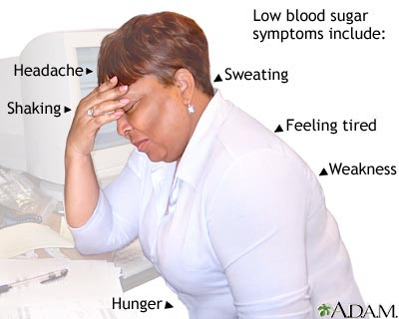

[This Photo](https://yourhealthforever.blogspot.com/2011/10/hypoglycemia-low-blood-sugar-sign.html) by Unknown Author is licensed under [CC BY](https://creativecommons.org/licenses/by/3.0/)

* Dizziness, lightheadedness, shakiness, weakness
* Difficulty concentrating, blurred vision, confusion
* Anxiety, irritability
* Fast heartbeat
* Increased hunger, nausea
* Sweating, pale skin

Follow the following steps if your blood sugar level falls below 70mg/dl:

# Treating a Low Blood Sugar

1. Consume 15 grams of carbohydrates (1 yellow or red food serving)
2. Recheck blood glucose after 15 minutes
3. Repeat if blood glucose remains low (<70mg/dl)



[This Photo](https://freebie.photography/food/slides/orange_juice.htm) by Unknown Author is licensed under [CC BY](https://creativecommons.org/licenses/by/3.0/)

Examples of 15 grams carbohydrates:

* 4 ounces (1/2 cup) juice or regular (not diet) soda
* 8 ounces (1 cup) of milk
* 1 tablespoon of honey or syrup
* 3-4 glucose tablets
* 1 dose of glucose gel

# Diabetes Medication Changes

**MEDICATIONS TO STOP:**

Some medications are not preferred or may not be appropriate for people on low or very low-carbohydrate diets.

* Short Acting (mealtime) Insulin & Mixed Insulins
* SGLT2 Inhibitors: empagliflozin (Jardiance)
* Sulfonylureas: glipizide, glimepiride, glyburide
* Meglitinides: repaglinide, nateglinide
* 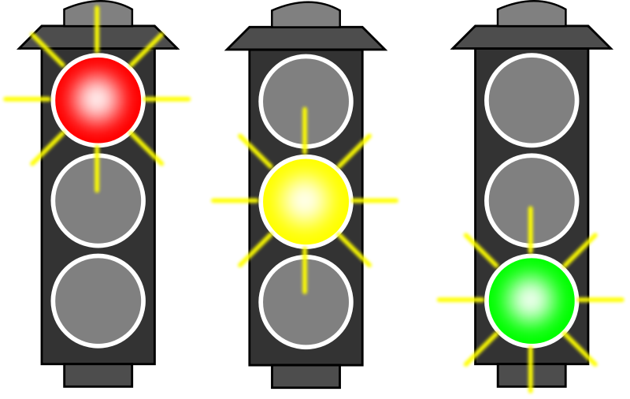Alpha-Glucosidase Inhibitors: acarbose, miglitol

**MEDICATIONS TO ADJUST:**Some medications may need to be reduced when on a low carbohydrate diet.

* **Long-acting Insulin**: detemir, glargine
* **Concentrated Insulin:** insulin U-500
* **Thiazolidinediones (TZDs):** pioglitazone

   
**MEDICATIONS TO CONTINUE:**

These medications do not usually cause hypoglycemia. Some individuals may still need to adjust/reduce these medications:

* **Metformin**
* **GLP-1 Receptor Agonists:** semaglutide (Ozempic), dulaglutide (Trulicity), liraglutide (Victoza)
* **DPP-4 Inhibitors:** alogliptin, saxagliptin, sitgliptin

**What diabetes medications are you currently taking?____________________________________  
___________________________________________  
___________________________________________**

**When will you check your blood sugar? ________________________________________________________________________________________________________**

A low or very low carbohydrate diet may cause you to have more urine output. Low urine output is called diuresis. This can cause low blood pressure (hypotension) and low sodium levels (hyponatremia).

# Changes in Blood Pressure

If you are on a blood pressure medication, you should check your blood pressure at home at least three times each week.

**SIGNS OF HYPOTENSION:**

* Dizziness or lightheadedness, especially upon standing
* Blurred vision
* Fatigue
* Difficulty concentrating
* Confusion

**MONITORING BLOOD PRESSURE:**

How to check blood pressure at home:

* Rest for at least 5 minutes before checking blood pressure
* Sit in a chair with back supported
* Place both feet flat on the ground
* Place arm on table at heart level
* Do not place cuff over clothing
* Do not talk while measuring blood pressure
* Make sure bladder is empty

If you have low blood pressure, diuretics (water pills) may need to be stopped or reduced. Commonly prescribed diuretics include:

# Hypertension Medication Changes

* Furosemide, bumetanide
* Hydrochlorothiazide, chlorthalidone
* Spironolactone, eplerenone

**OTHER MEDICATIONS TO CONSIDER ADJUSTING:**

* Other blood pressure lowering medications:
  + ACE inhibitors: lisinopril, enalapril, benazepril, captopril
  + ARBs: losartan, valsartan, Olmesartan, telmisartan
  + Calcium Channel Blockers: amlodipine, nifedipine
  + Beta Blockers: metoprolol, carvedilol, bisoprolol
  + Clonidine, guanfacine, hydralazine, terazosin
* Drugs that can decrease sodium level (Hyponatremia):
  + SGLT2 Inhibitors, Sulfonylureas
  + Diuretics
  + NSAIDS (ibuprofen, naproxen, meloxicam)
  + Antidepressants
  + Antipsychotics
  + Seizure medications (oxcarbazepine, carbamazepine)
  + Amiodarone
  + Cyclosporine
* Other Medications To Monitor:
  + Warfarin: dietary changes may cause an increase or decrease in INR (clotting rate).
  + Implementing a low or very low carbohydrate diet may initially require more frequent INR monitoring and medication adjustment.
* Other medications that require drug level monitoring:
  + 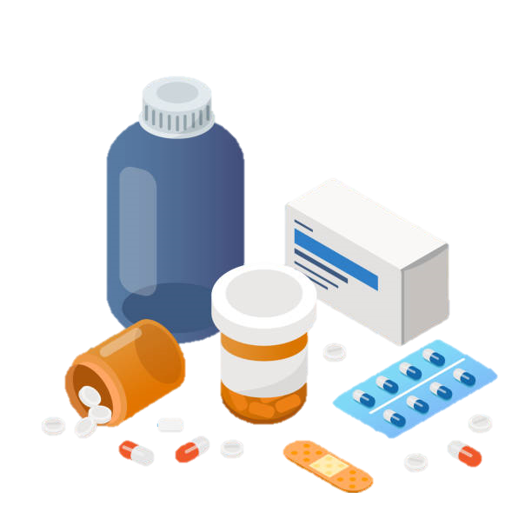Valproic acid
  + Carbamazepine
  + Lithium
  + Digoxin

**What blood pressure medications are you currently taking? ________________________________________  
________________________________________**

**When will you check your blood pressure? ________________________________________________________________________________________________________**

**What other medications do you need to monitor? ____________  
____________________________**



[This Photo](https://freepngimg.com/png/88553-emoticon-area-text-smiley-question-mark) by Unknown Author is licensed under [CC BY-NC](https://creativecommons.org/licenses/by-nc/3.0/)

**Take a few moments to reflect on the medications you are currently taking. Do you have any questions for our Clinical Pharmacists about your medications?**

**________________________________________________________________________________________________________**

# “Low Carb Flu” and TCR “Side Effects”

Also called “Keto Flu” or “Carbohydrate Withdrawal.

A low carb flu may occur shortly after starting a carbohydrate restricted diet. Symptoms may include:

* Dizziness or lightheadedness when standing
* Headache
* A person covering her face with her hands

  Description automatically generated with medium confidenceFatigue
* Muscle cramps

**COMMON SIDE EFFECTS ON THERAPEUTIC CARBOHYDRATE RESTRICTION:**

* **Constipation:** may occur if you do not eat enough fiber
  + Drink more water (at least 64oz daily)
  + Eat high-fiber vegetables (broccoli, cauliflower, leafy greens)
  + If constipation is still not relieved, consult a provider or pharmacist for help selecting an over-the-counter product.
* **Muscle Cramps:** 
  + Magnesium supplements: 200-400mg per day
  + Consume magnesium-rich foods (almonds, spinach, avocado, fatty fish)
* **Electrolyte Imbalances:** 
  + High levels of insulin can cause water and sodium retention.
    - Decreased insulin levels may cause increased excretion of water and sodium
    - Drink plenty of water to avoid dehydration
  + Low sodium: may cause dizziness, lightheadedness, fatigue, and headache. On occasion, someone may need to increase their salt consumption.
  + Low potassium: This occurs most often when someone is on a diuretic. A supplement may be needed.

**VITAMIN DEFICIENCIES:**

A well-balanced, low or very low-carbohydrate diet should provide all the vitamins and minerals you need. Supplementation is usually not necessary unless you have a pre-existing vitamin deficiency.

***************************************************************************

# Summary

We covered a lot of important information today. Let’s take a moment to reflect on the key points from Chapter 3.

1. TCR Aspire requires close monitoring of blood sugar and blood pressure.
2. If you are on a medication for blood sugar or blood pressure, you may need to work with a pharmacist to reduce or stop some medications.
3. If you experience a low blood sugar, follow the 15/15 rule to treat your low blood sugar.
4. There are some side-effects common in people eating a low carbohydrate diet. Drinking at least 64 ounces of water and choosing high fiber “green” foods will help you reduce these side effects.
5. It is important for you to contact your provider or the TCR Pharmacist if you experience low blood sugar and/or low blood pressure.

*This week’s goal is to get further practice self-monitoring. You will use your food and activity log to record what you eat and your blood sugar and/or blood pressure.*



# **This Week’s Goals**

**Home Activities**

* Continue to log everything I eat & drink for the next week.

* Identify the average number of Green, Yellow, and Red foods you eat each day.
* Review good logs each day and identify the foods that you should eat more of and the foods you should reduce or eliminate.
* Check my blood sugar and blood pressure.

***Ways I will reach this goal (including strategies to remember to write down meals, snacks, beverages such as when, where, how)*:**

1. _______________________________________________________

2. _____________________________________________________________

3. _____________________________________________________________

**Physical Activity Goals**

* **My goal this week is to find ways to move my body.**

**CONFIDENCE:** How confident, on a scale from 0-10, are you that you can succeed in achieving these health goals?

**0......1... 2…. 3…. 4…...5…. 6…. 7……8……9……10  
Not at all**   **Very Confident Confident**

|  |
| --- |
| ***NOTES*** |
|  |
|  |
|  |
|  |
|  |
|  |
|  |
|  |
|  |
|  |
|  |
|  |
|  |
|  |
|  |
|  |
|  |
|  |
|  |
|  |
|  |
|  |

# Chapter Four



*Digging into the stop light system:*



*During this session you will:*

* Learn about energy balance, carbohydrates, and weight loss.
* Practice determining the colors of your foods.
* Explore “color swaps”.
* Practice reading food labels.

Recording what we eat, and drink can be challenging. Over the past week, you set a goal to continue logging and to begin identifying the colors of the foods you ate.

*Nutrition to the Max:*

How did your second week of self-monitoring go for you? ____________________________________________________

________________________________________________________________________________________________________

What is something that went well for you this week? ____________________________________________________

____________________________________________________

____________________________________________________

What was a challenge that you encountered this week? What made it difficult for you? ____________________________________________________________________________________________________________________________________________________________

What did you learn about your food choices and eating patterns? Were you surprised by the number of foods in any given color? ____________________________________________________

________________________________________________________________________________________________________

 Now that you have reflected on your second week of logging and your first week of using the stop light system to identify your food choices. Let’s spend some time talking about why the stop-light system works for weight loss.   
  
Discussion – who has counted calories in the past?

**

# Your Stoplight

**What will I learn?**

In this activity, you will learn about your current stoplight patterns.

**What will I do?**

1. Look back at your baseline food record. Pick the last two days of the week and check whether each food is Green, Yellow, or Red using your Stoplight Information Guide booklet.
2. Tally up the count for each food type at the bottom of each page. Then, write each of the counts in the list below so that we can calculate your average of Red, Yellow, and Green foods each day.

**Day 1** Total **Green**: _______ **Yellow:** _______ **Red:** _______

**Day 2** Total **Green**: _______ **Yellow:** _______ **Red:** _______

**TOTAL FOR**

**BOTH DAYS: Green**: _______ **Yellow:** _______ **Red:** _______

**Compute your AVERAGE by dividing by the total days (2)**

**GREEN: ______ YELLOW: ______ RED: _____**

Look at your daily average. Is it what you expected? Are there any surprises? Please explain.

________________________________________________________________________________________________________________________________________________________________________________________________________________

**BEYOND CALORIES:**

To lose weight we must create a calorie deficit. We must take in less than we burn off. From last week, we also know that not all calories are created equal.

The TCR Aspire stop light system is designed to help you eat less calories, less carbohydrates and improve the quality of the foods you eat. Eating nutritious foods while losing weight can help you to control, or even reverse, many chronic diseases. The TCR Aspire stop light system is a lower carbohydrate diet that can help you control blood sugar.

What medical conditions do you want to improve or reverse?

_______________________________________________  
_______________________________________________  
_______________________________________________

In a future session we will review your TCR Aspire “Report Card”. If you have not already done so. Please get your labs drawn. During session seven we will be reviewing those labs and helping you understand how your diet and activity can influence them.

We have explored why the stop light system works and how it can help you not only lose weight, but also improve your overall health and wellness. Now, let’s spend some time answering your questions about the stop light system.   
  
What foods are you unsure how to classify? _________________________________________________

What other questions do you have? __________________________________________________

COLOR SWAPS



The stop light system makes it easy to substitute more nourishing food for less nourishing food. By replacing green foods with a yellow or a red food or a yellow food for a red food, you will be improving the quality of the food you are eating. We call this “color swapping” or doing a “color swap”.

Let’s look at an example of how we can use color swapping to improve the quality, and lower the calories, of the food we are eating.

|  |  |
| --- | --- |
| Replace these favorites | …with these satisfying substitutions! |
| Bread   * Wrap * Tortillas * Buns | * Lettuce leaf wrap * Cabbage leaf wrap * Low-Carb tortillas * Low-carb breads made from eggs,  nut flour, cream cheese, and/or psyllium husk |
| Potatoes   * Mashed potatoes * French fries * Boiled potatoes * Potato salad | * Mashed cauliflower * Oven-roasted celery root * Steamed cauliflower, boiled rutabaga * Roasted cubed zucchini or kohlrabi  dressed with potato salad fixings |
| Pasta   * Noodles * Mac and cheese * Lasagna noodles | * Shaved or spiralized zucchini * Spiralized rutabaga * Cooked spaghetti squash * Homemade noodles made with eggs, cheese, nut flours and/or pureed  cauliflower * Shirataki noodles or cubed cauliflower  with mac and cheese fixings * Sliced zucchini, eggplant, deli meat, or homemade low-carb noodles with  lasagna fixings |
| Rice | * Riced cauliflower or rutabaga * Shredded cabbage |
| Pizza | * Crust made from cheese, eggs,  cauliflower and/or nut flower with pizza toppings * “Meatza” (Crust made from ground meat) with pizza fixings * Portabella mushroom or eggplant with  pizza fixings |
| Cereal and breakfast  foods | * Porridge made with eggs, chia/flax/hemp seeds and/or coconut flour * Low-carb granola * Low-carb pancakes made with eggs, nut flours, and/or cream cheese |
| Chips, crackers, and snacks | * Parmesan cheese crips * Low-carb seed crackers * Roasted nuts * Cheese |
| Dessert | * Cheese plate * Low-carb berries with sugar-free  whipped cream * Square of dark chocolate (>80% cacao) * Cheesecake made with low-calorie sweetener and nut flour crust * Low-carb and keto recipes for almost anything you like (look on-line) |
| Sugar | * Natural low-calorie sweeteners like erythritol, xylitol, monk fruit, and stevia or artificial options (aspartame, sucralose, |

Example: Ben’s Burrito vs. Amy’s Burrito Bowl

|  |  |  |  |
| --- | --- | --- | --- |
| **Ben’s Burrito** | Color | Calories (kcal) | Carbs (g) |
| **Large Flour Tortilla -1** | Red | 200 | 34 |
| **Ribeye Steak – 4oz** | Green | 278 | 1.7 |
| **White Rice - 1/3 cup** | Red | 72 | 16 |
| **Refried Beans – 1/3 cup** | Red | 71 | 11.7 |
| **Salsa – 2 tablespoons** | Green | 9 | 2 |
| **Sour Cream – 1 tablespoon** | Red | 26 | 1 |

Let’s add up our colors:

**Green: 2 Yellow: 0 Red: 5**

Let’s add up the nutrition facts:

**Calories: 656 Carbohydrates: 66.4g**

_____________________________________________________

|  |  |  |  |
| --- | --- | --- | --- |
| **Amy’s Burrito Bowl** | Color | Calories (kcal) | Carbs (g) |
| **Lettuce – 3 cups** | Green | 15 | 3 |
| **Chicken Breast – 4oz** | Green | 142 | 0 |
| **Black Beans – 1/3 cup** | Yellow | 66 | 23 |
| **Cherry Tomatoes – 1 cup** | Green | 27 | 5.8 |
| **Salsa – 2 tablespoons** | Green | 9 | 2 |
| **Guacamole– 2 tablespoons** | Green | 50 | 3 |

Let’s add up our colors:

**Green: 5 Yellow: 1 Red: 0**



Let’s add up the nutrition facts:

**Calories: 309 Carbohydrates: 36.8g**

**Side by side comparison:**

|  |  |  |  |  |  |
| --- | --- | --- | --- | --- | --- |
|  | **Green** | **Yellow** | **Red** | **Calories** | **Carbs** |
| **Ben’s Burrito** | 2 | 0 | 5 | 656 | 66.4 |
| **Amy’s Bowl** | 5 | 1 | 0 | 309 | 36.8 |



**Consider the foods you eat often. What color swaps (substitutions) can you make?**

|  |  |
| --- | --- |
| **Old Favorite** | **Replacement Food** |
|  |  |
|  |  |
|  |  |
|  |  |
|  |  |
|  |  |
|  |  |
|  |  |
|  |  |

## **How to Read a Food Label:**

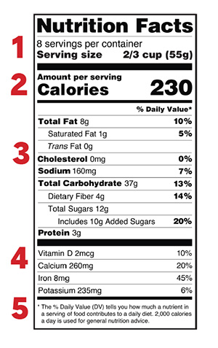

### How to Read a Food Label Continued:

### 1 - Start with the serving information at the top.

This will tell you the size of a single serving and the total number of servings per container (package).

### 2 - Next, check total calories per serving and container.

Pay attention to the calories per serving and how many calories you’re really consuming if you eat the whole package. If you double the servings you eat, you double the calories and nutrients.

The next section of information on a nutrition label is about the amounts of specific nutrients in the product.

### 3 – Limit certain nutrients.

Check key nutrients and understand what you’re looking for. In TCR Aspire, you are limiting your total carbohydrates and trying to avoid added sugar. You want to choose foods that are lower in carbohydrates AND high in fiber.

### 4 - Get enough of the beneficial nutrients.

Make sure you get enough of the nutrients your body needs, such as: calcium, choline, dietary fiber, iron, magnesium, potassium, and vitamins A, C, D and E.*

### 5 - Understand % Daily Value.

The % Daily Value (DV) tells you the percentage of each nutrient in a single serving, in terms of the daily recommended amount. If you want to consume less of a nutrient (such as saturated fat or sodium), choose foods with a lower % DV (5 percent or less). If you want to consume more of a nutrient (such as fiber), choose foods with a higher % DV (20 percent or more).

How big is one serving of this food item? ___________

How many servings are in the container? ______

How many total carbohydrates are in one serving? _______

How many total carbohydrates are in the container? _______

How many grams of beneficial fiber are in one serving? _______

++++++++++++++++++++++++++++++++++++++++++++++++++

During this session you learned about energy balance, carbohydrates, and weight loss. You practiced identifying foods you ate based on the stop-light color system. You learned how to “swap out” foods you commonly eat that are high in carbohydrates and sugar for lower carbohydrate alternatives. You also practiced reading food labels.

*This week’s goal is to get further practice using the Stoplight Guide to track your daily food patterns.*



# **This Week’s Goals**

**Home Activities**

* Continue to log everything I eat & drink for the next week.

* Substitute some Green foods for Yellow foods and Red foods.

**Nutrition Goals**

* My Red food goal for the week is ______ foods per day.
* My Yellow food goal for the week is _____foods per day.
* My Green food goal this week is _______ foods per day.

***Ways I will reach this goal (including strategies to remember to write down meals, snacks, beverages such as when, where, how)*:**

1. _______________________________________________________

2. _____________________________________________________________

3. _____________________________________________________________

**Physical Activity Goals**

* **My goal this week is to keep my regular routine and**

**continue recording my steps.**

**CONFIDENCE:** How confident, on a scale from 0-10, are you that you can succeed in achieving these health goals?

**0......1…. 2…. 3…. 4…...5…. 6…. 7……8……9……10**

**Not at all**   **Very Confident Confident**

|  |
| --- |
| ***NOTES*** |
|  |
|  |
|  |
|  |
|  |
|  |
|  |
|  |
|  |
|  |
|  |
|  |
|  |
|  |
|  |
|  |
|  |
|  |
|  |
|  |
|  |
|  |