**Business Case Proposal to Evaluate the Impact and ROI**

**of Introducing a Non-invasive Technology to Measure Hemoglobin Level at the Veteran Health Care System of the Ozarks**

**Return on Investment for Training and Performance Improvement**

August 28, 2022

**Executive Summary**

This proposal will explain how the evaluation process will analyze the program to ensure it is aligned to address the critical performance impact measure needs. It will then establish five program objective levels required to evaluate the program’s success to address these business needs. The proposal will then explain how it will use data collected during the program’s roll-out and the plan to collect the post-implementation results. The proposal will then explain how it proposes to analyze the key performance impact measures to (1) isolate the effects of introducing a non-invasive hemoglobin monitor to VHSO, (2) determine which isolated impact measures to leave as intangibles or convert to a monetary value, (3) recommended a feasible method to convert these impact measures to an economic value, and (4) forecast an ROI based on estimated costs and monetized benefits. This proposal will conclude with recommended next steps.

At VHSO, patients may have up to 8 blood draws in the first 24-hours when being monitored for acute anemia. At the VHSO the past fiscal year, there were 4256 inpatient blood draws monitoring hemoglobin (cost $225,014.72), 154 patients admitted for acute anemia (cost $79,516.48), and 543 blood transfusions administered (cost $111,315.00). The total cost for VHSO was $415,846.20. The current business impact to VHSO with traditional invasive lab draws additional costs are potential unintentional needle sticks to healthcare workers, risks for nosocomial infections, unnecessary blood transfusions, biomedical waste, supplies, and customer (Veteran) dissatisfaction from the discomfort of multiple needle sticks during their hospital stay.

The problem at the VHSO is that when a Veteran is admitted with acute anemia, the traditional practice or current performance is to use an invasive blood test which costs money and takes time to process. The customer satisfaction impact for the Veteran should be improved by decreasing multiple blood draws, increasing the Veterans' comfort from less blood draws, decreased iatrogenic blood loss from serial blood draws, improved clinical decision-making time for Veterans' treatment, and decrease Veterans' inpatient treatment cost.

The lab turnaround time (TAT) current performance results in a lag in clinical decision-making time for medical interventions. The performance improvement team conducted chart reviews of Veteran admitted to VHSO with anemia, the clinical decision-making time based on lab TAT to order a type and cross for transfusing blood products is 1 hour and 18 minutes. The minimal total time before a Veteran is admitted to VHSO who needs a blood transfusion is 3 hours and 55 mins based on the variables affecting the process. Additionally, with surveillance of the inpatient Veteran with acute anemia in the Intensive Care Unit (ICU), the traditional practice or current performance is to use an invasive blood test every three to four hours to monitor the hemoglobin values, resulting in a total of 8 hours 15 mins of lab TAT for 24 hour period. Inpatient hemoglobin labs at the VHSO for one year were $225,000.00. Part of the $225,000 cost is the surveillance for anemia at $69,000.00. Data was collected by chart review of the VHSO computerized patient records (PR) and generated totals from VHSO's other databases. Cost breakdown was obtained by interviewing VHSO's stakeholders in the Clinical Laboratory, Utilization Management Services, and Logistics. Finally, examining the phlebotomist's touchpoints identifies current workflow activities for TAT at VHSO.

Introducing a non-invasive hemoglobin monitor will decrease invasive blood draws, TAT, and lab process touchpoints for acute anemic hospitalized patients at the VHSO. There will need to be a commitment and coordination with multiple hospital services to introduce the non-invasive continuous hemoglobin monitor to the VHSO This performance improvement team will evaluate the feasibility and business impact and ROI levels by achieving the following objectives:

1. Investigate the validity of the non-invasive technology by comparing the non-invasive hemoglobin values to invasive blood hemoglobin levels.
2. Examine the clinical lab's current TAT for invasive blood draws and the current process to reduce touchpoints for timely lab values.
3. Investigate if the non-invasive technology will reduce the current process of invasive blood draws.
4. Gain a commitment by VHSO' to purchase the new technology.
5. Examine stakeholders' resistance to accepting new technology in the clinical setting of implementing a non-invasive hemoglobin monitor to monitor hemoglobin levels.

The ROI Methodology provides us with a process to apply across organizational boundaries, linking programs, processes, and initiatives to bottom-line measures. The ROI Methodology is the most-used approach to evaluate human capital performance improvement programs, projects, and initiatives for the following three reasons. The ROI Methodology:

* reports a balanced set of measures,
* follows a methodical, step-by-step process, and
* adheres to standards and a philosophy of maintaining a conservative approach and credible outcomes.

Based on the needs assessment and needs analysis work, we have developed five

program objectives represented by the following questions for this evaluation to answer:

1. Will implementing an informational session for clinical staff motivate the staff to use the non-invasive hemoglobin monitoring at VHSO to reduce invasive hemoglobin bloodlabs, reduce the anxiety of staff about new technology, improve the lab process, decrease Veterans' discomfort, decrease the potential of nosocomial infections, and decrease the potential of healthcare workers' unintentional needle sticks?

2. Did the clinical staff learn how to use the non-invasive hemoglobin monitors to monitor patients correctly to achieve the desired outcome?

3. Within 30 days will , 90% of clinical staff who monitor inpatient blood values start using the non-invasive continuous tool to monitor inpatient patient hemoglobin with Veteran’s being monitored for anemia?

4. Within six months of program implementation, did the organization reduce annual spending by 60% on the invasive surveillance blood draws, reduce 20% of annual spending on unnecessary blood transfusions, reduce unintentional needle sticks to healthcare workers by 60%, reduce blood-draw related nosocomial infections by 60%, reduce biowaste by 60%, and increase Veteran's satisfaction by 60%?

5. Did the program reduce traditional invasive blood draws resulting in a a minimum ROI of 60%?

This proposal includes three plans—evaluation, communication, and

implementation—that we will finalize with all key stakeholders to ensure they will

support this evaluation effort during the data collection, data analysis, and optimize

results phases. This last phase describes how we will include conclusions and

recommendations to improve the program based on the evaluation data analysis.

Finally, this proposal includes a pre-program forecast ROI using estimated program

costs and monetized benefits for the three business measures. Credible internal sources

provided these monetary figures. All forecasts indicate a minimal positive 25 percent ROI is

achievable.

We request approval of this proposal to implement a non-invasive hemoglobin monitor and to begin to finalize the evaluation, communication, and implementation plans in this proposal with the key stakeholders to ensure the program evaluation is successful in answering our five program objective questions.

**Table of Contents**

Introduction 11

Background Information 12

Organizational Needs Assessment 14

Operational Needs Assessment and Analysis 15

Rationale to Evaluate Program to Impact and ROI 18

Evaluation Plan 20

Evaluation Framework 20

Process Model 22

Operating Standards and Philosophy 30

Program Objectives 34

Level 1 Perception Needs and Reaction Objectives 34

Level 2 Learning Needs and Objectives 35

Level 3 Performance Needs and Application Objectives 36

Level 4 Business Needs and Impact Objectives 37

Level 5 Payoff Need and Return on Investment (ROI) Objective 38

Data Collection Plan 39

Level 1 Reaction Data Collection Plan 40

Level 2 Learning Data Collection Plan 42

Level 3 Application Data Collection Plan 43

Level 4 Business Impact Data Collection Plan 45

ROI Analysis Plan 46

Program Isolation 47

Program Benefits Estimates: Monetary and Intangible 52

Other Potential Intangible Benefits 59

Program Cost Estimates and ROI/BCR Formulas 60

Cost Categories 60

Pre-Program ROI Forecast 61

Communication Plan & Evaluation Implementation Plan 65

Communication Results 65

Planning Phase 66

Data Collection Phase 66

ROI Analysis Phase 67

Optimize Results Phase 67

Evaluation Implementation Plan 68

Process Improvement Plan 69

Conclusions and Recommendations 71

References 74

Appendix A 77

**List of Tables**

Table 1 Organization and operations Needs Alignment……………………………………….16

Table 2 ROI Process Model Evaluation Planning Steps………………………………………24

Table 3Data Collection Steps………………………………………………………………...27

Table 4ROI Process Model Data Analysis Steps…………………………………………….28

Table 5ROI Process Model Optimize Results Steps …………………………………………30

Table 6 Level 1 Perception Needs and Reaction Objectives…………………………………. 35

Table 7 Level 2 Learning Needs and Objective……………………………………………… 36

Table 8 Level 3 Performance Needs and Application Objectives...………………………….. 37

Table 9 Level 4 Business Needs and Impact Objectives…..………………………………… 38

Table 10 Level 5 Payoff Need and Return on Investment (ROI) Objective…………………. 39

Table 11 Level 1 Reaction Data Collection Plan…………………………………………… 41

Table 12 Level 2 Learning Data Collection Plan……………………………………………. 42

Table 13 Level 3 Application Data Collection Plan………………………………………….. 44

Table 14 Level 4 Business Impact Data Collection Plan……………………………………... 45

Table 15 Current Performance - LAB TAT No intervention ……………………...………… 49

Table 16 Invasive Hemoglbin Lab Cost Breakdown………………………………………… 51

Table 17 Pre-Program Forecast ROI projects………………………………………..………. 63

Table 18 Pre-Program Forecast ROI Sensitivity Analysis………………………………….. 64

Table 19 Introducing Non-invasive Hemoglobin Technology to VHSO……………………. 69

Table 20 Program and Process Improvement Use of Evaluation Data……………………… 71

**List of Figures**

Figure 1 Evaluation Framework 21

Figure 2 ROI Process Model – Evaluation Planning and Data Collection Phases 23

Figure 3 Business Alignment V-Model 26

Figure 4 ROI Process Model - Data Analysis and Optimize Results Phases 28

Figure 5 Program Data Method Collection and Use of Level Options……………………………..40

Figure 6 Current Performance...……………………………………………………………….49

Figure 7 Four-Part Monetary Conversion Test……...…………………………………………54

Introduction

At VHSO, patients may have up to 8 blood draws in the first 24-hours when being monitored for acute anemia. At the VHSO the past fiscal year, there were 4256 inpatient blood draws monitoring hemoglobin (cost $225,014.72), 154 patients admitted for acute anemia (cost $79,516.48), and 543 blood transfusions administered (cost $111,315.00). The total cost for VHSO was $415,846.20. Additional costs are potential unintentional needle sticks to healthcare workers, risks for nosocomial infections, unnecessary blood transfusions, biomedical waste, supplies, and customer (Veteran) dissatisfaction from the discomfort of multiple needle sticks during their hospital stay.

Utilizing non-invasive hemoglobin monitor for continuous trends in hemoglobin levels will reduce redundant invasive testing for inpatient surveillance for anemia, reduce lab touchpoints, and create a positive cost-benefit payoff for the VHSO Introducing SpHb and reducing blood draws will also have a business impact by reducing potential unintentional needle sticks to healthcare workers, decreasing risks for nosocomial infections, reducing unnecessary blood transfusions, reducing biomedical waste, reducing supplies, and improving customer (Veterans) satisfaction by reducing discomfort from needle sticks during their hospital stay. The business implication of the non-invasive SpHb monitors for the VHSO will positively impact cost (hard business data), quality of care (hard business data), and client service (soft business data). The stakeholders impacted the most at the VHSO are the patients (Veteran), nurses, phlebotomists, and environmental specialists.

The next logical step, to satisfy the 10 Standards of Performance Improvement

advocated by the International Society for Performance Improvement (ISPI) (2018), is to

evaluate this program to answer these and other questions about the effectiveness and

efficiencies of this new compensation incentive program. Further, this evaluation will analyze

the collected data to provide actionable data necessary to improve the program’s effectiveness

and minimize avoidable costs. This proposal intends to establish a business case to justify

approving, funding, and supporting this evaluation. After completing the evaluation, executives

will receive an Impact Study that will report six types of meaningful measures that will include

impact and ROI results. This proposal will explain how the evaluation process will analyze the program to ensure it is aligned to address the critical performance impact measure needs. It will then establish five program objective levels required to evaluate the program’s success to address these business needs. The proposal will then explain how it will use data collected during the program’s roll-out and the plan to collect the post-implementation results. The proposal will then explain how it proposes to analyze the key performance impact measures to (1) isolate the effects of introducing a non-invasive hemoglobin monitor to VHSO, (2) determine which isolated impact measures to leave as intangibles or convert to a monetary value, (3) recommended a feasible method to convert these impact measures to an economic value, and (4) forecast an ROI based on estimated costs and monetized benefits. This proposal will conclude with recommended next steps.

Background Information

*Anemia* is a condition that results in reduced oxygen-carrying capacity because of a reduction of hemoglobin in an individual who may need to be medically monitored with multiple invasive blood draws. Anemia is diagnosed when hemoglobin levels are below 11 g/dl on admissions resulting from blood loss, specifically leading to loss of red blood cells and iron deficiency associated with the potential severity of a hospital stay (Lasocki et al., 2020). According to the World Health Organization, anemia is a worldwide public health issue that affects 30% of the world's population (Pinto et al., 2020). The traditional and most widely used method to measure hemoglobin levels in individuals is invasive blood draw from a vein.

The invasive method of collecting blood is painful, and delays between collections can prolong clinical decision-making (Pinto et al., 2020). In medical centers, the two biggest dangers to threaten healthcare workers and patients are unintentional needle sticks and nosocomial infections. Nosocomial infections cost 4.5 billion dollars annually, affecting 90,000 patients, with infections occurring within the first 48 hours of hospital stays. Accidental needle sticks expose healthcare workers to potential viruses resulting in expensive treatment and care (Suksatan et al., 2022). On average, a person hospitalized for acute anemia will have 6 blood draws in the first 48 hours and will be transfused on average 2.6 units of blood (Jaben et al., 2020). Laboratory testing accounts for 4% of the $4.4 trillion health care expenditures in the United States, and redundant/repeated testing wastes up to $5 billion a year (Konger et al., 2016). A potential way to reduce blood draws and costs for this population is to introduce new available non-invasive technology.

With the evolution of medical non-invasive technology, hemoglobin can now be monitored without invasive blood draws. Tang et al. "found trends in non-invasive hemoglobin (SpHb) could detect a decrease in blood hemoglobin situations and indicate the appropriate timing for further blood hemoglobin measurements" (2019, p. 7). Tang et al. also suggested that even a delayed SpHb detection of anemia may be earlier than a clinician could detect change with a traditional invasive blood draw due to time it takes for the results (2019). Implementing a non-invasive hemoglobin monitor will decrease invasive blood draws, lab turnaround time (TAT), and unnecessary touchpoints for acute anemic hospitalized patients at the Veteran Healthcare System of the Ozarks (VHSO).

Organizational Needs Assessment

The selected organization is a federal government level 3 hospital. The VHSO is a 78-bed facility providing medical care to Veterans from Arkansas and nearby states. Services provided to these Veterans for acute or chronic care involve surgical, medical, and psychiatric care. The administration of the VHSO wants to implement new medical technology for the Veterans that no other regional hospital provides to its patients. This technology is a non-invasive continuous hemoglobin monitor that will reduce the number of blood draws for individuals at the VHSO who are experiencing acute anemia. An ROI methodology will help examine if a non-invasive continuous monitor that the administration wants to introduce is the right financial decision to reduce invasive blood draws for the VHSO, address business needs, and cost savings.

At the VHSO, patients may have up to 8 blood draws in the first 24-hours when being monitored for acute anemia. At the VHSO the past fiscal year, there were 4256 inpatient blood draws monitoring hemoglobin (cost $225,014.72), 154 patients admitted for acute anemia (cost $79,516.48), and 543 blood transfusions administered(cost $111,315.00). The total cost for the VHSO was $415,846.20. Utilizing SpHb to monitor hemoglobin levels will reduce redundant invasive testing for inpatient surveillance for anemia, reduce lab touchpoints, and create a positive cost-benefit payoff for the VHSO Introducing SpHb and reducing blood draws will also have a business impact by reducing potential unintentional needle sticks to healthcare workers, decreasing risks for nosocomial infections, reducing unnecessary blood transfusions, reducing biomedical waste, reducing supplies, and improving customer (Veterans) satisfaction by reducing discomfort from needle sticks during their hospital stay. The business implication of the non-invasive SpHb monitors for the VHSO will positively impact cost (hard business data), quality of care (hard business data), and client service (soft business data). The stakeholders impacted the most at the VHSO are the patients (Veterans), nurses, phlebotomists, and environmental specialists.

## Operational Needs Assessment and Analysis

The problem at the VHSO is that when a Veteran is admitted with acute anemia, the traditional practice or current performance is to use an invasive blood test which costs money and takes time to process. Customer sataisfaction impact for the Veterans at VHSO by stakeholders who serve them are decrease multiple blood draws on the Veterans, increase the Veterans' comfort from less invasive blood draws, decrease iatrogenic blood losses from serial blood draws for Veterans, improve clinical decision-making time for Veterans' treatment, and decrease Veterans' inpatient treatment cost.

The TAT for current performance results in a lag in clinical decision-making time for medical interventions. Performance improvement team conducted chart reviews of Veterans admitted to VHSO with anemia, the clinical decision-making time based on lab turnaround time to order a type and cross for transfusing blood products is 1 hour and 18 minutes. The minimal total time before a Veteran is admitted to VHSO who needs a blood transfusion is 3 hours and 55 mins based on the variables affecting the process. Additionally, with surveillance of the inpatient Veteran with acute anemia in the Intensive Care Unit (ICU), the traditional practice or current performance is to use an invasive blood test every three to four hours to monitor the hemoglobin values, resulting in a total of 8 hours 15 mins of lab TAT for 24 hour period. Inpatient hemoglobin labs at the VHSO for one year were $225,000.00. Part of the $225,000 cost is the surveillance for anemia at $69,000.00. Data was collected by chart review of the VHSO computerized patient records (PR) and generated totals from VHSO's other databases. Cost breakdown was obtained by interviewing VHSO's stakeholders in the Clinical Laboratory, Utilization Management Services, and Logistics. Finally, examining the phlebotomist's touchpoints identifies current workflow activities for TAT at VHSO.

## Table 1

*Organization and operations Needs Alignment*

|  |  |  |
| --- | --- | --- |
| **Need Level** | **Questions** | **Need** |
| 5  Payoff | * Is this program worth doing? | * Lab efficiency (TAT) * Patient care -safety * Clinical decision-making efficiency |
|  | Is this a problem or issue worth addressing?  • Is this an opportunity worth pursuing?  • Is the problem feasible?  • Is there a potential payoff?   * What is the likelihood of a positive ROI? | * Yes * Yes * Yes * Yes * High likelihood |

|  |  |  |
| --- | --- | --- |
| 4  Business | * What are the specific KPI measures? | * Decrease the number of invasive labs drawn for anemic inpatient Veterans. |
|  | * Hard Data: Cost, quality, output, time | * Treatment costs, waste, infections, incidents, operating costs, patient discharge, accident costs, length of stay, process time, and wait time. |
|  | * Soft Data: Client Service | * Client satisfaction |
|  | * What happens if we do nothing? | * The current performance will potentially get worse. |

|  |  |  |
| --- | --- | --- |
| 3  Performance | * What is or not occurring on the job influences the business measure? | * Involve others in discussion to implement new technology in the clinical environment. |
|  | * What must people start doing, stop doing, or do differently to improve their workplace performance and business measures? | * Stakeholders need to accept and use the new technology when implemented. |

|  |  |  |
| --- | --- | --- |
| 2  Learning | * What must people learn to change their workplace behaviors to improve the business measures? | * Present to stakeholders the new technology that will be introduced in the clinical areas. |
|  |  | * Proper use of non-invasive monitors to achieve the desired outcome. * How to know if the monitor is working properly * Answer questions and concerns about the patient population that the non-invasive device should not be used * The accepted Standard deviation non-invasive values |

|  |  |  |
| --- | --- | --- |
| 1  Preference | * What best way to design and implement the solution to ensure success? | * Implementing an informational session for clinical staff, educating them on non-invasive hemoglobin monitoring and VHSO project to reduce invasive hemoglobin blood labs. |
|  |  | * Reduce staff's anxiety about new technology and increase use and acceptance by showing that the technology will: |
|  |  | * Improve the lab process |
|  |  | * Decrease Veterans' discomfort from invasive labs. |
|  |  | * Decrease the potential of nosocomial infections. |
|  |  | * Decrease the potential of healthcare workers' unintentional needle sticks. |

## Rationale to Evaluate Program to Impact and ROI

Introducing a non-invasive hemoglobin monitor will decrease invasive blood draws, lab turnaround time (TAT), and lab process touchpoints for acute anemic hospitalized patients at the VHSO. There will need to be a commitment and coordination with multiple hospital services to introduce the non-invasive continuous hemoglobin monitor to the VHSO This performance improvement team will evaluate the business impact and ROI levels by:

1. Investigate the validity of the non-invasive technology by comparing the non-invasive hemoglobin values to invasive blood hemoglobin levels.
2. Examine the clinical lab's current TAT for invasive blood draws and the current process to reduce touchpoints for timely lab values.
3. Investigate if the non-invasive technology will reduce the current process of invasive blood draws.
4. A commitment by VHSO's monetary commitment to purchase the new technology.
5. Examine stakeholders' resistance to accepting new technology in the clinical setting of implementing a non-invasive hemoglobin monitor to monitor hemoglobin levels.

With a new intervention, the purpose of the evaluation is to determine what worked, what didn't, and what can improve. A second purpose is to calculate a credible ROI using actual monetized benefits and program costs to determine if it was a good financial investment.

This ROI process is important because the primary aim of performance improvement is "a fundamentally economic purpose" (Gilbert, 1996, p. 11). Furthermore, because there are high stakes associated with high investments, we must demonstrate "concern with bottom-line results and Return on Investment (ROI) issues" (Stolovitch & Keeps, 2006, p. xvi).

An organizational readiness assessment (see Appendix A) indicates that our

organization is a candidate for building skills to evaluate the impact and ROI of programs.

While there is no pressure to do so now, this is ideal for implementing this comprehensive

evaluation methodology and perfecting the evaluation process before it becomes a requirement.

Evaluation Plan

We will use the ROI Methodology (Phillips et al., 2019) to evaluate this program. The ROI Methodology is the most used measurement and evaluation approach. Over half of the Fortune 500 companies use it in throughout the US and 70 other countries. Adopters include over 6,000 organizations (i.e., for-profit, non-profit, military, government) and non-governmental agencies (NGA) such as the United Nations and World Bank (Phillips et al., 2019).

The ROI Methodology provides us with a process to apply across organizational boundaries, linking programs, processes, and initiatives to bottom-line measures. The ROI Methodology is the most-used approach to evaluate human capital performance improvement programs, projects, and initiatives for the following three reasons. The ROI Methodology:

* reports a balanced set of measures,
* follows a methodical, step-by-step process, and
* adheres to standards and a philosophy of maintaining a conservative approach and credible outcomes.

Evaluation Framework

The ROI Methodology evaluation framework establishes a balanced set of measures, not just an ROI calculation (Phillips, 2017). Organizations have used the concepts of cost-benefit analysis and ROI to show the value of programs, processes, projects, and initiatives for centuries. Cost-benefit analysis is grounded in welfare economics and public finance. ROI is the focus of business accounting and finance. Together the two are the ultimate measures of the contributions of programs, processes, and initiatives. But alone, they are insufficient.

While cost-benefit analysis and ROI report the financial success of programs, they omit critical evidence of why the economic impact is as it is. By balancing financial impact with measures that address individual perspectives with the systems and processes that support learning transfer, it is possible to capture and report a complete program success story (Phillips & Phillips, 2019).

Figure 1 identifies the six data levels of the ROI Methodology evaluation framework necessary to tell the ultimate story of program success (Phillips et al., 2019). These six levels establish a chain of impact where success or failure at a lower level will result in success or failure at higher levels.

**Figure 1**   
Evaluation Framework

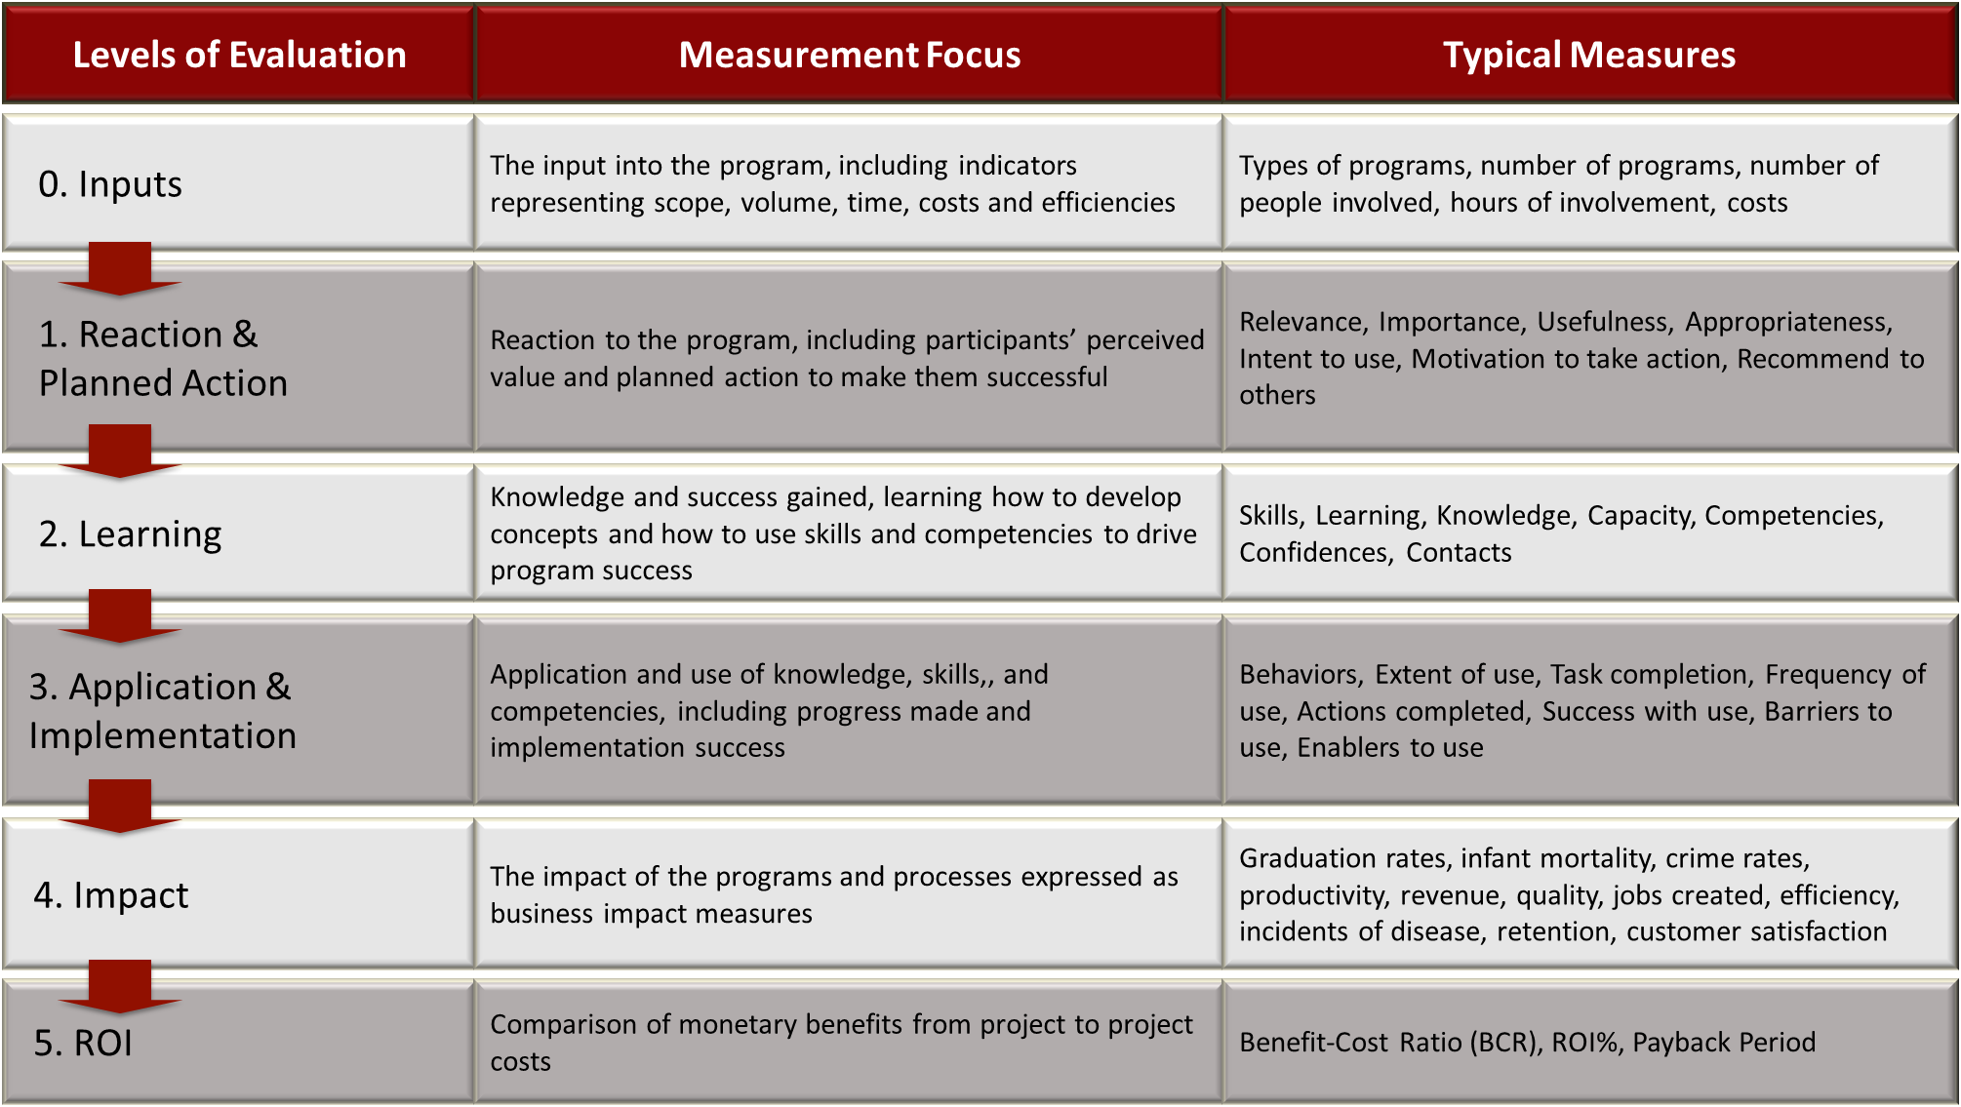

Source: Adopted from Phillips, P. P., Phillips, J. J., Paone, G., & Gaudet, C. H. (2019). *Value for money: How to show the value for all types of projects and programs in government, nongovernmental organizations, nonprofits, and business*. Scrivener Publishing.

It is important to note that Level 0 Input is not a program evaluation level. This Level represents the inputs, activities, and outputs of the program or project under review. It represents our investments in the program, not program results.

It is important to note that it is not appropriate to evaluate all programs at every Level. Only specific programs require such comprehensive evaluation. ROI Institute benchmarking studies indicate that impact and ROI evaluation candidates are typically expensive, critical to the organization, part of a strategy, or important to the management team. Other factors, such as the necessity of the program, the purpose of the evaluation, and the stakeholders' needs, often drive the program evaluation level (Phillips et al., 2019).

Process Model

The ROI process model (Phillips et al., 2019) ensures that the data captured in the framework are credible and reliable.  It integrates design thinking principles into four process phases to ensure we collect the appropriate data from the proper sources at the right time to drive the business. This proposal will show how we plan to follow this process as we describe our business case to evaluate the program we recommend.

Figure 2 shows that the first two phases of this process model—evaluation planning and data collection. These five steps provide the foundation for a successful program evaluation to ensure data that matters to the stakeholders are collected, analyzed, and reported to make decisions to drive the business.

**Figure 2**

*ROI Process Model – Evaluation Planning and Data Collection Phases*

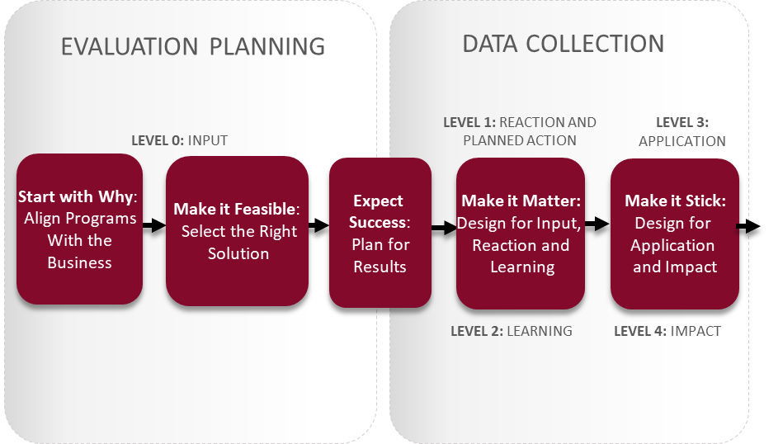

Source: Adapted from Phillips, P. P., Phillips, J. J., & Ray, R. L. (2020). *Proving the value of soft skills: Measuring impact and calculating ROI*. ASTD Press.

Table 2 explains the three steps in the evaluation planning phase we will complete. These steps are critical for implementing the most feasible, right solution to address the organizational and operational needs that our executives and stakeholders expect in return for their investment and implementation support.

**Table 2**  
  
ROI Process Model Evaluation Planning Steps

|  |  |
| --- | --- |
| **Process Steps** | **Description** |
| 1. Start with Why: Align Programs with the Business | This step involves two types of data, payoff and business.  The payoff need or opportunity is *why* an organization decides to act. The typical reasons to act are to make money, save money, avoid costs, or do something for the greater good. The payoff is to decide if the program is worth doing to solve a problem or pursue an opportunity. If the answers are yes, this is the answer to why the organization decided to act.  Next, this step pinpoints one or more business measures *already in the system* that should improve to achieve the desired payoff. These business needs can come from excessive costs and inefficiencies, behavior, understanding, and even individual perceptions. Business measures are classified as either (e.g., output, quality, cost, time) or soft (e.g., leadership, client service, work climate/satisfaction, development/ advancement, initiative/innovation, image/reputation). The ultimate payoff for a program that improves business measures is its effect on profit (or margin), cost savings, or cost avoidance. |
| 1. Make it Feasible: Select the Right Solution | This step determines how to improve the business measure by identifying the cause of the problem or explores various approaches to address an opportunity. This step defines the best solution and how to implement it that will address the business need. This step answers these five questions:   * What must change to influence the impact measure? * What can enable this change? * What is the best solution? * What must people learn to implement this change? * What is the best way to design and deliver the course for success? |
| 1. Expect Success: Plan for Results | This step defines success for the program by setting needs-driven program objectives at multiple levels (Reaction, Learning, Application, Impact, and ROI), defining responsibilities of all stakeholders, and completing data collection, ROI analysis, and evaluation implementation (aka project) plans. The objectives are the "should-be" results that define what success each stakeholder expects from the program. The evaluation determines how well the program did to achieve those program objectives. |

We must complete this needs assessment and cause analysis work to establish the baseline to evaluate the program against to determine the Level of improvement and select the right solution to address those needs. For programs that have already been implemented, we reverse engineer these steps to ensure we have the measures and objectives required for us to evaluate the program's effectiveness to improve the measures it was funded to improve.

The needs assessment and cause analysis we will complete at steps 1 and 2 drives the program objectives developed at step 3, which will then drive the evaluation. We will also involve the solution designers, facilitators, and participants to ensure they are involved in this process to understand the operational environment required to establish desired outcomes and define clear objectives. We will then evaluate the solution against those objectives. Figure 3 depicts this connection between needs, objectives, and evaluation. The needs assessment drives the program objectives, which then drives the evaluation.

**Figure 3**Business Alignment V-Model

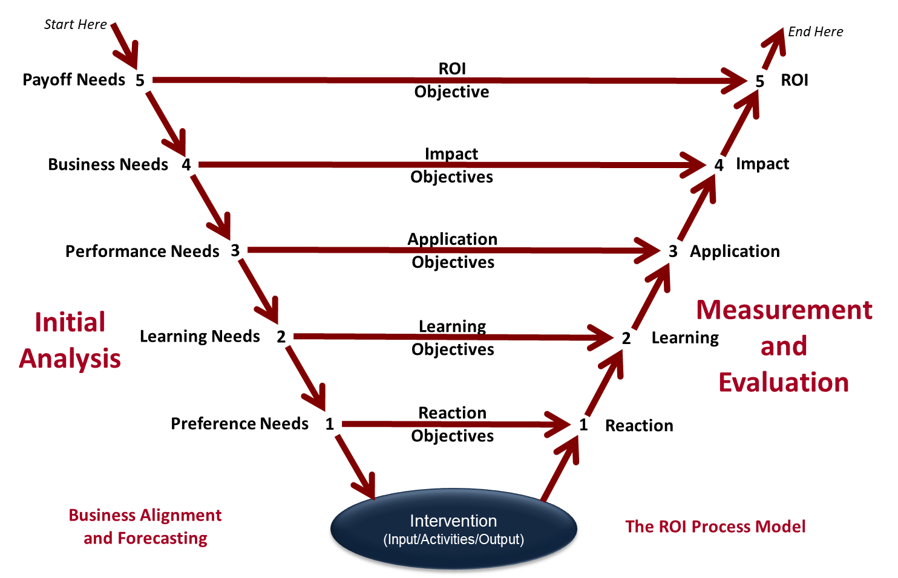

Source: Adapted from Phillips, J. J., & Phillips, P. P. (2018). *The value of innovation: Knowing, proving, and showing the value of innovation and creativity*. John Wiley & Sons.

Table 3 explains the two steps in the data collection phase, steps 4 and 5 of the process, that guide how we will collect measurement data to determine if the program met each Level's objectives. During the planning phase, all stakeholders will agree to support these steps to collect the data they defined as important to them. This data collection agreement includes the methods they will support, the most credible sources to provide this data, the best time to collect that data, and who is responsible for collecting the data.

**Table 3**Data Collection Steps

|  |  |
| --- | --- |
| **Process Steps** | **Description** |
| 1. Make it Matter: Design for Inputs, Reaction, and Learning | This step collects data to determine if the solution was designed and delivered in a way that mattered to the individuals who must change their workplace behaviors that will improve the defined business measures to meet the business impact objectives. |
| 1. Make it Stick: Design for Application and Impact | This last data collection step collects data to measure and determine if the program participants changed their workplace behaviors and how they affected the business impact measures. This step also identifies barriers preventing the participants from changing their workplace behaviors to achieve program success. |

Figure 4 represents the last two phases of the ROI Process Model. We will analyze the collected data and report the results and our recommendations to the key stakeholders to make data-driven decisions to optimize the program's effectiveness. These analysis and reporting phases are dependent on the proper evaluation planning to collect the agreed-upon quantitative and qualitative measures that matter to the stakeholder from credible sources at the appropriate levels of evaluation.

**Figure 4**  
  
ROI Process Model - Data Analysis and Optimize Results Phases

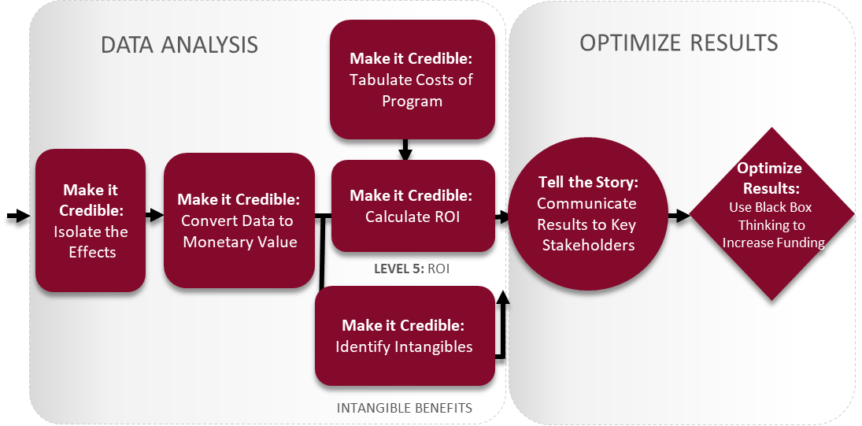

Source: Adapted from Phillips, P. P., Phillips, J. J., & Ray, R. L. (2020). *Proving the value of soft skills: Measuring impact and calculating ROI*. ASTD Press.

Table 4 explains the five steps in the data analysis phase, steps 6 – 10, that are essential to reporting credible, financially-conservative impact data directly due to the program to give management confidence in the credibility of the financial and non-financial results.

**Table 4**ROI Process Model Data Analysis Steps

|  |  |
| --- | --- |
| **Process Steps** | **Description** |
| 1. Make it Credible: Isolate the Effects of the Program | One of the most critical steps in the process is to isolate the program's effects on impact data. Isolation identifies the amount of impact directly connected to the program to ensure we take and give credit for the improvement where it is due. |
| 1. Make it Credible: Convert Data to Monetary Value | To calculate the ROI, we must convert appropriate business measures to money. There is a five-step process to calculate a monetary benefit credibly and conservatively using different techniques to determine an impact measure's value. |
| 1. Make it Credible: Identify Intangible Measures | Intangible benefits are program benefits that you choose not to convert to monetary value. They are measures that cannot be converted to money credibly with minimum resources. They are still measured and reported because they are directly connected to the program and have value. We will use a four-step decision process to determine which impact measures are appropriate to convert to a monetary value and which ones are appropriate to leave as intangibles. |
| 1. Make it Credible: Capture Costs of Program | Evaluations conducted to the impact level must include the total, fully loaded costs (i.e., all direct and indirect costs) of the program for a credible ROI calculation. |
| 1. Make it Credible: Calculate Return on Investment | Return on Investment (ROI) is a standard financial equation developed through finance and economics. It represents the ultimate measure of program success. Benefit-Cost Ratio (BCR) is the efficient use of funds. This study will calculate both financial measures using the program monetized benefits and costs. The two formulas are: |

Table 5 explains the two steps in the optimize results phase, steps 11 – 12, which addresses two steps that are often overlooked or not given the Level of attention and planning necessary to use evaluation results to help drive business success. Stakeholders will learn how well the program did to achieve the program objectives using the measures that matter to the stakeholders. If the ROI is negative, we will make recommendations to turn the program into an investment, if possible. If ROI is positive, we will make recommendations to optimize program results further.

**Table 5**ROI Process Model Optimize Results Steps

|  |  |
| --- | --- |
| **Process Steps** | **Description** |
| 1. Tell the Story: Communicate Results to Key Stakeholders | It is essential to accurately report the evaluation study results to the key stakeholders that fully describe the program's financial and intangible value to improve the measures that the stakeholders established were important to them during the evaluation planning phase through the needs assessment and program objectives. |
| 1. Optimize Results: Use Black Box Thinking to Increase Funding | Communication must lead to action. This step links the evaluation measures to process improvement recommendations to optimize program results. Using evaluation data to improve programs and influence the allocation of organization resources helps justify continuing or increasing evaluation funding for other vital issues. |

Operating Standards and Philosophy

We will comply with the ROI Methodology twelve guiding principles (Phillips, 2017) to ensure we consistently apply the evaluation process. We take a fiscally conservative approach when analyzing data that executives expect. The operating standards ensure that the data captured in the framework are credible and reliable.

These guiding principles keep the evaluation credible, support the replication of the process, and ensure the reliability of the collected evaluation framework data.

1. Tell the Complete Story of Program Success

*When conducting a higher-level of evaluation, collect data at lower levels.*

ROI is a critical measure. However, it is only one of the measures necessary to explain the full impact of a program. Therefore, we must include the lower levels of data to establish the chain of impact between the evaluation framework's program measures. The lower-level data also provide important process improvement information for future programs. The complete story of program success is the chain of impact story.

1. Conserve Resources for Higher-Level Evaluations

*When conducting a higher-level evaluation, the previous Level of evaluation is not required to be comprehensive.*

While it is critical not to omit lower-level measures to tell a complete chain of impact story, we can take shortcuts at these lower levels to conserve resources. For example, if our focus is on business impact measures, we can collect data that is less robust at Levels 2 and 3 that is good enough to establish a credible chain of impact and also ensure resources are available for the business impact focus.

1. Use the Most Credible Sources

*When collecting and analyzing data, use only the most credible sources.*

Credibility is the most important factor in any measurement and evaluation process. Without it, the results are meaningless. Collecting data from the most credible sources improves stakeholders' perception about the quality and accuracy of our data analysis and results. We define a credible source as someone who knows about the measure and what influences improvement in that measure. Many times, program participants are the most credible source. However, we can also balance their perspective with input from another and equally credible source.

1. Choose the Most Conservative Alternative

*When analyzing data, select the most conservative alternative for cal­culations.*

This principle is at the heart of this evaluation process. A conservative approach lowers the ROI and helps to build the credibility expected by the target audience. It also ensures we make reliable compari­sons of data between different programs.

1. Give Credit Where Credit Is Due

*Use at least one method to isolate the effects of the solution.*

This step is imperative. If we cannot provide evidence of how much our program influenced the business impact measure(s), our evaluation results are considered inaccurate and overstated. This isolation guiding principle is non-negotiable. It is also the first step of the analysis phase of the process model. This guiding prin­ciple requires consideration of multiple isolation techniques.

1. Make No Assumptions for Non-Respondents

*If no improvement data are available for a population or from a specific source, assume that little or no improvement has occurred.*

We must never speculate the data. We must see the data. If program participants do not provide data, regardless of the reason, we assume they had little or no improvement. When we infer benefits without evidence, we overstate the results. This speculation risks the credibility and reliability of the results we claim. This guiding principle protects the credibility of the results and allows us to compare other program evaluation results.

1. Adjust Estimates for Error

*Adjust estimates of improvement for the potential errors of estimation.*

This is another conservative approach pro­cess guideline. Using estimates is quite common in reporting data, including financial and cost-benefit information. Adjusted estimates improve the credibility of estimated data used in ROI evaluation of learning and performance improvement programs because the estimates are weighted with a level of confidence. This weighting adjusts the estimate for potential error.

1. Omit the Extremes

*Avoid the use of extreme data items and unsupported claims when calculating ROI.*

This guiding principle omits extreme data items that skew results one way or another to eliminate their influence on the analysis results. It is another data credibility protection action.

1. Report First-Year Benefits Only for Short-Term Programs

*Use only the first year of annual benefits in the ROI analysis of short-term solutions.*

Most learning and performance improvement programs are short-term solutions to justify the cost. We calculate the ROI for short-term programs based on first-year benefits. We do not inflate the results by assuming benefits will continue in future years. It may be appropriate for more extensive programs that span several months or more to presume benefits for multiple years.

1. Account for All Program Costs

*Fully load all costs of a solution, project, or program when analyzing ROI.*

The ROI calculation must include all program costs, beginning with the cost of the needs analysis and ending with the evaluation cost. This fiscally conservative approach ensures a more credible and reliable ROI.

1. Report Intangible Benefits

*Intangible measures are defined as measures that are purposely not con­verted to monetary values.*

While the ROI is the ultimate measure of program success, intangibles also have value. Intangible benefits such as customer satisfaction, employee engagement, better teamwork, and innovation are also important measures of program success. Intangibles can carry as much weight with senior executives as a program's financial benefits.

1. Communicate and Use Evaluation Data

*Communicate the results of the ROI Methodology to all key stakeholders.*

The purpose of evaluating programs using the ROI Methodology is to report success, gain respect, influence decisions, and improve programs. We report evaluation results to the key stakeholders to prevent it from becoming another activity that represents a cost rather than a process and performance improvement investment.

**Program Objectives**

We will work with executive leadership, managers, and clinical staff at the VHSO to implement a non-invasive hemoglobin monitor. The performance improvement must meet the stakeholders' needs: "the first step towards securing the acceptance of digital solutions and innovative medical technology by patients and professionals is to understand their anxieties and feelings of insecurity" (Safi et al., 2018, p. 8). Introducing a non-invasive hemoglobin monitor and reducing blood draws will also have a business impact by reducing potential unintentional needle sticks to healthcare workers, decreasing risks for nosocomial infections, reducing unnecessary blood transfusions, reducing biomedical waste, reducing supplies, and improving customers (Veterans) satisfaction by reducing discomfort from needle sticks during their hospital stay. The business implication of the non-invasive SpHb monitors for the VHSO will positively impact cost, quality of care, and client service.The program objectives for this proposed evaluation are as follows:

**Level 1 Perception Needs and Reaction Objectives**

Meeting Level 1 Perception Needs and Reaction Objectives will be difficult if stakeholders' anxieties about introducing new technology are not addressed. Education of the staff is one step but must be approached by leadership using these potential models. The three models of *the technology acceptance model, the untidied technology acceptance and use of technology, and the theory of technical innovation diffusion* can be used as models for the ROI to be successful and the leadership's awareness of acceptance or rejection of technology (Safi et al., 2018). Poncette et al.'s study provides insight into stakeholders' perspectives on new technology for patient care monitoring. In Poncette et al.'s research, emerging themes were 1) *current patient monitoring*, 2) *future patient monitoring*, and 3) *barriers to implantation of novel patient monitoring* (2019). According to Poncette et al., "to introduce more sustainable digital health solutions in the ICU, health care stakeholders might have to focus more on user-derived findings than top-down administrative speculations" (2019, p.8). Educating the staff about the non-invasive SpHb continuous monitors will help address anxiety.

**Table 6**

*Level 1 Perception Needs and Reaction Objectives*

­­­­­­­­________________________________________________________________­­­­­­­­­­__________

Need Objective

|  |  |
| --- | --- |
| Implementing an informational session for clinical staff educating them on non-invasive hemoglobin monitoring and the VHSO project to reduce invasive hemoglobin blood labs. | At the end of the learning session, clinical staff will rate the following statements at least 4 out of 5 on a five-point Likert Scale: |
| * Reduce the anxiety of staff about new technology | * With my knowledge of how the technology works, I am willing to use non-invasive technology. |
| * improve the lab process | * The new technology will reduce invasive labs, improve TAT for labs, and reduce trips to the ICU/Floor for blood draws. |
| * Decrease Veterans' discomfort | * I can see the benefits of the new technology for those we serve. |
| * Decrease the potential of nosocomial infections. | * I understand that the technology will help reduce invasive needle sticks in the first 48 hours of hospitalization when patients are at high risk of contracting a nosocomial infection. |
| * Decrease the potential of healthcare workers' unintentional needle sticks. | * I am motivated to use the new technology to help reduce potential risks to myself and my co-workers. |

**Level 2 Learning Needs and Objectives**

Training the clinical staff on properly using the non-invasive continuous SpHb monitors will help achieve the program goal and reduce the VHSO lab costs. The learning needs of the staff aligning with the learning objective will help achieve the leadership's goal to introduce the non-invasive continuous SpHb monitors and reduce staff anxiety about the new technology in the clinical setting.

**Table 7**

*Level 2 Learning Needs and Objective*

*____________________________________________________________________________*

Need Objective

|  |  |
| --- | --- |
| Teach the clinical staff using the non-invasive hemoglobin monitors how to use the technology and monitor patients correctly: | The clinical staff will score an 80% on the practicum on the proper steps of using the device settings and how to monitor patients using the non-invasive machine by: |
| * Proper use of non-invasive monitors to achieve the desired outcome. | * What each setting is used for, and what screen should be used for continuous SpHb monitoring. |
| * How to know if the monitor is working properly | * What are the range values for pulse index for effective monitoring? |
| * Answer questions and concerns about the patient population that the non-invasive device should not be used | * The clinical staff will be able to verbalize the medical conditions that the SpHb should be used with during the device practicum |
| * The accepted standard deviation non-invasive values | * The clinical staff will know the variabiltiy of non-invasive monitor values compared to blood values. |

**Level 3 Performance Needs and Application Objectives**

For the non-invasive continuous hemoglobin monitor to reduce the number of blood draws at the VHSO for patients experiencing acute anemia; clinical staff must apply what they have learned at the Level 2 to use the non-invasive monitor properly to achieve the VHSO's leadership goals. These goals include introducing a non-invasive continuous monitor to reduce invasive blood draws for the VHSO business needs and cost savings.

**Table 8**

*Level 3 Performance Needs and Application Objectives*

____________________________________________________________________________

Need Objective

|  |  |
| --- | --- |
| The clinal staff has completed training on the non-invasive continuous hemoglobin monitor: | Within 30 days, 90% of clinical staff who monitor inpatient blood values will start using the non-invasive continuous tool to monitor inpatient patient hemoglobin when experiencing anemia. |
| * Implement non-invasive continuous SpHb monitoring | * To develop comfort with using the non-invasive device in the clinical setting. |
| * Recognition and appreciation | * Gaining an appreciation of the potential the non-invasive monitor has in the clinical setting. |

**Level 4 Business Needs and Impact Objectives**

Introducing non-invasive continuous SpHb at the VHSO aims to improve business measures identified by the assessment of the organizational needs. Reducing blood draws will also have a business impact by reducing potential unintentional needle sticks to healthcare workers, decreasing risks for nosocomial infections, reducing unnecessary blood transfusions, reducing biomedical waste, reducing supplies, and improving customers' (Veterans') satisfaction by reducing discomfort from needle sticks during their hospital stay. The business implication of the non-invasive SpHb monitors for the VHSO will positively impact cost, quality of care, and client service. The stakeholders impacted the most at the VHSO are the patients (Veterans), nurses, phlebotomists, and environmental specialists.

**Table 9**

*Level 4 Business Needs and Impact Objectives*

___________________________________________________________________________

Need Objective

|  |  |
| --- | --- |
| The implementation of a non-invasive continuous SpHb monitor must: | Within six months of program implementation, the organization will realize a: |
| * Reduce invasive blood draws | * reduce 60% of annual spending on the invasive surveillance blood draw. |
| * Reduce unnecessary blood transfusions | * Reduce 20% of annual spending on unnecessary blood transfusions |
| * Decrease potential unintentional needle sticks to healthcare workers | * Reduce unintentional needle sticks to healthcare workersby 60% |
| * Decrease potential nosocomial infection within the first 48 hours from blood draws for anemia survallience | * Reduce blood-draw related nosocomial infections by 60% |
| * Decrease biowaste | * Reduction of biowaste by 60% |
| * Improve Veteran's satisfaction | Increase Veteran's satisfaction by 60% |

**Level 5 Payoff Need and Return on Investment (ROI) Objective**

The ultimate organizational accountability level is for the program to achieve a positive payoff from improving the associated business measure. The executive leadership believes introducing a non-invasive continuous monitor is the right financial decision to reduce invasive blood draws for the VHSO business needs and cost savings meeting the minimum annual ROI as indicated in Table 10.

**Table 10**

*Level 5 Payoff Need and Return on Investment (ROI) Objective*

*­­­­­­­­­­­­­­­­­­­__________________________________________________________________________*

Need Objective

|  |  |
| --- | --- |
| Redundant traditional invasive blood draws are costly to the VHSO | Achieve a minimum ROI of 60% |
|  |  |
|  |  |
|  |  |
|  |  |

Data Collection Plan

The data to be collected will be invasive hemoglobin labs, non-invasive hemoglobin values, touchpoints, and lab time. The data will be used to compareVeterans' blood hemoglobin values, the non-invasive hemoglobin monitor value for real-time trends, and the invasive blood draws. A Bland-Altman analysis will be used to compare the invasive hemoglobin level with the non-invasive hemoglobin levels for spot-check hemoglobin levels for the ED blood draws. A linear regression analysis will evaluate the ICU's invasive and non-invasive hemoglobin correlation trend.

The data on lab consult time, ED or ICU arrival time, lab draw time, and result time will be used to identify to which extent the non-invasive monitoring improves the Phlebotomoists' touchpoints. Qualitative data will also be collected from participant survey answers. According to Stringer and Aragón (2020), data analysis examines events that impact the participants most. Time is a dependent variable in reducing phlebotomists' touchpoints. Touchpoints will be analyzed, creating value to the system by eliminating touchpoints, and improving decision-making time. The participants in the performance improvement initiative are the phlebotomists and clinical lab managers. Current performance process maps will be analyzed to help define touchpoints to eliminate creating a desired process map. The current performance will be compared to the new performance to answer the research question. The performance improvement team selected an cost breakdown estimate by interviewing VHSO's stakeholders in the Clinical Laboratory, Utilization Management Services, and Logistics.

We applied three Guiding Principles (GP) during this planning step:

• GP 1 - When conducting a higher-level evaluation, collect data at lower levels.

• GP 2 - When planning a higher-level evaluation, the previous Level of evaluation is not required to be comprehensive.

• GP 3 - When collecting and analyzing data, use only the most credible sources.

Figure 5 indicates the data collection methods considered for each Level.

Figure 5



**Level 1 Reaction Data Collection Plan**

Table 11 shows the proposed data collection plan for Level. This plan ensures that the data collected is aligned to determine if the program achieved the desired reaction objectives. The plan will ensure the stakeholders properly use the non-invasive hemoglobin device to ensure correct data collection. This recommendation is subject to revision based on the key stakeholders' final preferences to support this task if this proposal is approved.

## Table 11

*Level 1 Reaction Data Collection Plan*

|  |  |  |  |  |  |
| --- | --- | --- | --- | --- | --- |
| ***Broad Objectives*** | ***Measure***  ***/data*** | ***Data Collection Method*** | ***Data Source*** | ***Timing*** | ***Responsibilities*** |
| * Information on new technology introduced to the clinical area * Identify areas to improve in the Clinical lab process * Introduce a new process that will help with patient care safety, healthcare safety, Veterans' comfort. * Gaining an appreciation of the non-invasive monitor has in the clinical setting | 4 out of 5 on a five- point Likert Scale | * Questionnaire * Question and answer session | * Clinical Staff | * End of a learning session * One month after the learning session | * The human performance improvement team |

A survey is recommended because it is inexpensive and the least disruptive method. A question and answer session will also be conducted after the teaching session to address the clinical staff's questions and concerns about the technology. The performance improvement team will document common themes from stakeholders' questions. The clinical staff is considered the most credible source because of their clinical expertise and perceptions of the program to determine if the objectives for this Level are achieved. A questionnaire was selected instead of a survey because we intend to ask questions beyond Likert Scale ratings to determine how to improve the course.

We propose collecting this data at the end of the event (looking forward) and one month later (looking back) to see if perceptions change after the program has been implemented. The human performance improvement team will provide the questionnaire and tally the results for both data collection methods.

Level 2 Learning Data Collection Plan

Table 12 shows the proposed data collection plan for Level 2. This plan ensures that the data collected is aligned to determine if the program achieved the desired learning objectives. This recommendation is subject to revision based on the key stakeholders' final preferences to support this task if this proposal is approved.

## Table 12

*Level 2 Learning Data Collection Plan*

|  |  |  |  |  |  |
| --- | --- | --- | --- | --- | --- |
| **Broad Objectives** | **Measure**  **/data** | **Data Collection**  **Method** | **Data Source** | **Timing** | **Responsibilities** |
| * To develop comfort with using the non-invasive device in the clinical setting * Can the clinical staff demo in simulation properly use of new technology? * The clinical   Staff will  provide a  simulation  on how to fill  out the  data collection  form properly. | * 80%   passing score on the simulation test   * Action Plan | * Test * Observation | * Clinical staff * Instructors | * End of the learning session | * human performance improvement team * instructors |

The human performance improvement team will create an observation checklist that will measure the clinical staff's understanding of the program's key points at the end of the learning session. The instructor will review the checklist to ensure that the clinical staff demonstrated proper use of the new technology before leaving the session. If an individual performs incorrectly using the new technology, the instructor will correct the clinical staff to ensure the device is used properly. The human performance team will also create a data collection form and ask questions of the clinical staff who are expected to collect data to ensure proper data collection.

The instructor will observe the class during the presentation to assess their interest level using non-verbal behaviors. The questions they ask indicate their motivation to apply what they learned when returning to their jobs. The instructor will guide the participants to demonstrate their ability to apply what they learned by completing an action plan. The instructors will collect the checklists and action plans, and the human performance improvement team will ensure clinical staff members' understanding before the session end.

Level 3 Application Data Collection Plan

Table 13 shows the proposed data collection plan for Level 3. This plan ensures that the data collected is aligned to determine if the program achieved the desired application objectives. This recommendation is subject to revision based on the key stakeholders' final preferences to support this task if this proposal is approved.

## Table 13

*Level 3 Application Data Collection Plan*

|  |  |  |  |  |  |
| --- | --- | --- | --- | --- | --- |
| **Broad Objectives** | **Measure**  **/data** | **Data Collection**  **Method** | **Data Source** | **Timing** | **Responsibilities** |
| * Implement non-invasive continuous SpHb monitoring * correlation with invasive hemoglobin * non-value touchpoints * Clinician satisfaction | * 90% of clinical staff will use the non-invasive continuous monitor | * Data collection form | * Clinical Staff | * 30 days after the program start date | * Human Performance Improvement Team |

After training the phlebotomist on the non-invasive hemoglobin monitor, the phlebotomist will use the Masimo Rad-67 device for the AIP data collection. In the lab, there will be a form to fill out. Once they get to the Emergency Room, the phlebotomist will apply the device to the patient's finger with the invasive blood draw. The blood draw will occur on the same limb on which the non-invasive probe was placed. Once the phlebotomist records the SpHb value, they will draw blood. Once the blood is drawn, the blood will be brought to the lab, and a time will be recorded on the lab arrival time. The hemoglobin lab will be analyzed, and the hemoglobin value will be recorded on the data collection sheet when the lab is read.

ICU RNs will be trained to use Masimo Rad-97 non-invasive hemoglobin monitors properly. They will utilize Masimo Rad-97 non-invasive technology to measure hemoglobin levels in real-time on the ICU patient monitor trends. The ICU RN will fill out a form recording the SpHb number on the monitor, the time the blood labs are drawn, and the blood hemoglobin when the results are received. This process will occur every three to four hours for the acutely anemic patient. The ICU RN will recalibrate the non-invasive SpHb to the recent hemoglobin lab value every morning. To determine tool reliability, this data collection will compare Veterans' blood hemoglobin values and the non-invasive hemoglobin monitor value.

Level 4 Business Impact Data Collection Plan

Table 14 shows the proposed data collection plan for Level 4. This plan ensures that the data collected is aligned to determine if the program achieved the desired business impact objectives. This recommendation is subject to revision based on the key stakeholders' final preferences to support this task if this proposal is approved.

**Table 14**

*Level 4 Business Impact Data Collection Plan*

|  |  |  |  |  |  |
| --- | --- | --- | --- | --- | --- |
| **Broad Objectives** | **Measure**  **/data** | **Data Collection Method** | **Data Source** | **Timing** | **Responsibilities** |
| * non-invasive hemoglobin monitors will   positively impact cost (Hard Business Data), quality of care (Hard business Data), and client service (Soft Business Data). | * Invasive Hgb lab value compared to non-invasive values * Time | * Non-invasive hemoglobin before the blood draw. * Invasive hemoglobin blood level at the time of invasive needle stick for the blood draw. * Lab Consult time * ED or ICU arrival time * Lab draw time | * Phlebotomist * ICU RNs * Collection sheets | * When * monitor Hgb levels | * Phlebotomist and ICU RNs |

For the question, "To what extent will non-invasive hemoglobin monitors improve Phlebotomists' non-value touchpoints affecting lab TAT at the VHSO?", data will be collected on the Phlebotomists’' total process or touchpoints from the clinical lab on the 3rd floor of the VHSO to the 2nd floor where the ICU is located, drawing the Veteran's blood, and returning to the clinical lab with the blood samples. A process map of current performance will be illustrated and data collected on the current performance of the Phlebotomists' touchpoints or total process from the clinical lab on the 3rd floor of the VHSO to the 1st floor where the ED is located, drawing the Veteran's blood, and returning to the clinical lab with the blood samples. The data collection or process time will be used to examine if the non-invasive tool can reduce the touchpoints for the Phlebotomists for the ED and ICU blood draws methodology of define, measure, analyze, improve, and control (DMAIC) process.

ROI Analysis Plan

The collection and comparisons of invasive hemoglobin blood values to non-invasive hemoglobin values will confirm the reliability and the potential financial impact of the non-invasive tool. If implemented, the ROI methodology will require the non-invasive hemoglobin monitor to have a positive monetary impact. The ROI Analysis will examine the benefits of VHSO by adding a non-invasive hemoglobin monitor to monitor acute anemia in Veterans to reduce invasive labs and unintended needle sticks and infections. This section will estimate the monetary benefits of the project will have a business implication of the non-invasive SpHb monitors for the VHSO and will positively impact cost (Hard Business Data), quality of care (Hard business Data), and client service (Soft Business Data). The stakeholders impacted the most at the VHSO are the patients (Veterans), nurses, phlebotomists, and environmental specialists.

**Program Isolation**

Isolation is the most critical analysis step because it attributes the impact directly to the program. We understand that in most situations, various factors influence specific business measures. To analyze and report credible results about this program's effectiveness, we must answer the question, "How do we know the impact we are claiming is a direct result of our program and not something else?" To answer this question, we considered eight isolation techniques for each impact measure that are part of the ROI Methodology. This proposal recommends the technique we believe is the most appropriate for each one. The isolation techniques considered as advocated by ROI Institute (Phillips et al., 2020) are listed below in their order of accuracy and credibility.

• Control group

• Trend Line Analysis

• Mathematical modeling

• Participant estimates

• Supervisor or Manager estimates

• Experts/Previous studies

• Other influencing factors

• Customers

We used the following Guiding Principles for our recommendations:

• GP 3: When collecting and analyzing data, use only the most credible sources.

• GP 5: Use at least one method to isolate the effects of a project.

The remainder is this section explains which method we recommend and why we selected it for each impact measure listed below

***Impact Measure 1 and Isolation Technique – Lab touchpoints and Control group***

The objective is to reduce inpatient lab touchpoints by 60% in six months. The area of interest is introducing non-invasive technology to measure hemoglobin non-invasively at VHSO. Utilizing non-invasive technology (SpHb) to measure hemoglobin levels will reduce invasive inpatient labs and provide clinical data in less time than traditional invasive blood labs. The Performance improvement team obtained estimated times from chart reviews of Veterans admitted to VHSO with anemia; the clinical decision-making time was based on lab turnaround time to order a type and cross to transfuse blood products. After times were obtained, the Performance improvement team mapped out a current process map to visualize the current process. The current process was obtained by chart reviews and interviewing the VHSO's clinical lab stakeholders. Reducing inpatient hemoglobin labs will provide additional benefits of non-invasive SpHb technology, decreasing Veterans' inpatient lab costs from multiple blood draws, improving clinical decision-making time for blood transfusion decisions, and decreasing VHSO costs. The times obtained from the Veterans' charts represent a control group for this impact measure. The performance improvement team recommends using phlebotomists (participants) to record their performance times against the chart review times with comparisons on lab turnaround benchmark times achieved and implement the non-invasive monitor for correlation to blood hemoglobin values.

**Table 15**

*Current Performance - LAB TAT No Intervention*

|  |  |
| --- | --- |
| Touchpoints | Time |
| ED MD assessment | 5 mins |
| ED MD places lab order | 2 mins |
| Phlebotomist lab drawing process | 35 mins |
| Clinical Lab TAT for Hemoglobin value | 26 mins |
| ED MD receives results | 10 mins |
| ED MD places Type & Cross order | 2 mins |
| Phlebotomist lab drawing process | 35 mins |
| Clinical Lab TAT for Type and Cross | 38 mins |
| ED MD receives notice Type and Cross is done | 10 mins |
| Total Time: | 80 mins/ with T&C: 165 mins |

**Figure 6**

***Impact Measure 2 and Isolation Technique – Invasive Blood Draws and Trend Line Analysis***

The second impact measure is invasive blood draws. The objective is to reduce invasive blood draws by 60% in six months, reducing costs. In the surveillance of the inpatient Veteran with acute anemia in the Intensive Care Unit (ICU), the traditional practice or current performance is to use an invasive blood test every 3 to 4 hours to monitor the hemoglobin values, supplies alone for each blood draw may range from $48.61 to $52.87. Inpatient hemoglobin labs at the VHSO for one year add to significant cost, especially with Veterans being surveillance for acute anemia with blood draws every 3-4 hours. The performance improvement team selected a cost breakdown estimate by interviewing VHSO's stakeholders in the Clinical Laboratory, Utilization Management Services, and Logistics. The estimated breakdown of the cost for one blood draw can be seen in Table 16 below. These costs do not represent the cost to the VHSO for the disposal of biomedical waste, personal protective equipment needed for blood draws, the time to don personal protective equipment when entering a COVID-19 unit, or some isolation contact precautions the Veteran may have.

The performance improvement team recommends a trend line analysis. This analysis will allow for a pre-program output trend line against the output trendline to provide a visual example of the program's impact.

**Table 16**

*Invasive Hemoglbin Lab Cost Breakdown*

__________________________________________________________________________________

|  |  |  |
| --- | --- | --- |
| **Description for Drawing a Lab** | U/I | Cost |
| Gloves (Exam) | 1 | $0.18 |
| Blood tubes (specifically purple top) | 1 | $0.43 |
| Blood tubes (specifically pink top) | 1 | $0.64 |
| Alcohol swabs ($0.01) | 1 | $0.01 |
| Gowns (for use in the COVID unit) ($1.40) | 1 | $1.40 |
| N95 masks ($0.52) | 1 | $0.52 |
| Regular masks ($0.09) | 1 | $0.09 |
| CBC ($2.11) | 1 | $2.11 |
| BD Needles (Preattached tube holder, built-in safety shield) | 1 | $1.10 |
| BD Vacutainer™ Safety-Lok™ Blood Collection Sets with Pre-Attached Holder­­­­­­­­­­­­­­­­­­­­­ | 1 | $5.36 |
| Tourniquets | 1 | $0.13 |
| Lab Tech | 1/hr | ~ $24.00 |
| Phelbotomist | 1/hr | ~ $18.00 |
| If transfusing Unit PRBCs | 1 | $205.00 |

***Impact Measure 3 and Isolation Technique –*** ***Customer Dissatisfaction and Customers***

The third impact measure is customer dissatisfaction and patient/employee safety. The first impact is to improve customer satisfaction by 60% by reducing the number of invasive blood draws. The recommendation to obtain an estimate for customer dissatisfaction would be to conduct a customer satisfaction survey. A customer satisfaction survey could be conducted asking Veterans after invasive blood draw labs their satisfaction with having labs drawn. Their satisfaction with invasive blood draws if they were to have their labs drawn every 3-4 hours for two days straight compared to how satisfied they would be if they were being monitored by a probe on their finger for anemia with blood draws only as needed.

***Impact Measure 4 and Isolation Technique – Stakeholder Near Miss and Customer Estimate***

For stakeholder near misses, impact measures would be mathematical modeling. Stakeholder near miss includes avoiding the Central Line-Associated Bloodstream Infection (CLABSI) of Veterans, and the number of unintentional employee needlesticks avoided using the non-invasive hemoglobin monitor. The number of CLABSI information will be retrieved on Strategic Analytics for Improvement and Learning (SAIL), a government medical database for all individual national VHSO statistics. The number of employee needlesticks for one year will be obtained from the Medical Director of the VHSO's employee health. Both of the safety issues can be very costly for hospital institutions. Using a non-invasive hemoglobin monitor can help reduce the amount of invasive blood draws, significantly reducing the potential of these two safety issues.

Program Benefits Estimates: Monetary and Intangible

Once we isolate the effects of our three impact measures, we must decide how we will

decide if we should credibly convert an impact measure to a monetary value to allow us to

calculate an ROI or if we should leave it as an intangible benefit. This is required by step 7 of

the ROI Methodology process.

There are several methods available to determine the value of a measure listed below in

their order of credibility (Phillips & Aaron, 2008).

• Standard value (these are conversion techniques the organization already uses and

accepts as true)

▪ Outputs converted to profit contribution or cost savings

▪ Quality improvements that are directly converted to cost savings

▪ Employee time (using compensation)

• Historical costs/savings

• Internal/external experts

• Data from external databases or studies

• Linking with other measures

• Supervisor/manager estimates

• Staff estimates

For each business measure, we will use the four-part data conversion logic test in Figure 7 to recommend whether to convert that measure to a monetary value. According to this four-part test, if a standard value exists for the measure, we can use that standard value to convert it to a monetary value and add it to the ROI formula numerator. We will make this determination with finance and human resources. If there is no standard value, we will work with finance to determine if they have a method to make this conversion. If they do not, the measure remains intangible. We will then determine if this conversion is possible using minimum resources if they do. If the conversion process is costly, then the measure remains intangible. If the conversion cost is reasonable, the last question we will consider is if we can briefly explain how this conversion process occurred so that our executives understand how we did and will believe the number. If we cannot do this, we will leave the measure intangible. If we can explain it and our executives conclude the conversion process and result credible, we will convert the measure to a monetary value and add it to the numerator.

**Figure 7***Four-Part Monetary Conversion Test*

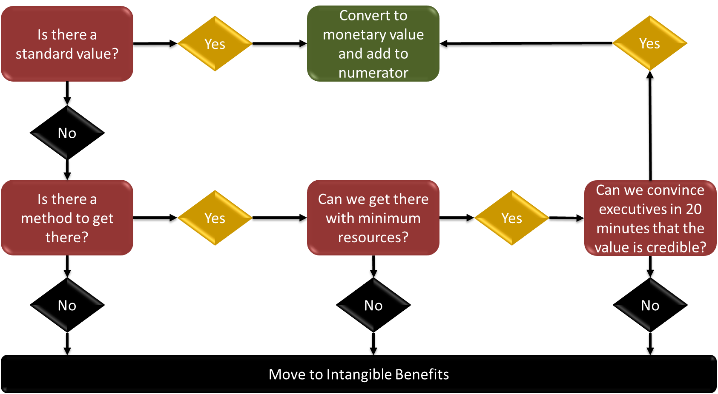

Source: Adapted from Phillips, P. P., Phillips, J. J., Paone, G., & Gaudet, C. H. (2019). *Value for money: How to show the value for all types of projects and programs in government, non-governmental organizations, nonprofits, and business*. Scrivener Publishing.

We will use the following Guiding Principles for our recommendations:

• GP 3: When collecting and analyzing data, use only the most credible sources.

• GP 4: When analyzing data, select the most conservative alternative for calculations.

• GP 11: Intangible measures are identified as measures that are purposely not converted

to a monetary value.

To convert one business impact measure to a monetary value, we will use a five-step

the conversion process is part of the seventh step of the ROI Methodology process. We will

complete the first two steps during the planning phase with the appropriate stakeholders before

implementing the non-invasive hemoglobin monitor in the clinical environment. We will use the business measures defined at step one of our process. Appropriate business measures were selected using the four-part monetary conversion test.

Step 1: Focus on one unit of business measure

Step 2: Determine the value (V) of each unit

Steps 3-5 calculate the annualized monetary benefit of the employee engagement and pay incentive system after we isolate the business impact measure data. We must do this to satisfy Guiding Principle 9 that requires us to use only the first year of annual benefits in ROI analysis for short-term solutions.

We will calculate the ROI of the program using these annualized monetary amounts to

allow the executives to compare this ROI to other annual ROIs. Step 3 is the difference

between the business baseline measure and the business measure change due to the employee

engagement and pay incentive program. Step 4 annualizes the improvement if the unit of

measure is based on days, weeks, months, quarters, or other units that are not annual. Step 5

calculates the annualized monetary value of improving the business measure.

Step 3: Calculate the change in performance (ΔP)

Step 4: Determine the annual amount of the change (AΔP)

Step 5: Calculate the total annual value of the improvement (AΔP x V)

In the following section, for measures determined appropriate to convert to a monetary

value, we will forecast an ROI assuming the employee engagement and pay incentive program

achieved that objective, and the improvement was attributed entirely to the performance

improvement program. Later in this proposal, we will provide a pre-program ROI forecast to

indicate the potential ROI possible from this employee engagement and pay incentive program.

If this evaluation is approved, we will calculate the program ROI after actual data is collected

and analyzed.

***Impact Measure 1 and Conversion Method – Lab Tounchpoints and Quality Improvement***

The recommendation is to convert lab turnaround time to a standard monetary value. After completing multiple chart reviews, we determined the current time from when a lab is drawn to when the medical doctor reads the results at VHSO. A non-invasive hemoglobin monitor reduces the number of touchpoints for lab personnel, reducing the time consumed with multiple labs draws for one stakeholder. When a Veteran is admitted for acute anemia first 48 hrs of labs x the annual amount of Veterans admitted for anemia. The clinical lab manager agreed to the standard lab time for 48 hr stakeholder blood draw for acute anemia.

***Impact Measure 1*** ***Lab Turnaround Time Monetary Conversion Forecast if Objective is Met***

This project's monetized benefits presume meeting the program objective for this measure. The decrease in lab touchpoints could be lower when actual unit improvement is measured using a non-invasive hemoglobin monitor.

1. Focus on one unit of measure = 48 hrs stakeholder blood draw for acute anemia

2. Determine the value (V) of the unit = $512

- HR provided this value, and multiple chart reviews were performed to determine the time cost for 1 lab is $32.00 x 16 labs (48 hrs).

3. Calculate the improvement in the measure (ΔP) = 113

- Meeting the time cost for 188 acute anemia admissions by 60% using a non-invasive hemoglobin monitor.

4. Determine the annual improvement in the measure (A x ΔP) = 113

- This unit is already an annual change

5. Calculate the total monetary value of the improvement (AΔP x V) = $57,856

- $512 x 113

***Impact Measure 2 and Conversion Method Invasive Blood Draws and Standard Value***

The cost to perform a lab and supplies is recommended to be a monetary value because of the standard value. The standard value for a lab at $52.87 was calculated with information that logistic departments, purchasing, HR, and the clinical laboratory agreed on.

***Impact Measure 2 Invasive Blood Draws Monetary Conversion Forecast if Objective is Met***

This project monetized the benefits by meeting the project goals of reducing invasive blood draws by using a non-invasive hemoglobin monitor for Veterans experiencing acute anemia.

1. Focus on one unit of measure = 1 labs for acute anemia admission

2. Determine the value (V) of the unit = $52.87

- HR, logistics, and purchasing provided this value.

3. Calculate the improvement in the measure (ΔP) = 1805

- Meeting the reduction in the cost of labs for acute anemia by 60% by using a non-invasive hemoglobin monitor between 3008 to 1805.

4. Determine the annual improvement in the measure (A x ΔP) = 1805

- This unit is already an annual change

5. Calculate the total monetary value of the improvement (AΔP x V) = $95,420

- $52.87 x 1805

***Impact Measure 3 and Conversion Method – Customer Dissatisfaction and Invasive needle stick as Intangible***

We recommend customer dissatisfaction with multiple invasive blood draws experiencing acute anemia as an intangible response since VHSO currently does not use the non-invasive hemoglobin technology.

***Impact Measure 3 Customer Dissatisfaction Conversion Forecast if Objective is Met***

Because of customer dissatisfaction experiencing acute anemia, invasive blood draws is the current practice.

***Impact Measure 4 and StakeHolder Near Misses and Quality Improvement***

The fourth impact measures the potential savings in near misses to stakeholders by introducing a non-invasive hemoglobin monitor and reducing the amount of invasive blood draws by 60%. The national average was $67,407 for costs related to accidental employee needlesticks and CLABSI. The infection control department and employee health agreed with the assigned value.

***Impact Measure 4 Stakeholder Near Misses Conversion Forecast if Objective is Met***

This project monetized the potential saving for VHSO by reducing potential threats to stakeholders costing VHSO in treatment and care. The actual improvement savings could be much more.

1. Focus on one unit of measure = 1 near miss

2. Determine the value (V) of the unit = $67,407.00 (near miss)

- This value was provided by Employee Health MD and Infection Control RN.

3. Calculate the improvement in the measure (ΔP) = 6

- Meeting prevention of safety issue 60% by using a non-invasive hemoglobin monitor a from 9 to 3 difference of 6.

4. Determine the annual improvement in the measure (A x ΔP) = 6

- This unit is already an annual change

5. Calculate the total monetary value of the improvement (AΔP x V) = $404,442 (near miss)

- $67,407.00 x 6

***Other Potential Intangible Benefits***

In addition to the impact measure that we recommend keeping as an intangible measure, the current project may result in other intangible benefits for VHSO:

* Improve VHSO reputation
* Employee Satisfaction
* Increase the use of other non-invasive technologies
* Increase Veteran's confidence in VA Care rather than community care
* Reduce stress on blood bank
* Reduce critical care RN stress level
* Improve clinical decision-making

Program Cost Estimates and ROI/BCR Formulas

This section explains the proposed capture for program costs and lists the cost

categories we will use. This section will include program cost estimates based on the costs of implementation of the new technology to VHSO. The ROI calculation will be explained using the calculations to forecast ROIs in this proposal and the actual ROI as part of the

program evaluation. The Guiding Principles will be identified to guide our

decisions and actions.

Cost Categories

Cost categories were identified to calculate program ROI evaluation by working with department heads. The leaders from the clinical laboratory, purchasing, utilization management services, and logistics provided the determined costs that may require additional actions because they are not part of our current cost collection routine. The categories listed below are the evaluation program's collected costs. The tabulated cost is estimated to be $135,384 for this business case proposal to forecast a later ROI for this proposal.

* Initial analysis and assessment $13,089.68
* Kit Rad-67 ($1,600)
* Kit, Rad-97 ($1845.00)
* Rainbow DCI Mini SC400 1box ($1,800)
* RD Rainbow probe 10 boxes ($886.00)
* Total Hemoglobin (SpHb) & Oxygen Content ($3,575.00)
* Lab Collection ($3,383.68)
* Equipment cost (loaner for Pilot Program from Masimo) - $9,706.00
* Lab equipment maintenance (12-month pilot) $84,000
* Evaluation and reporting (pilot) $48,000
* We will use the following Guiding Principles for our cost recommendations:
* GP 3: When collecting and analyzing data, use only the most credible sources.
* GP 10: Fully load all costs of a solution, project, or program for ROI analysis to
* calculate a credible ROI.

Financial Calculations

Two financial calculations with our evaluation are included—Benefit-Cost Ratio

(BCR) and Return on Investment (ROI). The BCR and ROI formulas in the

ROI forecast section of this proposal is based on cost and benefit estimates. The BCR is

expressed as a ratio. The ROI is expressed as a percent.

The BCR formula we will use is:

Program Benefits/Program Costs

The ROI formula we will use is:

Program Benefits – Program Costs/ Program Costs X 100

Pre-Program ROI Forecast

The pre-program forecast was conducted to help the administration decide to approve the proposed evaluation to implement the non-invasive hemoglobin technology at VHSO. The estimated cost presented earlier in this proposal will be used.

To establish estimated benefits, we asked experts to provide estimates specific to the

program. Experts from VHSO and Masimo were selected based on their area of expertise relevant to the business measure. Both units of measure had a standard value (SV). Isolation was unnecessary for these estimates since they were specific to the program. However, because we used estimates, each expert was asked to provide their confidence level in their estimate to comply with Guiding Principle 7, which requires us to adjust estimates of improvement for potential errors in estimation.

The experts were asked to estimate the improvement expectations based on the descriptions of the performance improvement program. Here are the expert estimates for implementing a non-invasive hemoglobin technology at VHSO to understand Table 15.

* Step 1: The units of measure lab turnaround time, lab/supplies, and near misses were identified in step 1 of the process model and converted to monetary value in step 7.
* Step 2: Each measure valued unit is established by two standard values (SV), provided by logistics, purchasing, HR, and clinical laboratory.
* Step 3: (FΔP) is the forecast change in performance. This figure is the estimated improvement in the business measure performance predicted by the experts due solely to the program. Therefore, no isolation actions are necessary.
* Step 4: Because step 3 is an estimate, we must apply Guiding Principle 7 to adjust improvement estimates for potential errors. In this case, CL represents the expert's confidence level (or the average of more than one expert) who provided the estimate. For the program objective, these forecasts' confidence level is set at 100% to represent the ideal desired results.
* Step 5: FAΔI is the forecast annualized improvement of the change expressed in a monetary value calculated for each estimate. Lab turnaround time is an estimate based on chart reviews, while lab costs unit/lab estimate and near misses are estimated costs for one infection treatment. The formula to calculate this figure is FΔP x C x A x SV. For lab turnaround time, the A equals one since the amount is already annual. The A for output is already an annual change.
* PC is the estimated program cost established earlier in this proposal. The estimated cost for improving both measures is used for each ROI calculation assuming the other measure showed no improvement. When the actual ROI is calculated, we will include both values in one ROI calculation since the program costs involve improving both impact measures and should reflect the benefits from both measures.

Table 17

Pre-Program Forecast ROI Projects

|  |  |  |  |  |  |  |  |  |
| --- | --- | --- | --- | --- | --- | --- | --- | --- |
| Measures | 1  Lab TAT  (SV) | 1  Lab  &  Supp  (SV) | 1  Near  Misses  (SV) | FΔP | CL | FAΔI | PC | Forecast  ROI |
| **Lab TAT Objectives** |  |  |  |  |  |  |  |  |
| Objective Met | $512 |  |  | 113 | 100% | $57,856 | $135,384 | -57% |
| Logistics | $512 |  |  | 113 | 90% | $52,070 | $135,384 | -62% |
| Purchasing | $512 |  |  | 113 | 90% | $52,070 | $135,384 | -62% |
| HR Dept | $512 |  |  | 113 | 90% | $52,070 | $135,384 | -62% |
| Clinical Lab | $512 |  |  | 113 | 100% | $57,856 | $135,384 | -57% |
| **Invasive Blood Draw**  **Objectives** |  |  |  |  |  |  |  |  |
| Objective Met |  | $52.87 |  | 1805 | 100% | $95,430 | $135,384 | -30% |
| Logistics |  | $52.87 |  | 1805 | 95% | $90,659 | $135,384 | -33% |
| Purchasing |  | $52.87 |  | 1805 | 95% | $90,659 | $135,384 | -33% |
| HR Dept |  | $52.87 |  | 1805 | 95% | $90,659 | $135,384 | -33% |
| Clinical Lab |  | $52.87 |  | 1805 | 90% | $85,887 | $135,384 | -37% |
| **Near Misses**  **Objectives** |  |  |  |  |  |  |  |  |
| Objective Met |  |  | $67,407 | 6 | 100% | $404,442 | $135,384 | 199% |
| Infection Control |  |  | $67,407 | 6 | 80% | $323,554 | $135,384 | 139% |
| Employee Health |  |  | $67,407 | 6 | 80% | $323,554 | $135,384 | 139% |

These three independent ROI forecasts indicate a significant range of possible ROI

results. These estimates also indicate that even if monetized benefit improvements do not

meet the impact objective for both measures, a positive ROI is possible for one measure even if

the other measure shows no improvement. This is because the cost to improve both measures is

used for the calculation cost to improve one measure. In addition, since these calculations are on estimates, we do not expect to achieve the forecast ROIs fully. However, even if the

program achieves as little as 10 percent of either or both forecast ROIs, a positive ROI is

still indicated.

It is unlikely that one measure will improve while the other does not.

Therefore, Table 16 displays a sensitivity analysis that forecasts possible ROIs using these

program objective and SME estimates for different combinations of the two impact measures.

Table 18

*Pre-Program Forecast ROI Sensitivity Analysis*

_______________________________________________________________________________________________________

|  |  |  |  |  |  |
| --- | --- | --- | --- | --- | --- |
| LAB TAT FΔP | Invasive Blood Draws FΔP | Near Misses FΔP | FAΔI | PC | Forecast ROI |
| 113 | 1805 | 6 | $557,782 | $135,384 | 312% |
| 113 | 1805 | 6 | $466,283 | $135,384 | 244% |
| 113 | 1805 | 6 | $143,743 | $135,384 | 6% |
| 113 | 1805 | 6 | $142,729 | $135,384 | 5% |

­­­­­­­­­­­­­­­­____________________________________________________________________________

Combining each unit of measure in the ROI numerator makes it reasonable to use a non-invasive hemoglobin monitor to reduce Lab TAT, invasive blood draws, and near misses andachieve the minimum desired ROI of 60%. This sensitivity analysis indicates that modest improvements in the two measures will result in a positive ROI. These calculations presume the program cost estimates are close to the program's actual costs. We will manage the program to minimize program costs. This sensitivity analysis supports a decision to implement this program. It also supports a decision to fund this evaluation proposal to learn how well the program did to meet the program objectives, particularly the desired business measures, what actions are necessary to improve the program, and insights from the ROI calculation economic variables to make the organization resource allocation decisions.

**Communication Plan & Evaluation Implementation Plan**

This plan of introducing a non-invasive hemoglobin monitor and reducing blood draws will have a business impact by reducing potential unintentional needle sticks to healthcare workers, decreasing risks for nosocomial infections, reducing unnecessary blood transfusions, reducing biomedical waste, reducing supplies, and improving customers (Veterans) satisfaction by reducing discomfort from needle sticks during their hospital stay. The business implication of the non-invasive SpHb monitors for the VHSO will positively impact cost, quality of care, and client service. The plan to implement a non-invasive hemoglobin monitor at VHSO will be communicated to the department heads and department chiefs at VHSO using Microsoft meet during an agreed-upon time to gain support. A PowerPoint presentation will use the seven principles for communicating results and plan implementation. Data from the project will be presented to inform the head stakeholders and how the non-invasive hemoglobin monitor will benefit VHSO, its employees, and the Veterans cared for at VHSO.

This presentation will also be presented to the Veterans Integrated Services Networks -16 (VISIN) leading innovation subcommittee to communicate how a non-invasive hemoglobin monitor, if implemented, will help improve VISIN-16 hospitals, their employees, and the Veterans who receive care at their facilities.

**Communication Results**

Step 10 of the ROI Methodology process model is to communicate the results to key stakeholders. We will also apply Guiding Principle 1 to tell the complete chain of impact story of success at every evaluation level and Guiding Principle 2 where we will conserve evaluation resources at the lower levels to ensure resources are available to evaluate the higher levels that matter to our leadership team. We will also show how we applied the other nine Guiding Principles in the detailed report. We will use the four phases of the ROI Methodology process as milestones for reporting results. We will report relevant data collection results as collected to provide leading indicator data for possible corrective action.

**Planning Phase**

We will revise this proposal to reflect any stakeholders' revisions to optimize a successful program and implementation. The CEO will approve this final product to serve as the evaluation plan all stakeholders agree to support. We will prove a copy of all planning documents to the key stakeholders and meet with individuals or groups of stakeholders to explain the evaluation plan and answer questions to ensure stakeholder support

**Data Collection Phase**

We will report the results of the data collecting during program implementation. The first report will involve the Level 1 Reaction and Planned Action results and the Level 2 Learning results. These evaluation results will provide early indicators about the program's potential for success when participants return to their work locations. This report will go to the direct supervisors to begin discussions about how the organization can take corrective actions to remove or minimize anticipated workplace barriers identified by participants to improve Level 3 Application and Implementation actions and measures.

We will report Level 3 Application and Implementation measures as we collect these measures to direct supervisors and one-over managers. This strategy will allow us to monitor and manage company actions to support the new behavior and performance desired from participants to improve the defined Level 4 Impact Measures.

**ROI Analysis Phase**

We will report early analysis findings to the senior leadership team members. We will work with them to analyze the impact data to ensure their continued support of our analysis efforts and prevent any surprises in the final report. We will offer our analysis to other stakeholders when requested.

**Optimize Results Phase**

We will communicate the evaluation study results to the executive leadership team

using a one-hour formal presentation that will allow us to tell the evaluation story and answer any questions. We will also provide each executive with a copy of the evaluation study report at the end of the presentation upon request.

Throughout our communication plan, we intend to apply the following basic guidelines (Phillips & Phillips, 2017, p. 178):

1. Make communication timely to prevent surprises and to maximize program impact.

2. Customize the communication to a specific audience based on their needs,

expectations, and interests.

3. Select the mode of communication carefully based on the preferences of each

audience.

4. Keep communication neutral by reporting data-driven facts and not opinions.

5. Include testimonials to ensure the human perception element is not ignored.

6. Be flexible to use formal communication practices as well as address the special

communication requirements of a specific audience.

7. Use communication to drive improvement to make decisions as data is collected to

adjust the program during implementation and after completing the program

evaluation to ensure the results are understood and actionable. These communication guidelines define how we plan to keep all appropriate stakeholders informed of the results during each evaluation program phase. We will meet with

all key stakeholders immediately after this evaluation plan is approved to plan the

communication strategy to ensure we apply these guidelines.

**Evaluation Implementation Plan**

The plan is to implement a non-invasive hemoglobin monitor to reduce touchpoints for Phlebotomists, decrease multiple blood draws, increase the Veterans' comfort from less invasive blood draws, decrease iatrogenic blood losses from serial blood draws, and improve clinical decision-making time. The Gantt Chart shows a timeline for implementing the performance improvement plan in Table 19. The stakeholders and performance improvement team established this timeline. A barrier mitigation plan will also include proactive steps to remove or minimize potential barriers to ensure the participants have the organizational support and tools required for success.

**Table 19**

*Introducing Non-invasive Hemoglobin Technology to VHSO*



**Process Improvement Plan**

Step 12 of the ROI Methodology process model is to optimize results using black box thinking from the airline industry to learn what went right and what went wrong to prevent the human and system errors from happening again. Our first goal is to learn where the program evaluated was successful in achieving its program objectives, where it fell short, and recommending actions to improve the program and reduce costs. This black box thinking will include identifying barriers to performance improvement outcomes and results that were not identified or addressed in the force field analysis and implementation plan. We also want to use the data we collect to sustain the program and justify further funding for additional performance improvement and evaluation programs.

Our program optimization goal is to transition this evaluation program into a process improvement program. We plan to use the data collected and analyzed to do the following process improvement actions as prescribed by the ROI Methodology (Phillips et al., 2019) to gain and build support for future program evaluations:

• Adjust any program’s design to improve its effectiveness.

• Improve any program’s delivery/implementation effectiveness and efficiencies.

• Influence any program’s sustainability.

• Strengthen our effort to reinforce workplace performance application.

• Improve management support for our performance improvement programs.

• Improve stakeholder satisfaction with the results we deliver.

• Recognize and reward participants for improving their workplace performance.

• Justify or improve our department’s budget because we add measurable value to the organization.

• Reduce operational costs.

• Market our performance improvement capabilities based on value offered.

• Expand our evaluation footprint to programs throughout the organization.

Whether the evaluation results are positive or negative, during this last step, we will make recommendations to improve the program to optimize the results using the evaluation data. Table 12 indicates how we plan to use data collected at the various evaluation levels to strengthen the implementation outcomes and results to improve this program and evaluate and improve other programs based on work by Phillips and Phillips (2017, p. 237).

**Table 19**

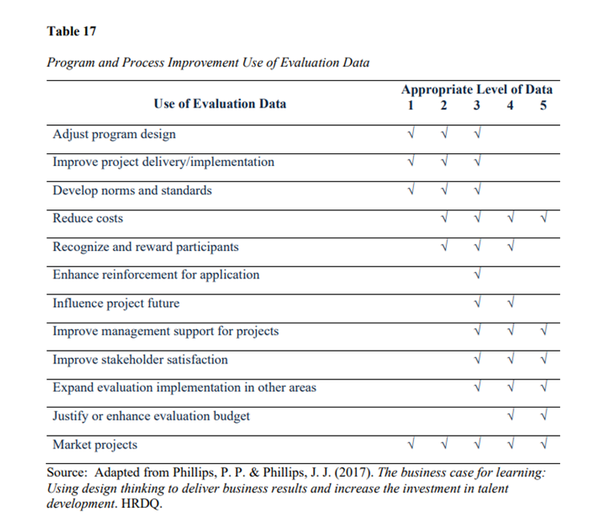

We will work with the key stakeholders to finalize our plan to turn this evaluation program into a continuous process improvement program. We will also work with all stakeholders to optimize the results to drive the business. Finally, we will work with designated stakeholders to finalize our plan to hold this program to the highest level of economic accountability—ROI.

Conclusions and Recommendations

The invasive method of collecting blood is painful, and delays between collections can prolong clinical decision-making (Pinto et al., 2020). In medical centers, the two biggest dangers to threaten healthcare workers and patients are unintentional needle sticks and nosocomial infections. Nosocomial infections cost 4.5 billion dollars annually, affecting 90,000 patients, with infections occurring within the first 48 hours of hospital stays. Accidental needle sticks expose healthcare workers to potential viruses resulting in expensive treatment and care (Suksatan et al., 2022). On average, a person hospitalized for acute anemia will have six blood draws in the first 48 hours and will be transfused an average of 2.6 units (Jaben et al., 2020). Laboratory testing accounts for 4% of the $4.4 trillion health care expenditures in the United States, and redundant/repeated testing wastes up to $5 billion a year (Konger et al., 2016). A potential way to reduce blood draws and costs for this population is to introduce new available non-invasive technology.

VHSO faces the same challenges identified above. This proposal makes the business case for why implementing a non-invasive hemoglobin monitor is important to VHSO's success. This proposal uses ROI methodology to show how the non-invasive hemoglobin monitor can benefit VHSO. By reducing invasive labs by 60%, VHSO can reduce multiple painful blood draws on inpatient VHSO's acutely anemic Veterans, reduce delays in clinical decision-making, nosocomial infections, and unintentional needle sticks to employees, reduce redundant laboratory testing, reduce unnecessary hospital stays, biomedical waste, and overall cost. The non-invasive hemoglobin monitor could reduce unnecessary blood transfusions by 20%.

This proposal provided different forecast ROIs using cost and monetized benefit estimates for the two impact measures, indicating the possibility of a positive ROI. Actual costs and monetized benefit figures are required to determine where the performance improvement program is working and where improvements are warranted to reduce costs and improve the program's benefits and ROI.

The Performance Improvement Team recommends approval of this proposal to implement a non-invasive hemoglobin monitor to VHSO, impacting the organization and its ROI. We are prepared to begin implementing the new technology and finalizingwork immediately upon proposal approval.

**References**

Hepatitis C information for Veterans. (n.d.). Retrieved August 2, 2022, from https://www.hepatitis.va.gov/pdf/Hepatitis-C-Factsheet-Veterans.pdf

*History of Pulse Oximetry*. (2022). Amperor Direct USA. Retrieved August 26, 2022, from https://www.amperordirect.com/pc/help-pulse-oximeter/z-pulse-oximeter-history.html

Jaben, I., Sasso, R., & Rockey, D. C. (2021). Hemoglobin Monitoring in Acute

Gastrointestinal Bleeding: Are We Monitoring Blood Counts Too Frequently? *The*

*American Journal of Medicine, 134(5), 682-687.*

International Society for Performance Improvement. (2018). ISPI 10 standards. Retrieved December 18 from <https://www.ispi.org/ISPI/Our_Society/About_ISPI/10_Standards/ISPI/About_IS> PI/10_Standards.aspx?hkey=3cde04b8-2f30-49ec-babd-afcf4946933

Konger, R., Ndekwe, P., Jones, G., Schmidt, R., Trey, M., Baty, E., Whilhite, D., Munshi, D.,

Sutter, B., Rao, M., & Bashir, C. M. (2016). Reduction in unnecessary clinical

laboratory testing through utilization management at a US government Veterans affairs

hospital*. American journal of clinical pathology, 145(3), 355-364.*

Lasocki, S., Pène, F., Ait-Oufella, H., Aubron, C., Ausset, S., Buffet, P., ... & Chanques, G.

(2020). Management and prevention of Anemia (acute bleeding excluded) in adult critical care patients. *Annals of intensive care*, *10*(1), 1-12.

Phillips, P. P. (2017). *The bottomline on ROI* (3rd ed.). HRDQ.

Phillips, P. P., & Phillips, J. J. (2017). *The business case for learning: Using design thinking to deliver business results and increase the investment in talent development*. HRDQ and ATD Press.

Phillips, P. P., & Phillips, J. J. (2019). *ROI basics* (Second ed.). ATD Press and ROI Institute.

Phillips, P. P., Phillips, J. J., Paone, G., & Gaudet, C. H. (2019). *Value for money: How to show the value for all types of projects and programs in government, nongovernmental organizations, nonprofits, and business*. Scrivener Publishing.

Pinto, C., Parab, J., & Naik, G. (2020). Non-invasive hemoglobin measurement using

embeddedplatform*. Sensing and Bio-Sensing Research, 29, 100370*.

Pliakos, E. E., Andreatos, N., Ziakas, P. D., & Mylonakis, E. (2019). The cost-effectiveness of

antimicrobial lock solutions for the prevention of central line–associated bloodstream infections. Clinical Infectious Diseases, 68(3), 419-425.

Suksatan, W., Jasim, S. A., Widjaja, G., Jalil, A. T., Chupradit, S., Ansari, M. J., ... &

Mohammadi, M. J. (2022). Assessment effects and risk of nosocomial infection and

needle sticks injuries among patents and health care worker. *Toxicology Reports*.

Safi, S., Thiessen, T., & Schmailzl, K. J. (2018). Acceptance and resistance of new digital

technologies in medicine: Qualitative study.*JMIR Research Protocols, 7*(12), e11072- e11072. <https://doi.org/10.2196/11072>

Stolovitch, H. D., & Keeps, E. J. (2006). Forward to third edition. In J. A. Pershing (Ed.), Handbook of human performance technology: Principles, practices, potential (Third ed.). Pfeiffer.

Tang, B., Yu, X., Xu, L., Zhu, A., Zhang, Y., & Huang, Y. (2019). Continuous non-invasive hemoglobin monitoring estimates timing for detecting anemia better than clinicians: a randomized controlled trial. *BMC Anesthesiology*, *19*(1), 1-8. <https://doi.org/10.1186/s12871-019-0755-1>

Wakelam, L. (2019, October 9). *The cost of a needlestick injury*. Daniels Health. Retrieved August 2, 2022, from <https://www.danielshealth.com/knowledge-center/cost-> needlestick-injury

Watson, S. (2022, March 29). *5 things to know about the cost of hepatitis C treatment*. Healthline. Retrieved August 2, 2022, from https://www.healthline.com/health/hepatitis-c/treatment-costs

**Appendix A: Completed Gap Analysis Worksheet**

**Issue:** For Veterans who are admitted with acute anemia, the current performance is the use of serial invasive blood tests, which causes discomfort, resulting in iatrogenic blood losses from serial blood draws, increased lab costs, increased biomedical waste, increased time spent on laboratory personnel, and increase lag time for clinical decision-making for medical interventions.

|  |  |  |  |  |
| --- | --- | --- | --- | --- |
| **Process or Activity Title** | **Expected Performance (A)** | **Current Performance (B)** | **Performance Gap**  **(A minus B)** | **Effect of Gap on Organization** |
| Invasive blood draws | Reduce the amount of traditional blood draws for hemoglobin levels for Veterans admitted to the FH for anemia surveillance using a non-invasive SpHb monitor. | The use of traditional invasive blood draws every 3-4 hours. For hemoglobin levels for Veterans admitted to the FH for anemia surveillance. | When SpHb values trends on the monitor start to sustain, a decrease is not currently used at the FH. | * Reduce the total amount of discomfort from invasive blood draws. * Decrease iatrogenic blood losses from serial blood draws. * Decrease lab costs. * Decrease biomedical waste. * Reduced total time for labs. * Reduce lag time for clinical decision-making for medical interventions. * Reduce overall cost on the FH. |

|  |  |  |  |  |
| --- | --- | --- | --- | --- |
| **Process or Activity Title** | **Expected Performance (A)** | **Current Performance (B)** | **Performance Gap**  **(A minus B)** | **Effect of Gap on Organization** |
| Non-invasive SpHb | Introduction and education on the non-invasive SpHb monitors in the clinical setting (i.e., ICU, SDU, OR). | The use of traditional invasive blood draws every 3-4 hours. For hemoglobin levels for Veterans admitted to the FH for anemia surveillance. | There is no current transition phase from using Non-invasive SpHb monitoring instead of the invasive blood draws for Anemia surveillance at the FH. | Help ease stakeholders' mindsets to accept new technology in the clinical settings. |
| Non-invasive SpHb monitoring | The non-invasive SpHb monitoring correlates with invasive hemoglobin blood labs by an S.D.=  – 1.82 to 2.07 based on manufacturer Limits of Agreement. | The use of traditional invasive blood draws every 3-4 hours. For hemoglobin levels for Veterans admitted to the FH for anemia surveillance. | No correlation is currently assessed between SpHb and Blood Hemoglobin. | Clinical staffs' acceptance of new technology in the clinical settings. |
| Invasive blood draws | * Reduce the total amount of discomfort from invasive blood draws. * Decrease iatrogenic blood losses from serial blood draws. * Decrease lab costs. * Decrease biomedical waste. * Reduced total time for labs. * Reduce lag time for clinical decision-making for medical interventions. | The use of traditional invasive blood draws every 3-4 hours. For hemoglobin levels for Veterans admitted to the FH for anemia surveillance. | FH traditional invasive blood draws every 3-4 hours. For hemoglobin levels for Veterans admitted to the FH for anemia surveillance. | * Reduce overall cost on the FH. |