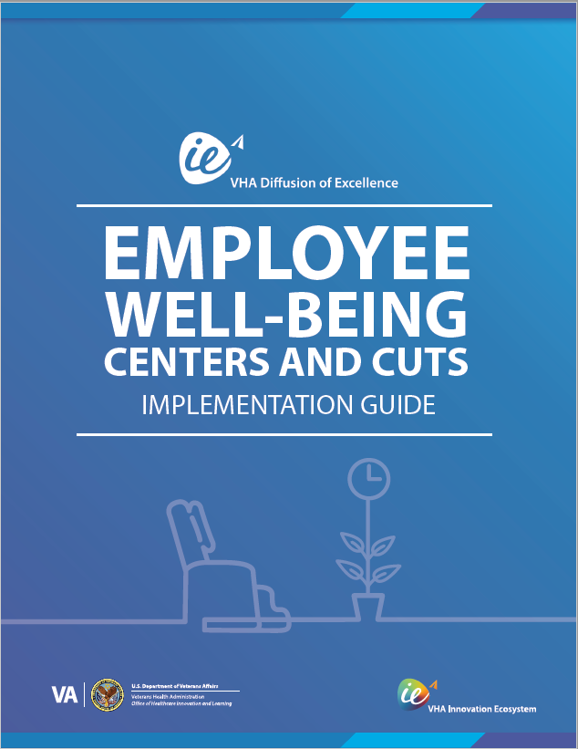
IMPLEMENTATION GUIDE
CARTS

Table of Contents
Chapter 1: Welcome 3
Chapter 2: Organizational Readiness 5
Chapter 3: Implementation Roadmap 6
Chapter 4: Implementation Phases 8
Chapter 5: Resources 16

Chapter 1: Welcome
Welcome! We are delighted that you have picked up our Implementation Guide for Employee Well-Being Centers and Carts. Whether you are looking to learn a little more about this practice, how to implement it, or how to support Veterans, you've come to the right place. This implementation guide is intended for stakeholders whose purpose is to improve employee well-being within their facility and leading implementation at your facility. Some primary stakeholders include Whole Health, Employee Whole Health, Center for Development and Civic Engagement (CDCE), Employee Experience Office, Chief Wellness Officer, etc.
The goals of this implementation guide are to provide:
- Background Information on Employee Well-Being Center and Carts;
- Instructions for how to implement this practice at your facility; and
- Tools for fostering interdisciplinary collaboration within facilities.

What is Employee Well-Being Centers and Carts?
Employers are recognizing that sincere and action-oriented efforts must be made to have a healthy, productive work force and to improve patient outcomes. Employee Well-Being Centers and Carts afford a unique and sustainable way to customize well-being interventions based on employee feedback and space available.
They offer a Whole Health approach to self-care and utilize methods from the Circle of Health. There is a direct link between enhancing employees’ abilities to provide the “best patient centered care” to our Veterans and operating as a High Reliability Organization (HRO). Ultimately, healthy employees lead to elevated patient care outcomes. An innovative environment driven towards HRO is shown to promote idea sharing, collaboration, feedback, and support process improvement. It also allows for there to be leadership support and tools for employees to implement their ideas. It is imperative that innovations can be monitored, evaluated, and measured to ensure achievement of objectives.
Innovations like the Employee Well-Being Centers and Carts are essential to support all employees, Veterans, and organizational excellence.

How Does This Practice Work?
Employee Well-Being Centers are rooms that offer reduced and ambient lighting, massage chairs, aromatherapy diffusers, and other resources to help reduce stress and burnout among staff. The Well-Being Carts offer mobile resources that can be moved around the facility and utilized by employees who would not otherwise be able to access the Centers. It aligns with nationwide Employee Whole Health efforts targeting employee wellbeing, resilience and burnout prevention, and HRO initiatives targeting resilience.

Employee Well-Being Centers and Carts Origin
The COVID-19 Pandemic brought about unprecedented and exacerbated levels of stress and anxiety within the healthcare industry workforce. Employers are looking for ways to address the rapidly increasing rates of burnout and mental health concerns while introducing positive ways to influence employee wellness.
The Employee Well-Being Centers and Carts practice is 1 of 11 Promising Practices to emerge from the eighth VHA Shark Tank Competition, selected from a total of 286 practice submissions.
The World Health Organization defines “three dimensions of burnout as feelings of energy depletion or exhaustion, increased mental distance from your work and reduced professional efficacy.” Ultimately this can affect the quality and safety of patient care.
The Employee Well-Being Centers and Carts were initially created to provide a level of support to members redeployed as part of COVID-19 efforts in Orlando with a goal to promote employee self-care techniques, mitigate stress, and build resiliency.

Chapter 2: Organizational Readiness
An Organizational Readiness Assessment can be employed to ensure maximum success in implementing Employee Well-Being Centers and Carts. This assessment takes stock of your site’s existing processes, which is a key step in preparing for the assimilation of a new intervention into your facility’s culture and work systems. One way of approaching this is through the Consolidated Framework for Implementation Research (CFIR), which is an implementation science model that offers several considerations to prepare your organization for a successful implementation. While any number of the CFIR considerations may be useful, we recommend focusing on evaluating your facility’s barriers and facilitators, and developing a plan to proceed by following these seven considerations:
- Seven considerations when evaluating barriers and facilitators
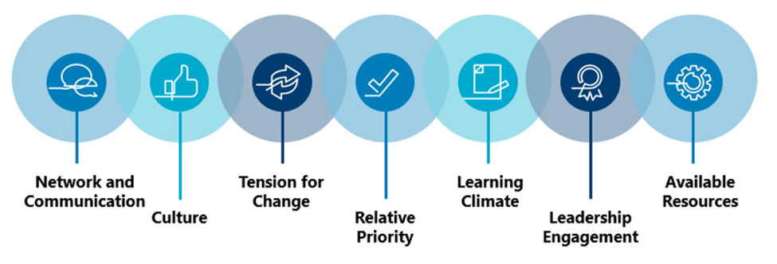
Refer to the attachments section for an embedded worksheet to assist your team in conducting this assessment. This exercise could shed valuable light on the existing work systems within your facility by identifying and planning for potential barriers, as well as understanding ways to leverage facilitators. Each consideration will allow you and your team to increase the likelihood of a successful implementation!

Chapter 3: Implementation Roadmap
Typically, it can take around six months to implement Employee Well-Being Centers and Carts once things are underway. In our experience, the main cause of delays is working with Logistics and various stakeholders to secure space and order the equipment necessary. Ensuring your funding sources ahead of time will make the process go much more smoothly, however.
Figure 2 provides a high-level roadmap for implementation.
- Implementation Overview for Employee Well-Being Centers and Carts
Phase One: Design Phase  (Months 0 - 2) | Step Zero: Ensure Facility Leadership Support and Secure Funds
 | Step One: Identify Process Owner, Stakeholders and Service Line Champions
 | Step Two: Set Project Scope and Charter
 | Step Three: Engage All Relevant Stakeholders
Phase Two: Planning Phase  (Months 2-5) | Step Four: Determine Administrative Needs
 | Step Five: Determine Practice Logistics
 | Step Six: Order Supplies
 | Step Seven: Receive Supplies/Establish Equipment Inventory List
 | Step Eight: Gather and Store Supplies and Materials
 | Step Nine: Recruit Volunteers
 | Step Ten: Assemble and Stock Carts and Rooms
 | Step Eleven: Train Volunteers and Staff
 | Step Twelve: Establish Plan to Deploy Carts
 | Step Thirteen: Develop a Plan for Metrics
Phase Three: Implementation Phase  (Months 6-7) | Step Fourteen: Practice Soft Launch
 | Step Fifteen: Go Live
 | Step Sixteen: Gather Feedback
 | Step Seventeen: Incorporate Feedback
Phase Four: Post-Implementation Phase  (Months 6-9) | Step Eighteen: Collect and Interpret Data/Continue Incorporating Feedback
 | Step Nineteen: Share Success and Celebrate!

Chapter 4: Implementation Phases

Phase One: Design Phase

Step Zero: Request and Ensure Facility Leadership Approval and Support
If possible, meet with facility leadership first to guarantee, to the best of your ability, that you have their support and approval. This can and should include identifying a funding source for the practice and requesting/securing those funds. Due to varying budget structures, this may need to be accomplished in the prior fiscal year.

Step One: Identify Process Owner, Stakeholders, and Champions (Service Line)
Identify the practice champion as the person(s) who will continue and maintain the practice once it has been fully implemented. In the case of the VA Sierra Nevada Health Care System, the practice champion is the Employee Whole Health Coordinator.

Step Two: Set Project Scope and Charter
This step is not required, but many facilities have found that creating a project charter helps to guide the implementation of the practice. This step is especially helpful if you are experiencing any barriers or pushback from leadership or other important stakeholders.
As with many practices that continue their growth through the Diffusion of Excellence, Employee Well-Being Centers and Carts can be modified to fit the needs of your medical center. Certain aspects of the practice are flexible and thus your team should discuss with the Interdisciplinary Team and then document them in the Project Charter. For example, the following bullets highlight some of the flexible components of the practice:
- If your facility wants to encourage supervisors to use the rooms or carts to celebrate team accomplishments, like top scores on the AES, or special recognition weeks such as National Nurses Week or Whole Health Week, they can be scheduled to acknowledge and build team morale.
- If your facility wants to customize the rooms and carts based on feedback from the surveys of those who use the room. There might be requests for additional VR headsets, aromatherapy bead bracelets, tabletop photobiomodulation units or even a change or extension of hours. It’s a great way to let employees know their ideas are being heard and acted on.
- If your facility wants to identify areas or sites where the staff may be unable to go to a room due its location and create the opportunity for those sites to have own resources, either a room, or a cart. Some examples are the Community Living Center staff, Inpatient Mental Health, Nursing Float Pool, Emergency room staff, EMS, or any other service or team that would have difficulty accessing the main Well Being center due to location or schedule.
- Another way the rooms or carts can be used is to provide Whole Health offerings and classes inside the rooms, rotate special resources during the year that are tied to holidays, special events, or introduce new equipment and tools for self-care.
The Project Charter will serve as a guide for implementing this practice and will include:
- General project description
- Scope of implementing this practice (e.g., which units to involve)
- Problem/opportunity statement to be addressed by implementing the practice
- Facility goals for implementation
- Facility timeline for implementation
- Resources your facility will need to obtain
- Team members and leadership who will support implementation (see Step 1), and their respective time commitments

Step Three: Engage all Relevant Stakeholders
Implementation of this practice requires actions from Employee Whole Health, Logistics, Facilities Management Service, and CDCE. Refer to the following table for a list of the commonly involved stakeholder groups. When you initially engage these groups for implementation at your site, consider how you can best communicate with them to get the response you need.
Table 1. Implementation Overview for Employee Well-Being Centers and Carts
Stakeholder Group  (From whom do I need help?) | Dependencies  (What do I need from them?)
Employee Whole Health | Ownership
Logistics | Purchase supplies and items
Facility Manage Service | Upgrades/repairs to rooms
Planning | Space for storage/rooms
Fiscal | Funding
Infection Prevention | Guidance/Consultation
Center for Development and Civic Engagement | Room staffing

Remember: Your facility might have additional stakeholders that you need to engage, so be sure to tailor this list to fit your facility needs!
Once you’ve determined the stakeholder groups and individuals to engage, you may want to host a meeting with your team members to present the Project Charter and provide background on the Practice and what the implementation process will look like.
After meeting with team members and working with them to refine the Project Charter, meet with your facility’s leadership and present the final Project Charter to obtain their buy-in and approval. Leadership may also be able to provide information and support around addressing potential challenges and obtaining resources. We have provided links to materials to assist you with engaging stakeholders below. Feel free to tailor the materials to be specific to your facility.
Remember: It is important to maintain regular stakeholder engagement during this phase, so we recommend monthly updates to less-involved stakeholders. During your first meeting with them, ask them how they would like to stay engaged in this process (email, in-person, etc.).

Phase Two: Planning Phase

Step Four: Determine Administrative Needs

Sit down, ideally with at least some of your stakeholders, and make a list of what you need to discuss and plan. This is not the time to start making decisions, just to plan for everything that your team needs to accomplish. This can include, but is not limited to the following:
- Standard Operating Procedures (SOPs)
- Position Descriptions (PDs)
- Material Safety Data Sheet (MSDS)
- Room/cart reservation process
- Room management
- Storage space for pre-positioning supplies and carts
- Union approval
- Procurement approval
- Communications/PR plan

Step Five: Determine Practice Logistics

In the previous step, you made a list of all required decisions and planning. In this step, it is time to sort out the details of those items. Building on what was on your list, this can include deciding exactly which supplies to order, where the space will be, etc.

Step Seven: Order Supplies and Materials

Once you have a list of what supplies and materials your site requires for the rooms and carts, work with Logistics to place the orders.

Important Items to Consider:
- Not all purchases will need to be done through Logistics. It depends where the funds are coming from and if that service/program has their own purchase card holder. If they do, work closely with them to complete your requests.
- If working with Logistics, meet to be sure you understand what their process is for purchase requests. This process may be different site to site. Many sites have requests entered via LEAF, Sharepoint, or Vista as a 2237. If possible, request the same purchaser be assigned to all the purchases you need completed for continuity.
- Any purchases greater than $10,000 will need to go to contracting. Before using just one vendor, ensure you search around for best pricing and do multiple requests if needed to be able to acquire all items. Do not try to do “split purchases” to get away from the contracting threshold.

Step Eight: Receive Supplies/Establish EIL
Once you have received the supplies, you need to determine if they need to go on an Equipment Inventory List (EIL). The EIL is a database for used to manage items that are valued over $300 or considered sensitive (e.g.: high risk of theft). The facility Logistics Equipment Team owns this process. Each service ward has a designated EIL number, custodial officer and designee who manage this inventory. Below are some helpful questions and resources for working with EILs.
Does it need to go on an EIL? Yes, if:
- If it is >$300 or sensitive
- Considered non-expendable with a life cycle of over 2 years
- It is not considered a medical supply
- It is a desirable item that can easily be taken
Lessons Learned:
- Medical equipment needs cleared by Biomed prior to Logistics
- Place EIL tag on location that is visible and accessible
- Place an EIL tag on the equipment
- If an EIL tag is placed on the box, do not dispose of the box without ensuring the equipment is tagged
If an EIL needs set up:
- Contact your Logistics Equipment Team
- Identify your Custodial Officer and Designee
- Identify annual trainings to complete (FLG 017)

Step Nine: Gather and Store Supplies and Materials

It is safe to assume that not all the supplies and materials for the rooms and carts will arrive at the same time, let alone within your planned timeline. As they come in, create a centralized storage place to put them while you are waiting to assemble and stock the rooms and carts. If possible, organize the items by whether they will be going in a room or a cart to make things simpler.

Step Ten: Assemble and Stock Carts and Rooms

Once the items have been delivered and the rooms and carts are ready, begin the assembly process. Try out different configurations to see what looks and works best.

Step Eleven: Establish Plan to Deploy Carts

One of the main perks of the carts is that they are mobile and can reach employee populations that might not be able to access the rooms. This also means that there must be a plan in place in order to deploy them in an orderly manner. Details to consider are where the carts are going to go, how they are going to get there, how long they are going to be there for, who is going to move them there, and who is going to maintain them while they’re there.

Step Twelve: Develop a Collection Plan for Monitoring Feedback Metrics
Potential Monitoring and Feedback Metrics
Implementation can be assessed through both process measures and outcome measures. We recommend using process measures to assess how the implementation is going for your team. We also recommend the use of outcome measures to assess the success of the program from the Employee perspective.
Ideas for process measures:
- 70% of open room slots utilized over three months
- Carts used 60% of scheduled workdays over three months
- Items utilized/rate of reorder for supplies over each quarter
- Employee Whole Health Wellbeing LEAF system- use for monthly reporting of usage, can be used to run reports of trends over time
Ideas for outcome measures:
- Our team recommends using the Employee Whole Health Evaluation Toolkit (see attachments) to obtain outcome measures related to employee wellbeing. This maintains consistency with other Employee Whole Health offerings at your site and throughout the nation.
- All Employee Survey Results by workgroup/location when implementing a location specific cart or center yearly
- MS Forms for user qualitative feedback using a standard template to all users monthly

Phase Three: Implementation Phase

Step Fourteen: Practice Soft Launch

Before officially launching the Employee Well-Being Centers and Carts, running a pilot is recommended. Invite a small group of people to use the rooms and/or carts. Make sure that everything is properly set up and stocked. Volunteers or staff who will be working the rooms and carts must understand their roles and procedures.

Step Fifteen: Go Live!
It is finally time to make this practice live! A small celebration is not necessary to officially kick off the opening of the rooms and carts but it can be a fun way to engage with people and introduce them to the resources now at their disposal.

Step Sixteen: Gather Feedback

After the room(s) and/or cart(s) are live and in active use, gather feedback from your stakeholders. This should not only include the people using the rooms and carts but also the staff or volunteers who are overseeing them and facility leadership. It could be helpful to hear how people find the reservation process, if the rooms and carts are stocked with the appropriate items, if they are being maintained well, etc.

Step Seventeen: Incorporate Feedback/Make Adjustments

As an Employee-facing solution, it is important that the voice of the customer is present. Employees should be given opportunities to provide their feedback and any changes made as a result of that feedback should be communicated back to the customer. Do your best to make any adjustments to the process that aid in efficiency or user experience and are within reason. The implementation of this practice is an iterative process and will continue to develop and change as time goes on and people’s needs change.

Phase Four: Post-Implementation Phase

Step Eighteen: Collect and Interpret Data/Continue Incorporating Feedback
Employee wellbeing is a unique area of intervention. Much of your data will be qualitative and we recommend you present it in a word cloud or narrative fashion—employees will have a meaningful connection with the employee well-being centers and carts and it is important for stakeholders and leadership to connect with the impact your project has made on the facility.
The use of a Microsoft Forms for feedback allows your team to incorporate general questions about the room (the users’ likes, dislikes, scheduling needs/barriers, items preferred, etc.) in a quantitative way so that it can be collected and presented in a concise manner. It also allows for integration of the Employee Whole Health Evaluation Toolkit AES Whole Health Module Measure so that you can compare your users to the whole population within facilities.
If your facility has not incorporated Employee Whole Health into your AES Survey yet, choose a measure that focuses on the areas you hope to target with this project at your site. Perhaps choosing the AES Whole Health Module Measure, Perceived Wellness Culture and Environment Support Scale, Quality of Life, or a provided Stress or Resilience scale would make the most sense.
The use of any of these measures will allow your team to present a diverse representation of the those people within the system that are seeking wellness offerings and will support future wellbeing initiatives by showing current gaps and successes.

Step Nineteen: Share Success with Stakeholders and Celebrate!
Be sure to share your success with leadership and other stakeholders to gain their continued support.
The celebration is of course an optional step, but after successfully implementing Employee Well-Being Centers and Carts at your facility, you and your team deserve some recognition and celebration! Regardless of the format you choose, it is important to celebrate the hard work put forth and the outcomes accomplished, because this practice directly enhances the experience of the Veterans that visit your facility.

Chapter 5: Resources

Questions?
Do you have questions or need advice about implementing Employee Well-Being Centers and Carts at your facility?
Check out the Employee Well-Being Centers and Carts Diffusion Marketplace page and our SharePoint site!
- Marketplace: Link
Or contact:
- VHAORLBeWell@va.gov

Acronym Key
Acronym | Definition
SOP | Standard Operating Procedure
PD | Position Description
IEL | Equipment Inventory List
MSDS | Material Safety Data Sheet
EWH | Employee Whole Health
WH | Whole Health
AES | All Employee Survey
WBCs & C | Well-being Centers & Carts
CDCE | Center for Development & Civic Engagement

Attachments
Document | File
Employee Well-Being Centers and Carts One-Pager
Organizational Readiness Survey
Project Charter 1
Project Charter 2
Employee Whole Health Evaluation Toolkit
SOP Template
Core Resources
Feedback Form
Toolkit PowerPoint
Lessons Learned
Marketing Examples
Optional Resources
Bookings Flyer Example
Volunteer Position Description
VA Appropriated Funds Guidance

Acknowledgements
The following individuals were instrumental in developing and replicating the Employee Well-Being Centers and Carts:
- Adelina Sowell, Biloxi VAMC
- Ashley M. Rush, Orlando VA Healthcare System
- Cristina Mercado Acevedo, Orlando VA Healthcare System

