**Billing Resolution Center**

IMPLEMENTATION GUIDE



**Table of Contents**

Chapter 1: Welcome & Overview 3

What is Billing Resolution Center (BRC)? 4

How does this practice work? 4

Billing Resolution Center Origin 5

Acknowledgements 6

Chapter 2: Organizational Readiness 7

Chapter 3: Implementation Roadmap 8

Chapter 4: Implementation Phases 9

Phase One: Design Phase 9

Step 1: Identify Practice Champion and Interdisciplinary Team 9

Step 2: Conduct Current State Analysis 9

Step 3: Set Project Scope and Charter 9

Step 4: Engage all Relevant Stakeholders 11

Phase Two: Planning Phase 13

Step 5: Compile Resources 13

Step 6: Determine Practice Logistics 14

Step 7: Train Staff 14

Step Eight: Develop a Collection Plan for Monitoring Feedback Metrics 15

Phase Three: Implementation Phase 15

Step Nine: Practice Go-Live! 15

Step Ten: Incorporate Lessons Learned 16

Phase Four: Post-Implementation Phase 16

Step Eleven: Collect and Interpret Data 16

Step Twelve: Share Success with Stakeholders and Celebrate! 16

Chapter 5: Resources 17

Questions? 17

Acronym Key 17

SharePoint Resource Links 18

Attachments 18

**Chapter 1: Welcome & Overview**

**Welcome, and thank you for your participation implementing The Billing Resolution Center (BRC) at your facility.** This implementation guide is intended for Community Care, Health System Specialists, Billing Representatives, Veteran Experience team and clinical staff leading implementation at your facility.

The goals of this implementation guide are to provide:

* Background Information on The Billing Resolution Center.
* Instructions for how to implement this Practice at your facility; and
* Resources to grow your Practice.

**What is Billing Resolution Center (BRC)?**

The Billing Resolution Center (BRC) is one central location where Veterans are directed for any referrals to Community Care, and for any billing concerns or issues.

BRC provides face to face customer service to Veterans and vendors to assist with claims and concerns related to billing procedures and policies. This helps to build and maintain trust with Veterans while striving toward excellence in all business operations. Building strong partnerships with care in the community, restoring trust with Veterans so they may be more focused on their health than their bill.

**How does this practice work?**

This multi-faceted approach directs Veterans to one central location to have Community Care scheduled along with any billing concerns and billing education handled. The Community Care Team takes ownership of billing concerns locally (including staffing of Veteran facing position). They are trained on Patient Advocate Training System-Replacement (PATS-R) data, copayments, and administrative outreach. The Community Care Team meets with the third-party administrator (Optum) and the community providers that have the greatest impact on billing concerns for Veterans.

The Billing Resolution team meets monthly to discuss and handle billing issues.

The Community Care Team trains internal providers to go through the referral process and reminds providers to send the Veterans to the BRC to have Community Care scheduled, and authorized.

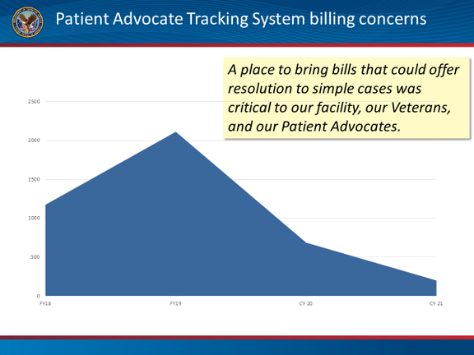

NUMBER OF PATIENTS

YEAR

Figure 1 Patient Advocate Tracking System concerns related to billing

The Consolidated Patient Account (CPAC) team educates Veterans on copayment requirements and repayment arrangements which aids in procedures being followed prior to care in the community leading to fewer billing errors and complaints.

See the flow chart below for process of Billing Resolution Center.

Figure 1. Process map of Billing Resolution Center

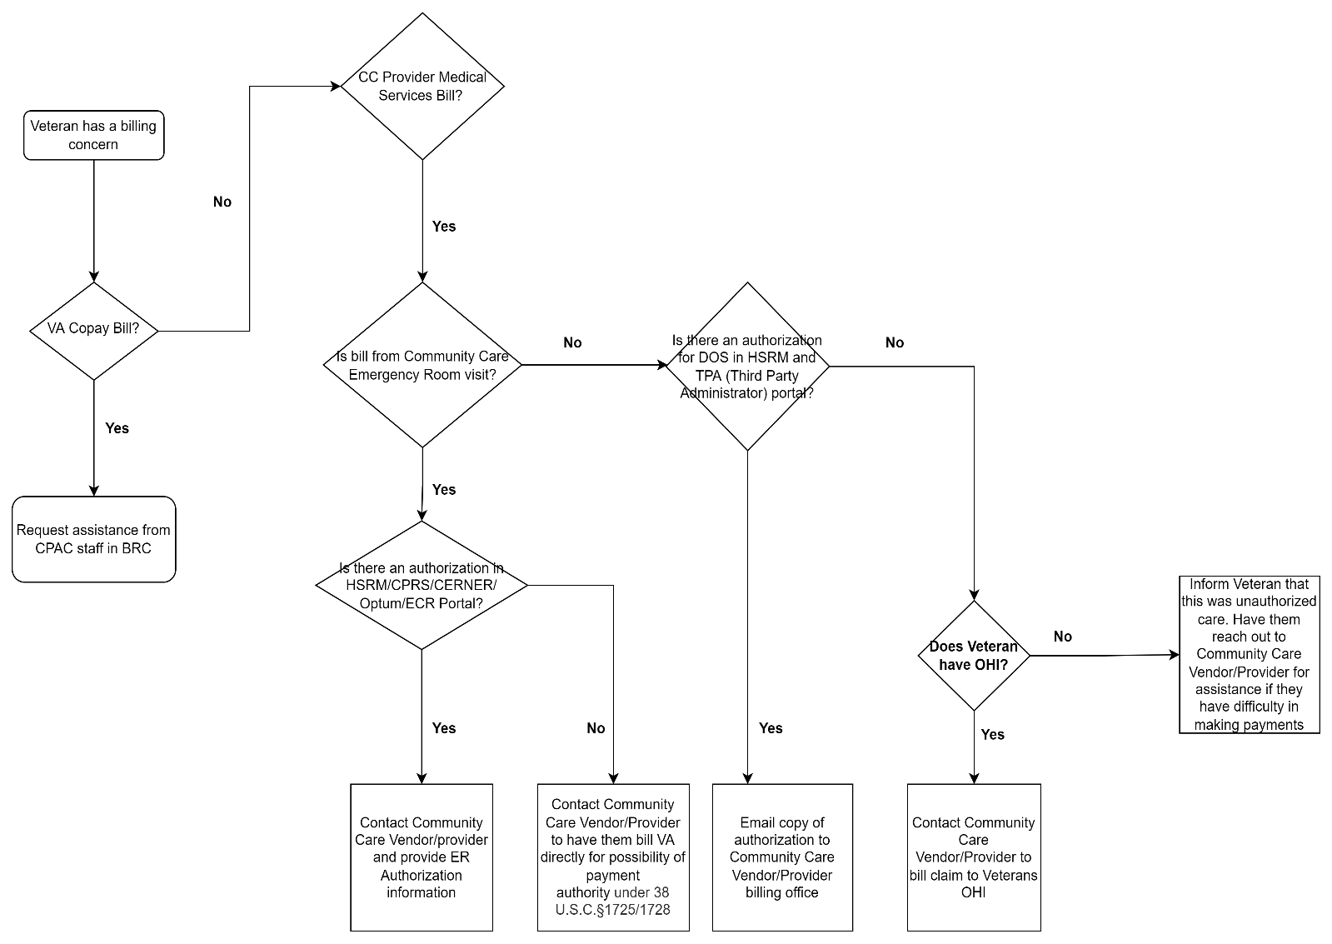

**Billing Resolution Center Origin**

The BRC started in June of 2020 at Chalmers P. Wylie Veterans Outpatient Clinic in Columbus, Ohio. It started when the community care team and Veteran Experience Officer noticed many Veterans complaining about receiving bills from Community Care Providers (vendors).

In July 2020, BRC began to initiate a process to resolve these concerns both prior to the Veteran receiving the bill or collections notice and with vendors. The direct vendor outreach resulted in over $2.5 million dollars in erroneous claims that were resolved for over 300 Veterans to date. Vendor outreach and monthly meetings with the top five local vendors encourage the use of Health Share Referral Management (HSRM). This has allowed vendors to obtain authorizations and other information, on their own accord, to resolve these concerns without further intervention from staff. The CPAC staff focused on educating Veterans and internal providers on VA copayment requirements along with how to communicate with billing representatives for repayment options. These steps have led to more satisfied Veterans and staff at Chalmers P. Wylie Veterans Outpatient Clinic.

In 2021, the team submitted the BRC to the seventh **Veterans Health Administration (VHA) Shark Tank Competition**, a Diffusion of Excellence initiative for sourcing clinical and operational Promising Practices that originate at VA facilities. After several rounds of rigorous evaluation from subject matter experts (SMEs) and program office representatives, the BRC practice was pitched in the seventh VHA Shark Tank Competition and designated as a Promising Practice after its selection to be replicated at Central Alabama Veterans Health Care System.



The Billing Resolution Center practice is **1 of 10** Promising Practices to emerge from the seventh VHA Shark Tank Competition, selected from a **total of 323** practices. submissions.

**Acknowledgements**

The following individuals were instrumental in developing and replicating the Billing Resolution Center:

* Cynthia Mullins, Chalmers P. Wylie Ambulatory Care Center (Former CPAC FRM)
* Dustin Doebert, Chalmers P. Wylie Ambulatory Care Center
* James Lee, Chalmers P. Wylie Ambulatory Care Center
* Chief, Community Care, Chalmers P. Wylie Ambulatory Care Center

**Chapter 2: Organizational Readiness**

An Organizational Readiness Assessment can by employed to ensure maximum success in implementing a Billing Resolution Center. This assessment takes stock of your site’s existing processes, which is a key step in preparing for the assimilation of a new intervention into your facility’s culture and work systems. One way of approaching this is through the [Consolidated Framework for Implementation Research (CFIR)](https://cfirguide.org/), which is an implementation science model that offers several considerations to prepare your organization for a successful implementation. While any number of the CFIR considerations may be useful, we recommend focusing on evaluating your facility’s barriers and facilitators, and developing a plan to proceed by following these seven considerations:

Figure 2. Seven considerations when evaluating barriers and facilitators

Refer to Table 4 in the Attachments section or an embedded worksheet to assist your team in conducting this assessment. This exercise could shed valuable light on the existing work systems within your facility by identifying and planning for potential barriers, as well as understanding ways to leverage facilitators. Each consideration will allow you and your team to increase the likelihood of a successful implementation!

**Chapter 3: Implementation Roadmap**

With dedicated champions and stakeholder support your facility can implement the Billing Resolution Center Practice in six to nine months. Establish your current state based on the metrics you want to monitor and understand your starting point so that you can share your success.

Figure 3 below provides a high-level roadmap for implementation.

Figure 3. High-level Roadmap for Implementation of Billing Resolution Center

**Chapter 4: Implementation Phases**

**Phase One: Design Phase**

**Step 1: Identify Practice Champion and Interdisciplinary Team**

Form an interdisciplinary team of key facility members include a Community Care Champion and CPAC Champion. This team will be instrumental in progressing though the phases of implementing BRC.

**Step 2: Conduct Current State Analysis**

Determine a current state analysis of top vendors with outstanding bills or largest dollar amount, number of referrals, and determine tracking system for Veteran complaints. Determine vendors that have access to HSRM and which vendors you have access to their Electronic Medical Record (EMR).

Identify Top Community Care Providers through WellHive ([Sign In Now](https://login.wellhive.com/sso/saml2/0oam3pb0BiCd7xvJm4h5)) or the Office of Community Care (OCC) [Integrated Informatics and Analytics Page](https://app.powerbigov.us/groups/me/apps/232df60c-2a29-461d-95cc-6265e4395f0e/reports/58f18caf-1b24-4634-962a-df00f0001769/ReportSection?ctid=e95f1b23-abaf-45ee-821d-b7ab251ab3bf) or the[Integrated Care Workspace (ICW) Page](https://va.palantirgov.com/workspace/carbon/ri.carbon.main.workspace.8d530b55-17bb-4f0d-8ed1-e203ed583753/home). Please note you will need permission to access these sites.

To understand the third-party process, and outstanding medical bills current state gain access to the Optum Portal ([vacommunitycare.com](https://www.vacommunitycare.com/)), HSRM, and/or the Computerized Patient Record System (CPRS) (or Cerner).

**Step 3: Set Project Scope and Charter**

This step is not required, but many facilities have found that creating a project charter helps to guide the implementation of the practice. It is especially helpful if you are experiencing any barriers or pushback from leadership or other important stakeholders.

As with many Promising Practices identified through Diffusion of Excellence, Billing Resolution Center can be modified to fit the needs of your medical center. Project Charter Templates can be found in Table 4 under Chapter 5: Resources. Certain aspects of the practice are flexible and should be discussed with the Interdisciplinary Team and then documented in the Project Charter. For example, the following bullets highlight some of the flexible components of the practice:

* If your facility wants to have staff in more than one space, then educate staff and Veterans of each location. Optimal would be all Billing Resolution Center staff in one central location.
* If your facility wants to host Veteran Town Halls for billing education, then offer this as an option.
* If your facility wants to host a Vendor Town Hall to educate and sign up for HSRM, then offer this as an option.

The **Project Charter** will serve as a guide for implementing this practice and will include:

* General project description
* Scope of implementing this practice (e.g., which units to involve)
* Problem/opportunity statement to be addressed by implementing the practice
* Facility goals for implementation
* Facility timeline for implementation
* Resources your facility will need to obtain
* Team members and leadership who will support implementation (see **Step 1**), and their respective time commitments

**Step 4: Engage all Relevant Stakeholders**

Implementation of this practice requires actions from CPAC, Community Care, Patient Advocate, Social Work, Veteran Experience Office. Refer to the following table (Table 1) for a list of the commonly involved stakeholder groups. When you initially engage these groups for implementation at your site, consider how you can best communicate with them to get the response you need.

Once the top five external Community Care providers are identified (from Step 2 above) through WellHive, establish meetings with both these top providers and Optum (third-party insurance payer) to review claims and/or authorizations.

Table 1. Implementation Overview for Billing Resolution Center

|  |  |
| --- | --- |
| Stakeholder Group  (From whom do I need help?) | Dependencies  (What do I need from them?) |
| Top External Community Care Providers (Vendors) | Medical record access |
| Optum (third-party payer) handling VA claims | Access to their system |
| Office of Community Care | Resources: 1-2 billing specialist and front desk staff (if applicable) |
| Veteran Experience Office (VEO) | Assistance with VSignal surveys and Veteran satisfaction |
| Patient Advocate | Assist with difficult/upset Veterans |
| Social Work | Assist with Veteran referrals to BRC and assistance with discharged Veterans |
| Consolidated Patient Account (CPAC) | Assist Veterans with VA Copays and bills for care received at VA |
| Executive Leadership Team (ELT) | Space for BRC and resources |

**Remember:** Your facility might have additional stakeholders that you need to engage, so be sure to tailor this list to fit your facility needs!

Once you determine the stakeholder groups and individuals to engage, you may want to host a meeting with your team members to present the Project Charter and provide background on the Practice and what the implementation process will look like.

After meeting with team members and working with them to refine the Project Charter, meet with your facility’s leadership and present the final Project Charter to obtain their buy-in and approval. Leadership may also be able to provide information and support around addressing potential challenges and obtaining resources. Links to materials to assist you with engaging stakeholders are included in the Resources section of this guide. Feel free to tailor the materials to be specific to your facility.

**Remember:** It is important to maintain regular stakeholder engagement during this phase, so we recommend monthly updates to less-involved stakeholders. During your first meeting with them, ask them how they would like to stay engaged in this process (email, in-person, etc.).

**Phase Two: Planning Phase**

**Step 5: Compile Resources**

**Create an Educational Brochure: Urgent Care vs. Emergency Care**

One of the common issues that has been identified related to billing issues is [understanding the difference between Urgent Care and Emergency Care](https://www.va.gov/resources/choosing-between-urgent-and-emergency-care/). To address this, it is important for administrative staff to understand the difference between these two so when they are entering information into the system it doesn’t impact billing issues later in the process. Statistically, most bills that are brought in from Veterans are emergency room (ER) bills.

Chalmers P. Wylie Veterans Outpatient Clinic (Columbus, Ohio) created an educational brochure to educate both Veterans and community care provider administrative staff to understand the difference between Urgent Care and Emergency Care.

**Get Access to Community Care Customer Relationship Management (CommCare CRM)**

If you don’t have access to CommCare CRM refer to the Resources in Table 4 section for “User Access Request Instructions. More information on the CommCare CRM can be found on their [SharePoint](https://dvagov.sharepoint.com/sites/VHAOCC/BOA/PPS/CX) (VA internal link). The CommCare CRM is used to record Veteran interactions.

**Include Question(s) on VSignals Survey**

Work with local Veteran Experience Office (VEO) to add billing concerns to survey questions on the Veteran Signals (VSignals) survey.

**Create Email Distribution List**

Create an e-mail distribution group and address (for example: Columbus CBOC created [VHACOSBillingResolution@va.gov](mailto:VHACOSBillingResolution@va.gov) to share with Veterans, Internal VA Employees, Community Care Providers) for one central location to communicate with stakeholders and Veterans.

**Step 6: Determine Practice Logistics**

Talk with space/planning committee and executive leadership team to find a space that will house up to eight people. Ideally, all Billing Resolution Center team members should reside in the same space for ultimate success.

By this step, access to all dashboards, surveys, and vendor Electronic Health Record Management (EHRM) should be established.

It is recommended to establish a regular meeting cadence with this team. Chalmers P. Wylie Veterans Outpatient Clinic (Columbus, Ohio) started meeting every two weeks early in implementation process and then eventually moved to meeting monthly to discuss and handle billing issues.

**Step 7: Train Staff**

All Billing Resolution Center staff need to be trained on current billing procedures, copayments, Electronic Health Record Management (EHRM), CPRS/CERNER, dashboards, HSRM, and reports needed to determine vendors, referrals.

Vendors should be trained on current VA billing procedures, where to find authorizations in HSRM. Work with vendors to place Veteran education brochures in Urgent Care and ERs to remind Veterans of proper procedures.

Community Care Representative and CPAC will need training on how to access and use these programs. This will establish where your referrals are going, what is outstanding, and Veteran satisfaction.

As noted in Step 5, staff need to be educated on the difference between Urgent Care and Emergency care so they can educate Veterans. Then, Veterans can be educated on copayment and billing requirements (i.e., townhalls and brochures).

**Step Eight: Develop a Collection Plan for Monitoring Feedback Metrics**

Take current state analysis (number of referrals, outstanding bills, complaints from Veterans, and erroneous bills) and in six months do another analysis to determine your metrics.

**Potential Monitoring and Feedback Metrics**

Implementation can be assessed through both process measures and outcome measures. We recommend using **process measures** to assess how the implementation is going for your team. We also recommend the use of **outcome measures** to assess the success of the program from the Veteran perspective.

Ideas for **process measures:**

* Number of Veteran complaints and dollar amount of the bill (may utilize Patient Advocate Tracking System or congressional concerns)
* Number of vendors using HSRM to obtain authorization

Ideas for **outcome measures:**

* Veteran satisfaction
* Staff satisfaction
* Amount of Veteran bill(s) resolved through Billing Resolution Center

**Phase Three: Implementation Phase**

**Step Nine: Practice Go-Live!**

Now that you have completed the pre-implementation portion of the BRC, you have a roadmap to educate and handle Veterans with their billing concerns and record them to show your progress. While meetings have been happening between the Interdisciplinary team, Optum (third-party payer), and Community Care providers/vendors to work through the bills to be paid or corrected, you can monitor reports from WellHive and VSignals to analyze data so that your team may be more proactive than reactive to complaints from Veterans.

**Step Ten: Incorporate Lessons Learned**

Consider working with Community Care staff regarding problems resulting in bills and improve processes based on this feedback.

As with any implementation process the BRC is an iterative process. BRC was started by building trust with vendors and Optum (third-party insurance payor). By meeting as a group and addressing concerns in those meetings, it was realized they could add internal clinical education to BRC by building trust with internal providers. As they learned more, they added more to address the core issue of Veterans receiving erroneous bills.

**Remember**: Incorporate your lessons learned as you monitor your outcomes.

**Phase Four: Post-Implementation Phase**

**Step Eleven: Collect and Interpret Data**

Determine your outcomes (Step 8) and the timeframe you want to monitor. Document and continue to share outcome measures using the resources and links provided.

**Step Twelve: Share Success with Stakeholders and Celebrate!**

Be sure to share your success with leadership and other stakeholders to gain their continued support.

The celebration is an optional step, but after successfully implementing the Billing Resolution Center at your facility, you and your team deserve recognition and celebration! Regardless of the format you choose, it is important to celebrate the hard work put forth and the outcomes accomplished, because this practice directly enhances the experience of the Veterans that visit your facility.

**Chapter 5: Resources**

**Questions?**

Do you have questions or need advice about implementing Billing Resolution Center at your facility?

Check out the Billing Resolution Center’s Diffusion Marketplace page!

* Marketplace: [Marketplace.va.gov/innovations/billing-resolution-center](https://marketplace.va.gov/innovations/billing-resolution-center)

Or contact:

* James Lee, [James.Lee@va.gov](mailto:James.Lee@va.gov)
* Dustin Doebert, [Dustin.Doebert@va.gov](mailto:Dustin.Doebert@va.gov)

**Acronym Key**

Table 2. Acronyms and definitions

|  |  |
| --- | --- |
| Acronym | Definition |
| BRC | Billing Resolution Center |
| PATS-R | Patient Advocate Training System-Replacement |
| CPAC | Consolidated Patient Account |
| OCC | Office of Community Care |
| CPRS | Computerized Patient Record System |
| VSignals | Veteran Signals: Real Time feedback tool |
| EHRM | Electronic Health Record Management |
| HSRM | Health Share Referral Management |
| EMR | Electronic Medical Record |
| CommCare CRM | Community Care Customer Relationship ManagementCustomer Relationship Management |

**SharePoint Resource Links**

Table 3. Links to SharePoint Resources

|  |  |
| --- | --- |
| Resource | Link |
| OCC Integrated in Informatics and Analytics | [OCC Integrated in Informatics and Analytics](https://app.powerbigov.us/groups/me/apps/232df60c-2a29-461d-95cc-6265e4395f0e/reports/58f18caf-1b24-4634-962a-df00f0001769/ReportSection?ctid=e95f1b23-abaf-45ee-821d-b7ab251ab3bf) (VA) |
| Integrated Care Workspace | [Integrated Care Workspace (ICW](https://va.palantirgov.com/workspace/carbon/ri.carbon.main.workspace.8d530b55-17bb-4f0d-8ed1-e203ed583753/home)) |
| Optum Portal | [www.vacommunitycare.com](http://www.vacommunitycare.com) |
| Urgent Care vs. ER | [VA Resource: Choosing between urgent and emergency care](https://www.va.gov/resources/choosing-between-urgent-and-emergency-care/) |
| CRM | [CRM](https://dvagov-commcare.crm9.dynamics.com/main.aspx?appid=2cf7d5c7-d7aa-4a50-9e4b-f91481908e2e) |
| VHAOCC SharePoint | [SharePoint](https://dvagov.sharepoint.com/sites/VHAOCC/BOA/PPS/CX) |

**Attachments**

Table 4. Documents attached

| Document | File |
| --- | --- |
| Organizational Readiness |  |
| Project Charter (option 1) |  |
| Project Charter (option 2) |  |
| CommCare CRM User Access Request Instructions |  |