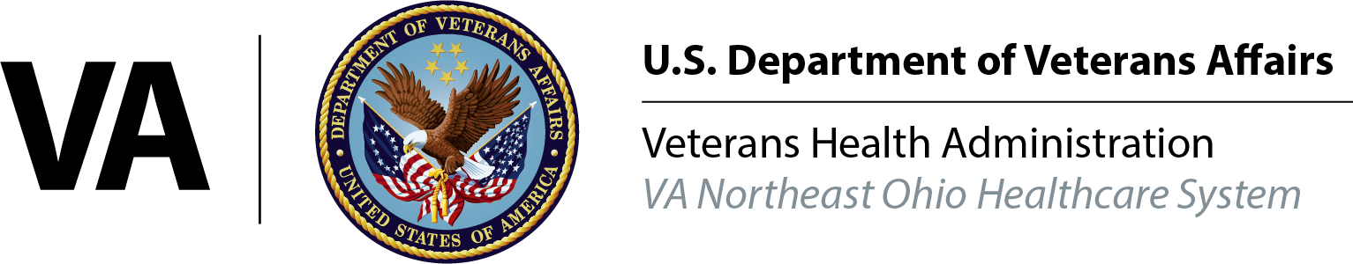
Camp Lejeune
Water Contamination
Veterans must have served at Camp Lejeune for at least 30 days between August 1, 1953,
and December 31, 1987, and later developed one of the following eight conditions:

- Adult leukemia
- Aplastic anemia and other myelodysplastic syndromes
- Bladder cancer
- Kidney cancer
- Liver cancer
- Multiple myeloma
- Non-Hodgkin’s lymphoma
- Parkinson’s disease
Contact: Will Berry, Outreach Coordinator EnrollVANEO@va.gov I 216-707-7914

