**Mini-Cog Screening Tool**

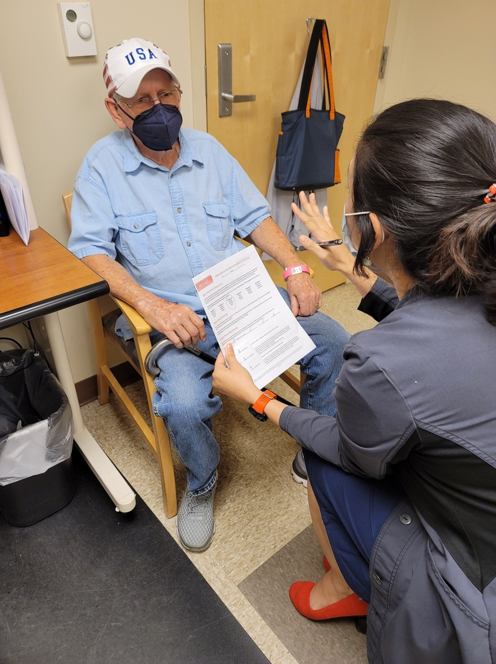IMPLEMENTATION GUIDE

Early Identification of Patients with Cognitive Impairment

**Table of Contents**

Chapter 1: Welcome & Overview 2

Mini-Cog Screening Tool Origin 4

What is Mini-Cog Screening Tool: Early Identification of Patients with Cognitive Impairment? 4

Guide to Scoring Mini-Cog Screening Tool 5

Acknowledgements 5

Chapter 2: Organizational Readiness 6

Chapter 3: Implementation Roadmap 7

Chapter 4: Implementation Phases 8

Phase One: Design Phase 8

Step One: Plan and Design 8

Step Two: Set Project Scope and Charter 9

Step Three: Engage all Relevant Stakeholders 10

Phase Two: Planning Phase 12

Step Four: Compile Resources 12

Step Five: Determine Practice Logistics 13

Step Six: Train Staff 14

Step Seven: Gather Supplies and Materials 14

Step Eight: Develop a Collection Plan for Monitoring Feedback Metrics 14

Phase Three: Implementation Phase 15

Step Nine: Practice Go-Live! 15

Step Ten: Incorporate Lessons Learned 15

Phase Four: Post-Implementation Phase 15

Step Eleven: Collect and Interpret Data 15

Step Twelve: Share Success with Stakeholders and Celebrate! 16

Chapter 5: Resources 17

Questions? 17

Acronym Key 17

Other Helpful Links 17

Attachments 18

**Chapter 1: Welcome & Overview**

**Welcome, and thank you for your participation implementing the Mini-Cog Screening Tool: Early Identification of Patients with Cognitive Impairment at your facility.** This implementation guide is intended for Nursing Staff leading implementation at your facility.

The goals of this implementation guide are to provide:

* **Background Information** on the Mini-Cog Screening Tool.
* 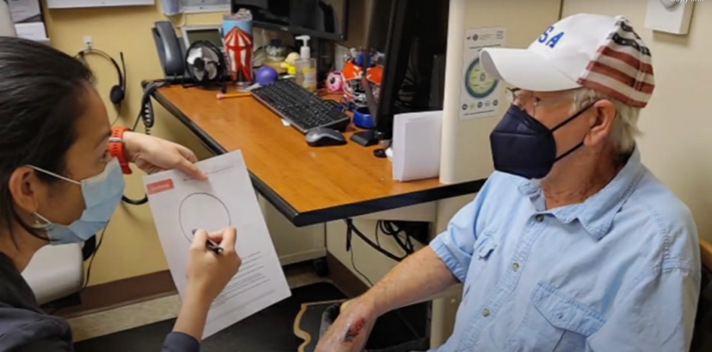**Instructions** for how to implement this practice at your facility; and
* **Resources**including commonly used acronyms, helpful links, and embedded documents.

**Mini-Cog Screening Tool Origin**

The Mini-Cog Screening Tool used in primary care clinics, was developed from the discussion of three registered nurses at The Villages VA Clinic in The Villages, FL. They observed patients with apparent cognitive decline had no follow-up or intervention. They researched the three-minute screening tool called Mini-Cog that results in Veterans and families getting the proper referral resources and help needed.

In 2021, these nurses submitted the Mini-Cog Screening Tool to the seventh **Veterans Health Administration (VHA) Shark Tank Competition**, a Diffusion of Excellence Initiative for sourcing clinical and operational Promising Practices that originate at VA facilities. After several rounds of rigorous evaluation from subject matter experts (SMEs) and program office representatives, the Mini-Cog Screening Tool practice was pitched in the seventh VHA Shark Tank Competition and designated as a Promising Practice after its selection to be replicated at the Iowa City VA Medical Center.



The Mini-Cog Screening Tool practice is **1 of 10** Promising Practices to emerge from the seventh VHA Shark Tank Competition, selected from a **total of 323** practice submissions.

**What is Mini-Cog Screening Tool: Early Identification of Patients with Cognitive Impairment?**

The Mini-Cog Screening Tool (MCST) is a three-minute instrument that can increase the detection of cognitive impairment in older patients. It can be used effectively after a brief training in both healthcare and community settings. It consists of two components:

1. a three-item recall that tests for memory
2. a scored clock drawing test

The goal of screening for cognitive impairment in primary care is to find patients whose cognitive deficits have gone unnoticed or unrecorded in routine clinical encounters. Symptoms may be severe enough to interfere with the patient’s self-care and medical management.  
  
Implementation of the Mini-Cog Screening Tool provides an easy and consistent process for early recognition of cognitive impairment. This results in appropriate referrals to provide early diagnosis, differential, and treatment. Early treatment can provide improved patient outcomes by slowing or delaying disease progression, which has been shown to improve quality of life for both the patient and their family, while allowing additional time for important decision making and planning.

**Guide to Scoring Mini-Cog Screening Tool**

Add the 3-item recall and clock drawing scores together. A total score of 3, 4, or 5 indicates lower likelihood of dementia but does not rule out some degree of cognitive impairment. The Mini-Cog© is not a diagnostic test for Alzheimer’s disease or any other dementia or cause of cognitive impairment. Diagnosis of brain disorders that cause cognitive impairment require a medical examination and additional examination.

**Acknowledgements**

The following individuals were instrumental in developing and replicating the Mini-Cog Screening Tool:

* Jocelyn Almazan, The Villages, FL
* Jessi Steege, Iowa City, IA

**Chapter 2: Organizational Readiness**

An Organizational Readiness Assessment can by employed to ensure maximum success in implementing Mini-Cog Screening Tool. This assessment takes stock of your site’s existing processes, which is a key step in preparing for the assimilation of a new intervention into your facility’s culture and work systems. One way of approaching this is through the [Consolidated Framework for Implementation Research (CFIR)](https://cfirguide.org/), which is an implementation science model that offers several considerations to prepare your organization for a successful implementation. While any number of the CFIR considerations may be useful, we recommend focusing on evaluating your facility’s barriers and facilitators, and developing a plan to proceed by following these seven considerations:

1. Seven considerations when evaluating barriers and facilitators

Refer to the *Organizational Readiness Assessment* document in the Attachments section of Table 8 for an embedded worksheet to assist your team in conducting this assessment. This exercise could shed valuable light on the existing work systems within your facility by identifying and planning for potential barriers, as well as understanding ways to leverage facilitators. Each consideration will allow you and your team to increase the likelihood of a successful implementation!

**Chapter 3: Implementation Roadmap**

Committed champions to encourage the use of the Mini-Cog Screening Tool makes implementation much easier. With leadership and champion buy-in, the Mini-Cog Screening Tool can be implemented as soon as your note is created by your Clinical Applications Coordinator (CAC).

Table 1 below provides a high-level roadmap for implementation.

**Table 1. Implementation Overview for Mini-Cog Screening Tool**

|  |  |
| --- | --- |
| **­ Phase One: Design Phase**  (Months 0-1) | *Step One:* Plan and Design |
| *Step Two:*Set Project Scope and Charter |
| *Step Three:* Engage all Relevant Stakeholders |
| **Phase Two: Planning Phase**  (Months 1-2) | *Step Four:* Compile Resources |
| *Step Five:* Determine Practice Logistics |
| *Step Six:* Train Staff |
| *Step Seven:* Gather Supplies and Materials |
| *Step Eight:* Develop a Plan for Metrics |
| **Phase Three: Implementation Phase**  (Months 1-2) | *Step Nine:* Practice Go-Live |
| *Step Ten:* Incorporate Feedback |
| **Phase Four: Post-Implementation Phase**  (Months 2-5) | *Step Eleven:* Collect and Interpret Data |
| *Step Twelve:* Share Success and Celebrate! |

**Chapter 4: Implementation Phases**

**Phase One: Design Phase**

**Step One: Plan and Design**

Determine ideal state for Mini-Cog Screening Tool practice. In Figure 2 below is an example of the process flow map Iowa City VA Medical Center used to implement within their facility.

**Figure 2. Process Flowchart**

RN or LPN verbally alerts provider to concerns

Provider meets with Veteran for routine PACT appt.

Provider completes SLUM or MOCHA tool or refers to social worker for SLUM assessment.

Provider notes cognitive concerns?

**YES**

**NO**

SLUMS or MOCHA tests positive for cognitive deficit?

**YES**

**NO**

Attain buy-in and support from Chief Nurse/Nurse Administrator, clinic site leadership and nursing team. Document leadership and identify site champions.

Determine goals and data to be measured by describing project: An example: Five Mini-Cog Screening Tool notes per month with appropriate referrals to the Social Work/Mental Health department(s).

**Step Two: Set Project Scope and Charter**

The **Project Charter** will serve as a guide for implementing this practice and will include:

* General project description
* Scope of implementing this practice (e.g., which units to involve)
* Problem/opportunity statement to be addressed by implementing the practice
* Facility goals for implementation
* Facility timeline for implementation
* Resources your facility will need to obtain
* Team members and leadership who will support implementation (see **Step 1**), and their respective time commitments

Many facilities have found that creating a project charter (refer to the Project Charter Template Option 1 and 2 templates attached in Table 8) helps to guide the implementation of the practice. This step is especially helpful if you are experiencing any barriers or pushback from leadership or other important stakeholders.

As with many Promising Practices identified through the VHA Shark Tank Competition, Mini-Cog Screening Tool can be modified to fit the needs of your medical center. Certain aspects of the practice are flexible and should be discussed with the Interdisciplinary Team and then documented in the Project Charter.

For example, the following bullets highlight some of the flexible components of the practice:

* If your facility wants to train Licensed Practical Nurses (LPN) to administer the Mini-Cog Screening Tool your team will need to check scope of practice and state laws to determine eligibility for LPNs to administer.
* If your facility wants to track a different set of metrics, then determine the best metrics for your facility and be consistent with tracking those statistics.
* If your facility wants to administer the Mini-Cog Screening Tool in another clinical setting, then add the clinical area to your note.
* If your facility wants to refer to Neuropsychology instead of Social Work for Saint Louis University Mental Status (SLUMS) testing, then set up your note and referral process appropriately in CPRS/CERNER.

**Step Three: Engage all Relevant Stakeholders**

Implementation of this practice requires actions from primary/ambulatory care service leaders, CAC, nursing staff, social workers, and providers. Refer to the following table for a list of the commonly involved stakeholder groups. When you initially engage these groups for implementation at your site, consider how you can best communicate with them to get the response you need.

Table 2 provides a list of recommended stakeholders.

**Table 2**. **Implementation Overview for Mini-Cog Screening Tool**

|  |  |
| --- | --- |
| Stakeholder Group  (From whom do I need help?) | Dependencies  (What do I need from them?) |
| Clinical nurse champion | Subject matter expert, project leader to roll-out MCST, mentor, go-to person, cheerleader, train others to use the MCST |
| Nurses (LPN & RN) | Collect data from patient/family, perform and document the MCST, submit SW consult for SLUMS exam, educate patient/family |
| Social Workers | Receive SW consult from MCST and perform SLUMS testing. Notify provider for further follow-up |
| Providers | Awareness of the MCST, submit neuropsych consult for further testing if indicated |
| Clinical Applications Coordinator (CAC) | Create and activate MCST note template; run monthly report on all MCST notes completed |

**Remember:** Your facility might have additional stakeholders that you need to engage, so be sure to tailor this list to fit your facility needs!

Once you’ve determined the stakeholder groups and individuals to engage, you may want to host a meeting with your team members to present the Project Charter and provide background on the Practice and what the implementation process will look like.

After meeting with team members and working with them to refine the Project Charter, meet with your facility’s leadership and present the final Project Charter to obtain their buy-in and approval. Leadership may also be able to provide information and support around addressing potential challenges and obtaining resources. We have provided links to materials to assist you with engaging stakeholders in Chapter 5: Resources in table 8. Feel free to tailor the materials to be specific to your facility.

**Remember:** It is important to maintain regular stakeholder engagement during this phase, so we recommend monthly updates to less-involved stakeholders. During your first meeting with them, ask them how they would like to stay engaged in this process (email, in-person, etc.).

**Phase Two: Planning Phase**

**Step Four: Compile Resources**

**Table 3. Set meetings and compile resources**

|  |  |  |  |  |
| --- | --- | --- | --- | --- |
| Action | Set Meetings | Item / Follow Up | Timeline | Feedback / Review |
| Get support from executive leadership team | * Set meeting with leadership | * Provide brief overview of project (in person, informal), include resources/validation * Get approval/support | * Determine best time. First of the month/15th |  |
| Buy-in from CBOC or Primary Care Clinic Coordinator (Pilot Sites) | * Set meeting with CBOC/clinic leadership | * Provide brief overview of project (in person, informal) * Get approval/support | * Within 1 week of Director, Chief of Staff approval |  |
| Determine Champion(s) at each location /Establish Champion(s) POC/mentor | * Identify & schedule meetings with Champion(s) | * Train Champion(s) * Build training for nursing with Champion(s) * Setup/schedule check-point meetings (set cadence) | * Within 1 week after buy-in from leadership and CBOC |  |
| Create note template to document the Mini-Cog Screening Tool | * With facility CAC as soon as leadership approves | * Get template from [Mini-Cog official website](https://mini-cog.com/download-the-mini-cog-instrument/) * Request note template creation meeting with local CPRS/CAC * Provide outline of the ‘note’ * Identify the key components and health factors * Review draft & test note. * Ask CPRS/CAC to make the ‘note’ live once testing is complete. | * Within 1 week of Director, Chief of Staff approval |  |
| Build out training facilitation/format | * Set virtual meeting date/time | * Determine training tools (video, document) * Update materials for training (refer to table 8) | * 2 weeks after Champions on board |  |
| Educate front line nurses, social workers, providers |  | * Invite key stakeholders to virtual meeting(s) * Print copies of the Mini-Cog Screening Tool and distribute. | * 2-3 weeks after Champions trained. CAC completes note in CPRS | * Establish easy link/location where copies can be printed on an ongoing basis |
| Go Live |  | * Set “Go Live” date * Send reminders to Stakeholders * Champions remind people during team huddles * Ensure Mini-Cog Screening Tool is readily accessible | * 3-4 weeks post note completion | * Recognize CBOCs for using tool * Share/ VA gratitude messages / awards |

**Step Five: Determine Practice Logistics**

Set specific, measurable, achievable, relevant, and time-bound (SMART) goals. Example: Primary care clinics will perform at least five (5) Mini-Cog Screening Tool screenings monthly on patients presenting with cognitive impairments.

Create note template and test note template draft.

Manage and mitigate risks. Examples from Iowa City are in Table 4 below.

**Table 4. Example of potential risks from Iowa City**

|  |  |  |  |
| --- | --- | --- | --- |
| # | Identified Risk | Mitigation Strategy | Who is Responsible? |
| 1 | Short staffing, lack of time (competing priorities) | Virtual appointment can be setup later; utilize Champions to help/support | Champions, CBOC Coordinators |
| 2 | Tool not being used, no interest | Reinforce positive outcomes | Champions, CBOC Coordinators |
| 3 | Don’t get buy-in from leadership and/or CBOC | Share what the positive outcome could be, listen to concerns, provide solutions to potential barriers – share real-life examples/stories | You or Chief Nurse/Ambulatory Nurse Chief |
| 4 | Lack of interest in being a “Champion” | Answer “What’s in it for me?” looks good on your annual eval; recognition (on the spot awards); real-life (+/-) examples/stories; | CBOC Coordinators |
| 5 | Education is not understood or no interest in learning something new | Provide different styles/tools of education; go back to the WHY | CBOC Coordinators |

**Step Six: Train Staff**

Conduct training using the PowerPoint (*attached in Chapter 5: Resources in Table 8*) which includes an example utilizing the Mini-Cog Screening Tool and note entry during a previous live virtual training session. If conducting a virtual training, we recommend recording for future use.

Answer questions and provide all available resources necessary.

Have site Champions train additional site Champions (sustainability of Practice).

**Step Seven: Gather Supplies and Materials**

**Table 5. Supplies needed to implement Mini-Cog Screening Tool**

|  |  |  |  |  |
| --- | --- | --- | --- | --- |
| Resource | Purpose | Quantity | Priority | “Must have” or “Nice to have”? |
| 1. Printing Paper & Scratch Paper | To print tool & scratch paper for clock drawing |  | High | Must have |
| 2. Pencil/pen | For completing tool |  | High | Must have |
| 4. Printer & Ink | To print |  | High | Must have |



**Tip:**

Recommend having the tool printed in bulk by your copy center or have one copy of the instructions (page 1) laminated so each PACT team has one on hand. Then only page 2 of the clock would need to be printed and reduces waste.

**Step Eight: Develop a Collection Plan for Monitoring Feedback Metrics**

**Potential Monitoring and Feedback Metrics**

Implementation can be assessed through both process and outcome measures. We recommend using **process measures** to assess how the implementation is going for your team. We also recommend the use of **outcome measures** to assess the success of the program from the Veteran perspective.

* Ideas for **process measures:**
* Total number of Mini-Cog Screening Tool notes completed at clinic
* Total number of Social Work consults generated through completion of Mini-Cog Screening Tool
* Total number of neuropsychology consults generated through completion of SLUMS exam
* Ideas for **outcome measures:**
* Staff Satisfaction
* Caregiver/Veteran Satisfaction

**Phase Three: Implementation Phase**

**Step Nine: Practice Go-Live!**

Start performing Mini-Cog Screening Tools with Veterans that display cognitive impairments. Your Chief Nurse/Nurse Administrator can audit notes (refer to example in Attachments in Table 8) to determine accurate documentation, referrals, and metrics. Staff members should ensure that lessons learned are documented by the nursing team.

**Step Ten: Incorporate Lessons Learned**

As with any implementation process, take the lessons your team has learned and incorporate those processes while maintaining the purpose and intent of the Mini-Cog Screening Tool.

**Phase Four: Post-Implementation Phase**

**Step Eleven: Collect and Interpret Data**

Your CAC can provide a report with the Mini-Cog Screening Tool notes to provide to your Chief Nurse/Nurse Administrator at a cadence your facility deems necessary (daily, weekly, monthly). Your Chief Nurse/Nurse Administrator can also audit notes monthly to determine accurate documentation, referrals, and metrics.

Capture via appropriate mechanism for your facility the metrics you determine. We have captured the number of Mini-Cog Screening Tool tests performed and referrals to Social Work and Neuropsychology for further testing. All documentation is in the note.

**Step Twelve: Share Success with Stakeholders and Celebrate!**

Be sure to share your success with leadership and other stakeholders to gain their continued support.

The celebration is of course an optional step, but after successfully implementing Mini-Cog Screening Tool at your facility, you and your team deserve some recognition and celebration! Regardless of the format you choose, it is important to celebrate the hard work put forth and the outcomes accomplished, because this practice directly enhances the experience of Veterans that visit your facility.

**Chapter 5: Resources**

**Questions?**

Do you have questions or need advice about implementing the Mini-Cog Screening Tool at your facility?

Check out the [Mini-Cog Screening Tool Diffusion Marketplace](https://marketplace.va.gov/innovations/mini-cog-screening-tool-early-identification-of-patients-with-cognitive-impairment) page or contact:

* Jocelyn Almazan: [Jocelyn.Almazan@va](mailto:Jocelyn.Almazan@va).gov

**Acronym Key**

**Table 6. Acronyms**

|  |  |
| --- | --- |
| Acronym | Definition |
| MCST | Mini-Cog Screening Tool |
| MOCHA | Montreal Cognitive Assessment |
| SLUMS | Saint Louis University Mental Status |
| RN | Registered Nurse |
| LPN | Licensed Practical Nurse |
| CAC | Computer Analytics Coordinator |
| CBOC | Community Based Outpatient Clinic |

**Other Helpful Links**

**Table 7. Helpful links**

|  |  |
| --- | --- |
| Resource | Link |
| Mini-Cog Website | <https://www.mini-cog.com> |

**Attachments**

**Table 8. Attachments**

|  |  |
| --- | --- |
| Document | File |
| Organizational Readiness Assessment |  |
| Project Charter Template Option 1 |  |
| Project Charter Template Option 2 |  |
| Training: Mini-Cog Education for Staff |  |
| Training: Primary Care for Providers |  |
| Mini-Cog Screening Tool |  |
| Blank Mini-Cog Audit Tool |  |