**HELPFUL INFORMATION FOR STARTING YOUR OWN D&I ADVOCATE PROGRAM**

**Where we ordered our Kiwi and Royal Blue Polos, Lanyards, and Keychains:**

**4imprint**

**POC: Vickie Weber**

Government Team Customer Service Representative

**Email** [vweber@4imprint.com](mailto:vweber@4imprint.com)

**Phone** 1-877-446-7746 Ext. 8478

**Fax** 1-866-779-0578

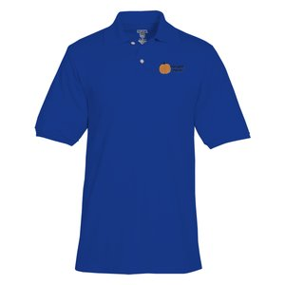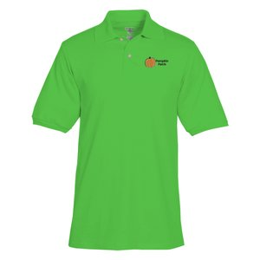**Web** 4imprint.com



**POLOS WE USED:**

Men:  Item #6443-M-E, Jerzees SpotShield Jersey Knit Shirt - Men's – Embroidered

Women:  Item #6443-L-BP-FC, Jerzees SpotShield Jersey Knit Shirt - Ladies' - Full Color

**Take the D&I Advocate Program Declaration**



**DRAFT VA D&I Advocate Program Collateral Duty Appointment Letter**



**VADIAP FY22 Book Club**



Our VA D&I Advocate Program Logo/Symbol