Medical Companion Program FY 2021 Data
Below is a graph that demonstrates proportionally, the number of admission into our observation unit to facilitate same day, outpatient procedures (in blue) vs the number of Veterans that utilized the Medical Companion Program to successfully complete their procedures in the outpatient setting (orange).
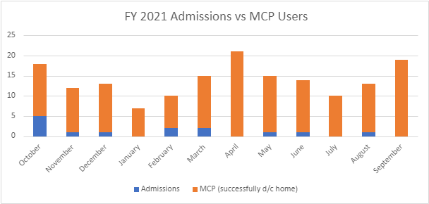

Below is a chart that provides an overview of the Medical Companion Program’s operational cost and cost savings to the VAMC per quarter. An 88% cost savings (compared to the cost of admission into an observation unit) per average Veteran user of medical companion services was proven in FY 2021.

