Spring, 2020

Getting Started:
A How-to Guide to Start “Kicking UTI” at Your VA site with
the Less is More Intervention

Hines-Munson, Casey E. (HOU)
Spring, 2020

Let’s Start with the “WHY”
As antibiotic-resistant bacteria continue to spread and increase in number, antimicrobial stewardship efforts combatting the associated dangers of resistant bugs are being prioritized both within the VHA system and beyond. One way to prevent the development of antibiotic resistance is to reduce unnecessary antibiotic prescriptions for asymptomatic bacteriuria (ASB). This intervention, Kicking UTI: The No Knee-Jerk Antibiotics Campaign, provides a useful, easy-to-follow pocket card pathway aimed at decreasing guideline-discordant ordering of urine cultures and misuse of antibiotics for ASB. It was specifically designed to address common cognitive biases driving the overuse of antibiotics, encouraging evidence-based and stream-lined decision making. Prior to roll-out, the pathway algorithm was reviewed by the CAUTI panel experts and then approved by the VA Antimicrobial Stewardship Task Force. The intervention also includes an extensive SharePoint library of teaching cases that can be used to drive home the message to intervention recipients. Want to use examples from your site? That is an option too and this guide provides instructions on how to do just that.
And, Kicking UTI has already proven to be effective! After a trial rollout at a complex VA medical center, unnecessary screening for ASB decreased by 71% and unnecessary treatment of cases determined to be ASB decreased by 75%.
Let’s get started at your site.

Determining WHO should Lead and WHOM to Reach
This tool was designed to be used by many different members of the care team. Using this guide, antimicrobial stewardship personnel can lead the implementation rollout of Kicking UTI to diverse audiences.
To start, identify who will be the “champion” of this project at your site. An effective champion will be passionate about this topic, as well as eager to create positive changes in care and contribute to a culture of antimicrobial stewardship. Successful Kicking UTI leaders can clearly communicate intervention aims to staff at various levels of an organization, provide support and follow-up to facilitate successful use of included tools, and seek opportunities to expand intervention reach beyond their own efforts. Some examples of intervention champions from study sites have included: infectious disease clinicians, infectious disease pharmacists, hospitalists, and long-term care nurse practitioners. If that is you reading this, you are two steps ahead!
Once a champion is identified, select nursing wards of interest and meet with corresponding leadership.
Start with leaders of target care areas:
- Meet with the medical director and nurse manager of long-term care units to create awareness and buy-in.
- Meet with the medical director and nurse manager of acute and long-term care to create awareness and buy-in.
- Meet with members of the local infection prevention team.
Next, identify health care providers and staff who are the intended target audience of this intervention. These include, but are not necessarily limited to:
- Hospitalists
- Residents-in-Training
- Physician fellows
  - ID
  - Geriatrics
  - Hospice care
- ID Physicians
- Pharmacists
- Nurse Practitioners
- RNs
- CNAs
- Other Antibiotic Stewardship Professionals
- Microbiology lab director
- Quality Management and Quality Improvement leaders
While you are starting this process, think about key staff who could potentially help sustain the intervention from year to year and/or expand the reach of the primary implementation champion. Some examples from intervention sites have included:
- Medicine residents interested in infectious disease/antibiotic stewardship
- Nurse practitioners from long-term care wards
- Infectious disease pharmacists

WHAT this Intervention Includes
Kicking UTI has two main components.
First, is the Kicking UTI Pocket Card.
This two-sided pocket card provides a pathway designed to address common cognitive biases that lead to overuse or misuse of antimicrobials in the setting of ASB. It guides users to first look for evidence-based symptoms of UTI. It also outlines misleading symptoms often associated with UTI, mistakenly taken as evidence for UTI.
If evidence-based symptoms are present, providers are asked to explore other potential causes. For example, while fever is an evidence-based symptom, it can be caused by other diagnoses when indicated (i.e. lung crackles and inflammation present in chest X-rays point to pneumonia).
If a non-UTI diagnosis is not identified, the pathway instructs the user to order a urine culture and then prescribe empiric antibiotics. The back side starts when the urine culture results are available and helps address low-hanging fruit for antibiotic stewardship, such as changing antibiotics. Care providers may utilize the pathway to determine how successful an antibiotic course has been in reducing or eliminating UTI symptoms as well. There is a focus on evidence-based decisions with continual evaluation emphasized as an important aspect of care. Broad-spectrum antibiotics may be narrowed following results, or discontinued altogether for patients who never needed antibiotics in the first place.

Here is the pocket card:
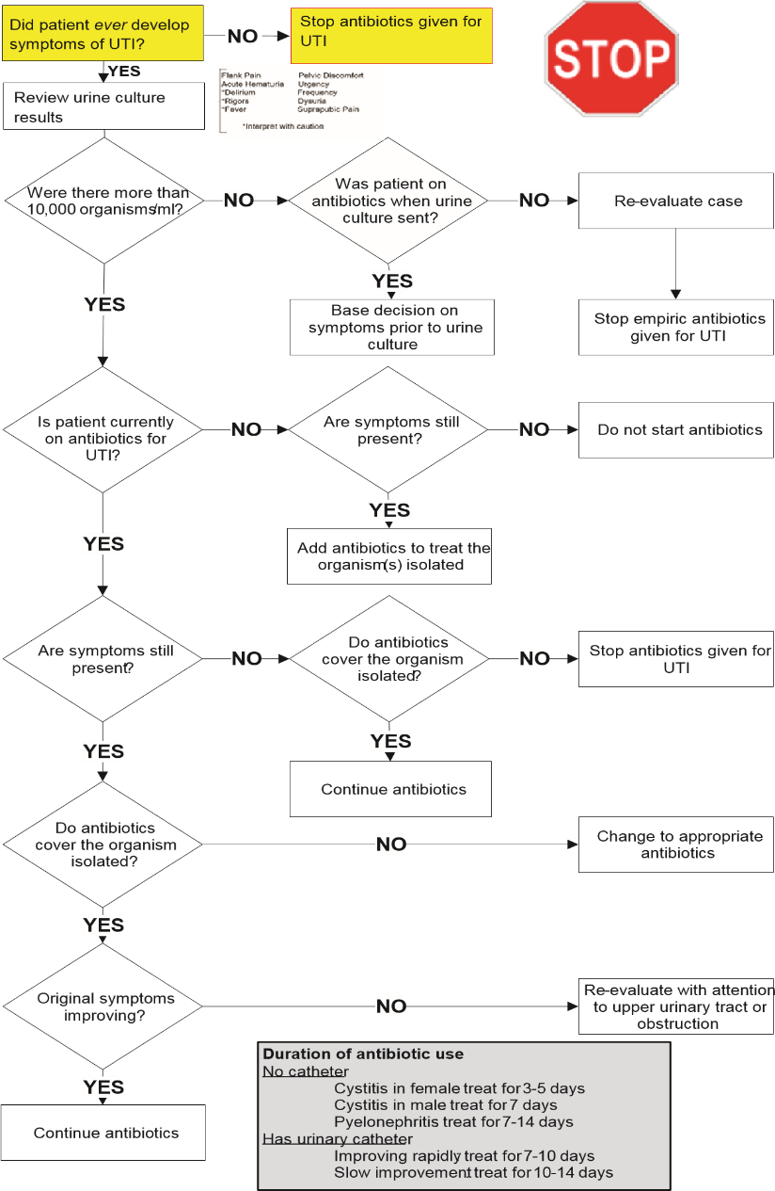
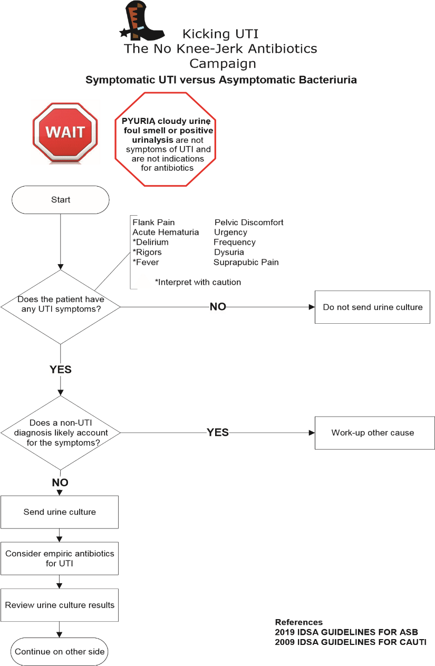
Back
Front
A pdf version of this document is available on SharePoint [insert link here] to allow printing of two-sided copies at your site.

The second main component of Kicking UTI is the Teaching Case SharePoint Library.
The Teaching Case Library is available on the VA Nationwide Antibiotic Stewardship Task Force SharePoint website: [insert link here]. It includes cases developed from and for the first Kicking UTI intervention sites.
The Case Library spreadsheet contains information on all Teaching Case PowerPoint presentations currently available for use. Each is a fully vetted, de-identified clinical case study featuring a hospital patient managed by a medicine team. All cases are sourced from and have been used in our VA intervention sites previously. The PowerPoint provides a history and summary of the patient’s primary medical complaint, relevant lab and culture results, and the clinical course that occurred during the hospital stay.
The PowerPoint walks through the Kicking UTI pathway with an easy-to-use algorithm tree. Intervention recipients are asked several questions about the case throughout the PowerPoint and their answers determine the pathway of the treatment.
Each case ends with the final determination of the case (UTI or ASB) and then, whether the case was treated with antibiotics or not (appropriately or inappropriately). The teaching points help to drive home intervention concepts and prepare providers and support staff to quickly work through similar cases in real time.

WHEN and WHERE
So, you know who you want to reach and what information you will be delivering. Now, when and where do you do it?
Select wards of interest. Ask yourself: Which wards have the highest rates of UTI overdiagnosis and overtreatment at my site? What wards may be receptive to this intervention right now? What wards may not have the capacity to receive this intervention right now?
Consider the following areas to begin:
- Acute Medicine
- Long Term Care
Select other areas you could potentially deliver the message.
Consider the following areas:
- Pharmacy Departments
- Emergency Room
Important to note: This intervention is not currently tested in surgical wards or rehabilitation/Spinal Cord Injury units yet. Please take this into consideration when selecting intervention areas.
Identify methods and settings appropriate to deliver the intervention:
Here are some examples:
- Nursing huddles
- Weekly team rounds with the residents
- Educational conferences
  - Case conferences
  - ID Conferences
- In-person one-on-one sessions with health care providers
- Phone consultations
- Pre-existing in-services and trainings
- Educational fairs
- Poster sessions
- Lab meetings
- Staff meetings

HOW
Start with education sessions. This type of outreach allows you to inform recipients of the basic intervention concepts while obtaining buy-in from local site leadership and management.
Discuss the following:
- Antimicrobial stewardship—what does it involve? How does the intervention fit in?
  - Define asymptomatic bacteriuria (ASB)
  - Antibiotic use—discuss appropriate and inappropriate use
  - Discuss consequences of overuse and misuse of antibiotics
    - Define bacterial resistance
    - Explain consequences of diagnostic delays (ex. C. diff)
Here is a useful script to use as a template while introducing the intervention in-person:
Setting up the visit:
This is [NAME] from Dr. [insert name]’s Less is More for ASB project. This project helps healthcare professionals learn to manage asymptomatic bacteriuria according to current guidelines. The overall goals of this project are to teach antibiotic stewardship while decreasing CAUTI. I would like to visit your team about a case of bacteriuria that was recently in our hospital. [Optional- I checked with the chief resident and she/he approves this process]. The visit should take 10 minutes or less. Is this afternoon a good time? If not, tomorrow afternoon?
Facilitate other intervention dissemination efforts, as discussed above.
- Don’t forget to distribute pocket cards to your audiences!
- Introduce the concepts, but also utilize the case library to create an engaging, interactive presentation that will help drive intervention goals home.
  - Plan for 5-8 minutes for each teaching case PowerPoint

Once you have defined your audience and scheduled your first presentation time slots, prepare to use the Teaching Case Slideshows with the following instructions:
Remember, it is important before you present to practice navigating through each individual PowerPoint. Each presentation is accompanied by a Navigation Key that is a useful resource to refer to while going through the presentation algorithm and walking through the pocket card pathway. Please have it on hand and/or review it prior to delivering the intervention.
Here are a few examples of a Navigation Key:—you can open the relevant cases to see how to apply it (Cases #57, 58, 61, and/or 62).
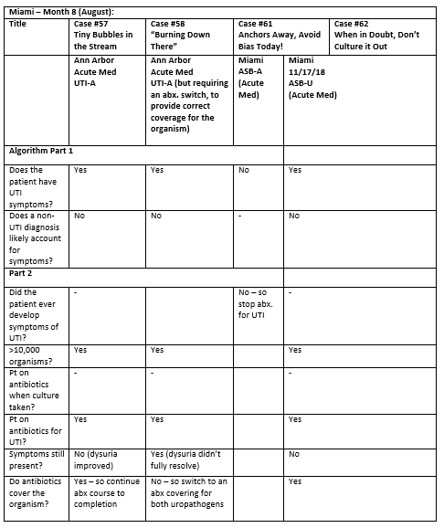

Here is how to use a Kicking UTI Teaching Case:
- Select a case from the provided library.
  - Each case has the following information:
    - Site of Case: A 3-4 letter abbreviation denotes the originating VA site of the case.
AAVA – Ann Arbor
MIA – Miami
GLA – Greater LA
MINN – Minneapolis
HOU – Houston
    - Case Number: This denotes the numerical ID number of the case.
    - Title: This is the case name, which gives a hint to the focus or theme of the case.
    - Ward Type: This denotes whether the case culture was ordered from an acute medicine ward or a community living center (CLC) ward.
    - Case Call: This denotes the original study group’s final case classification of the case.
    - Teaching point and theme: This is the central theme and teaching point conveyed by the case. Use this field to identify and select appropriate/relevant cases for teaching at your site.
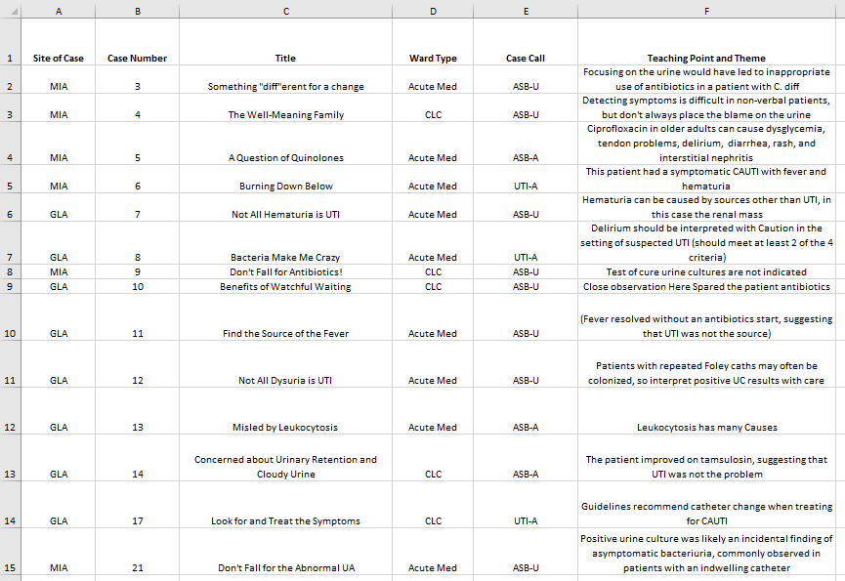
- Open the selected teaching case intended for presentation. Each case is labeled with the case number corresponding to the case number found in the Teaching Case Library file.
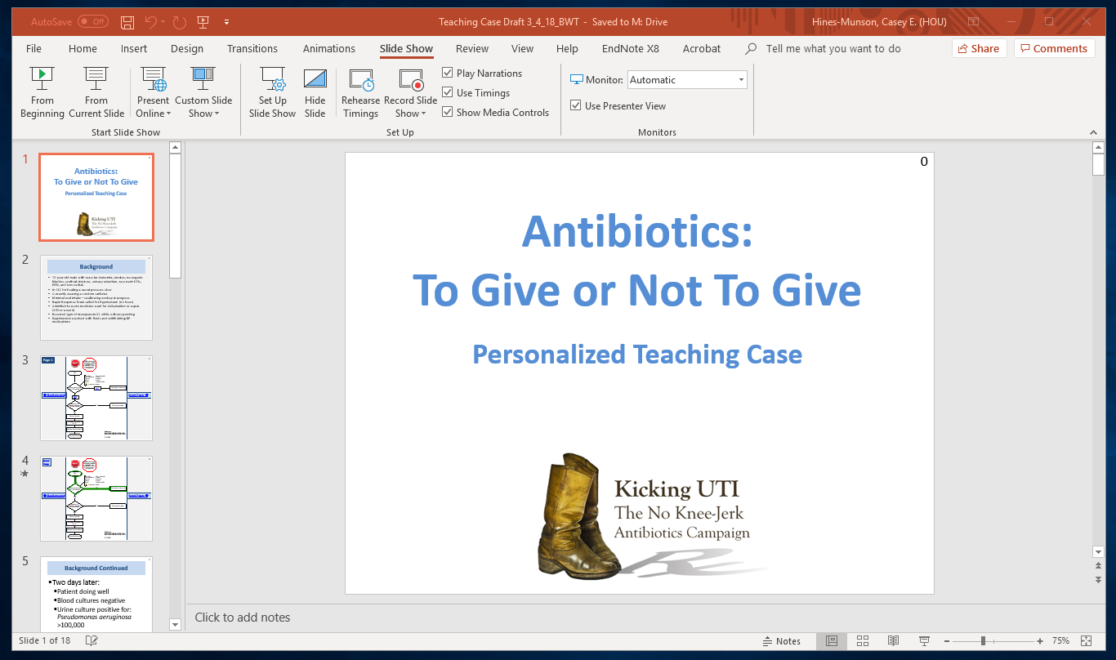
- Click on Slide Show and select ‘From Beginning’ to start it from the first slide. The first slide displays the title of the case. To advance to the next slide, click on the ‘Click to Begin’ box.
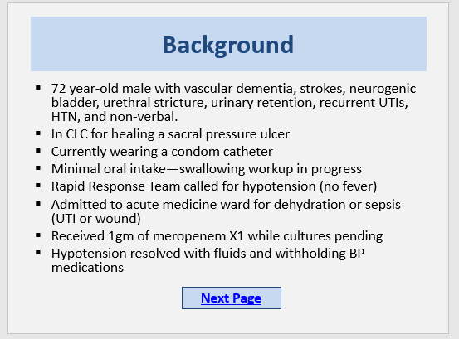
- The next slide displays the background of the case:

- Click ‘Next Page’ to advance to the next slide.
Navigation hyperlinks are displayed in blue, underlined text in a rectangular box. Be sure to click on the hyperlink text directly, and not in the spaces between.

This slide displays the front side of the Less is More – Kicking UTI Algorithm.
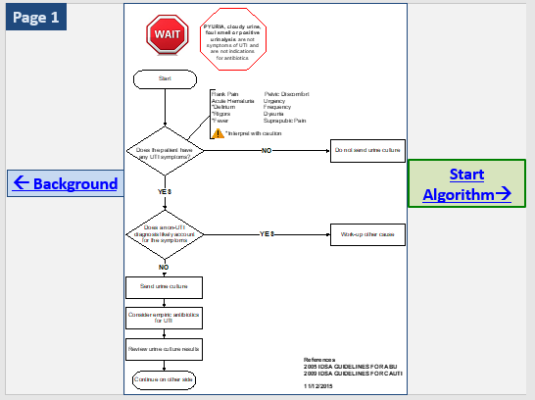

- Click on the ‘Start Algorithm’ box to advance OR click on the ‘Background’ box to return to the previous slide.
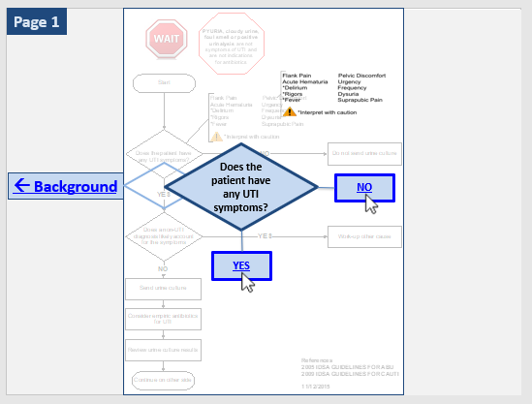
The Next slide, Page 1, asks the first question of the algorithm:

- Prompt intervention participants to discuss and select the correct answer, given the background information. Click on the answer corresponding to participant consensus.
  - If the correct answer is selected, the presentation will advance to the next algorithm question. If the answer selected is incorrect, then you will be re-routed back to the question to select the other (i.e., correct) option.
- Navigation through the algorithm depends on answering each question correctly. After the first two questions are asked, the algorithm will flow down the appropriate diagnostic path as below, with green arrows:

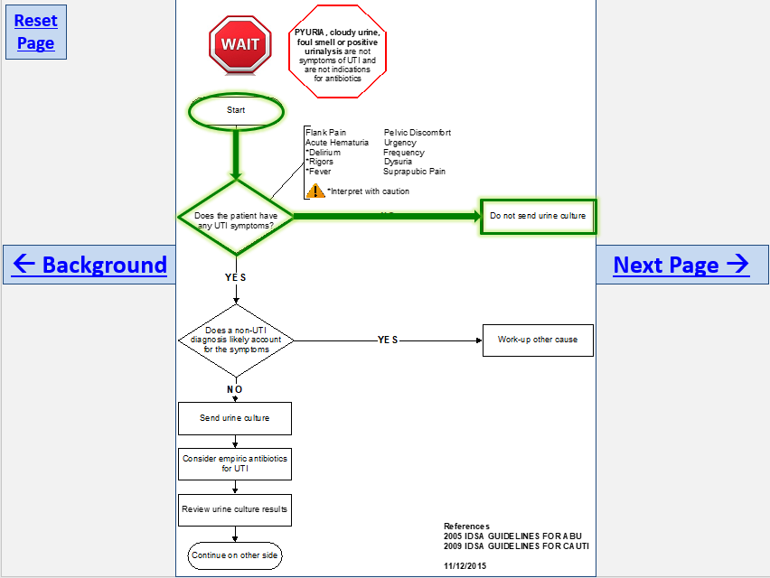

- The next slide displays the clinical course of the patient over the next several days. This includes urine culture results, other lab results (if applicable), and the details of patient’s subsequent clinical course.

Click on Next Page to advance.
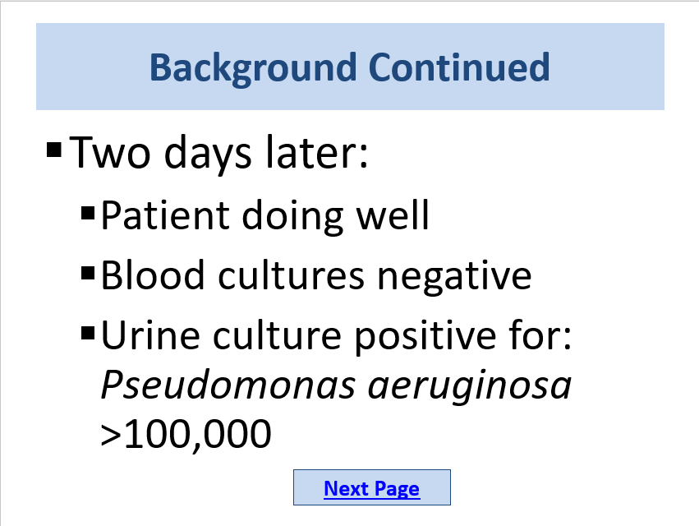

- This slide shows the back page of the Less is More algorithm. Click on ‘Start Algorithm’ to advance to the next set of questions.
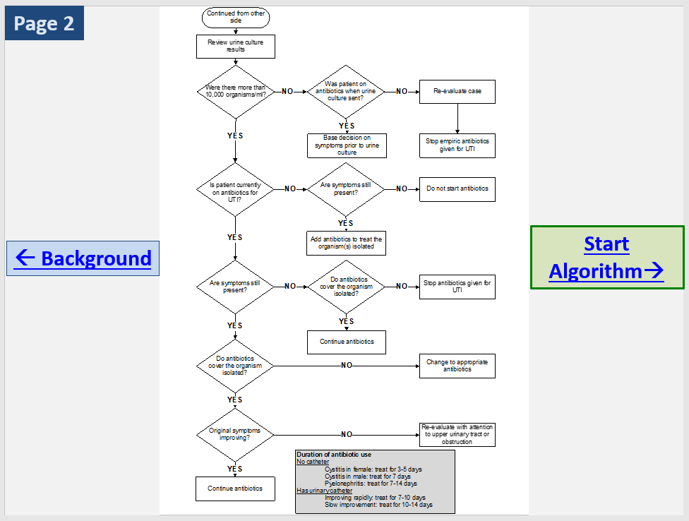

- Answering each case-related question correctly will result in the algorithm flowing down the appropriate treatment path as below, with green arrows. Click Wrap Up to proceed:
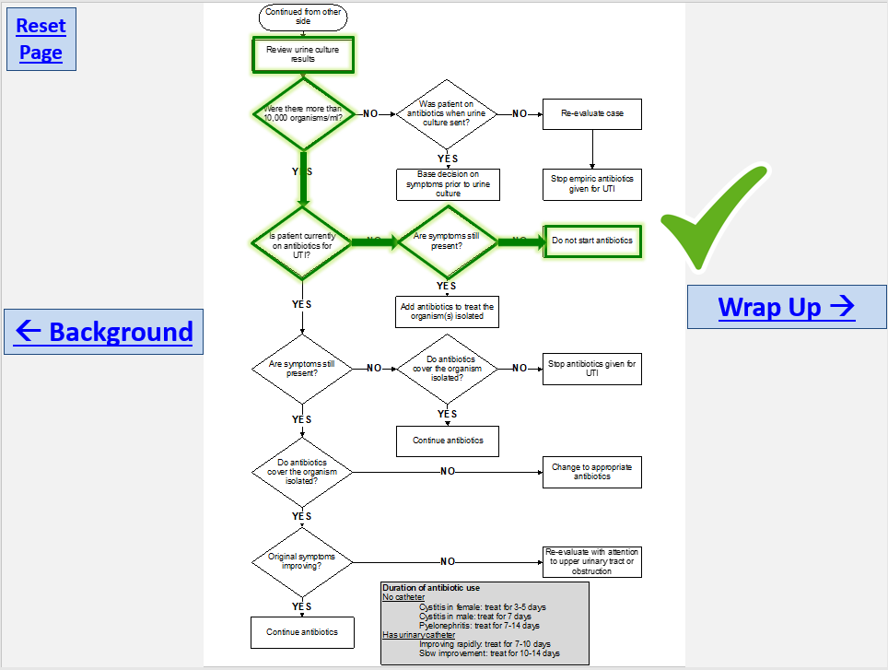

- The next slide provides a summary and final case call of the case. Teaching points are often introduced in this slide (bolded) to reinforce key teaching concepts.
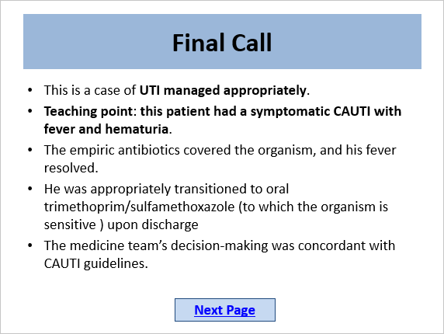

- And there you are, you have completed your first teaching case presentation!
  - It may be useful to use our presentation script, located in Appendix A, particularly for your first round of presentations.

Once you are comfortable using the case presentations found in the case library, you may wish to develop your own presentations with cases sourced from your local VA site.
Here is how to develop and disseminate teaching cases from your own site:
Start by asking providers to submit recent UTI-ASB cases of interest. Weekly rounds and conferences are good times to do this.
Doing so encourages local buy-in and involvement, reinforcing the intervention by using cases that intervention recipients themselves find interesting and relevant for review.
To classify a new case, use the following rules, based on the Kicking UTI algorithm, created using the IDSA CAUTI and ASB guidelines (2009 and 2005, respectively). There is a Microsoft Access file that allows you to document details about the case and your thinking about why it is ASB or UTI:
- Open Access File Cover page, entitled “Less is More: Antibiotic Stewardship for Asymptomatic Bacteriuria,” located on SharePoint.
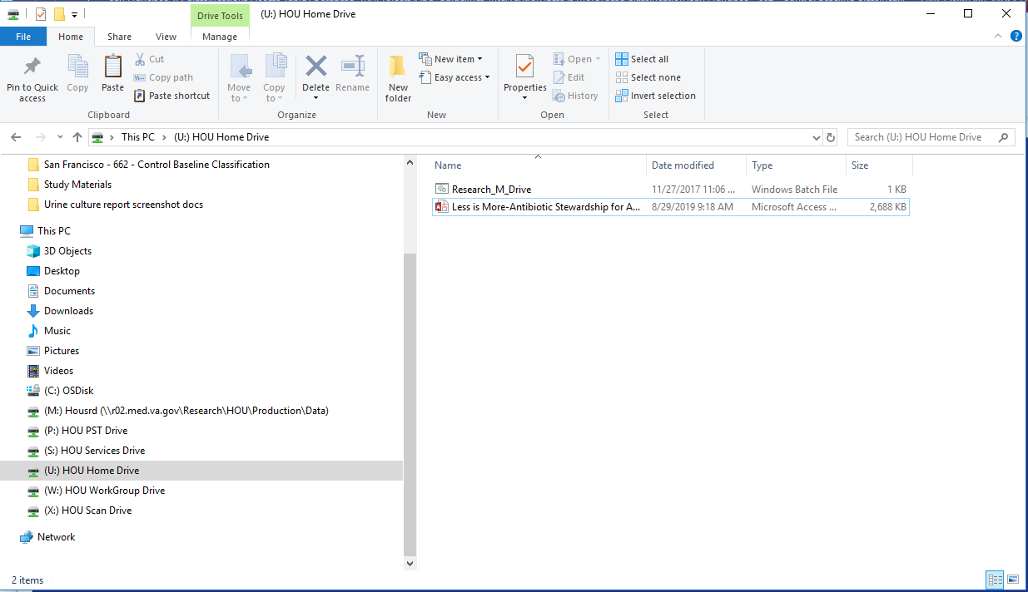
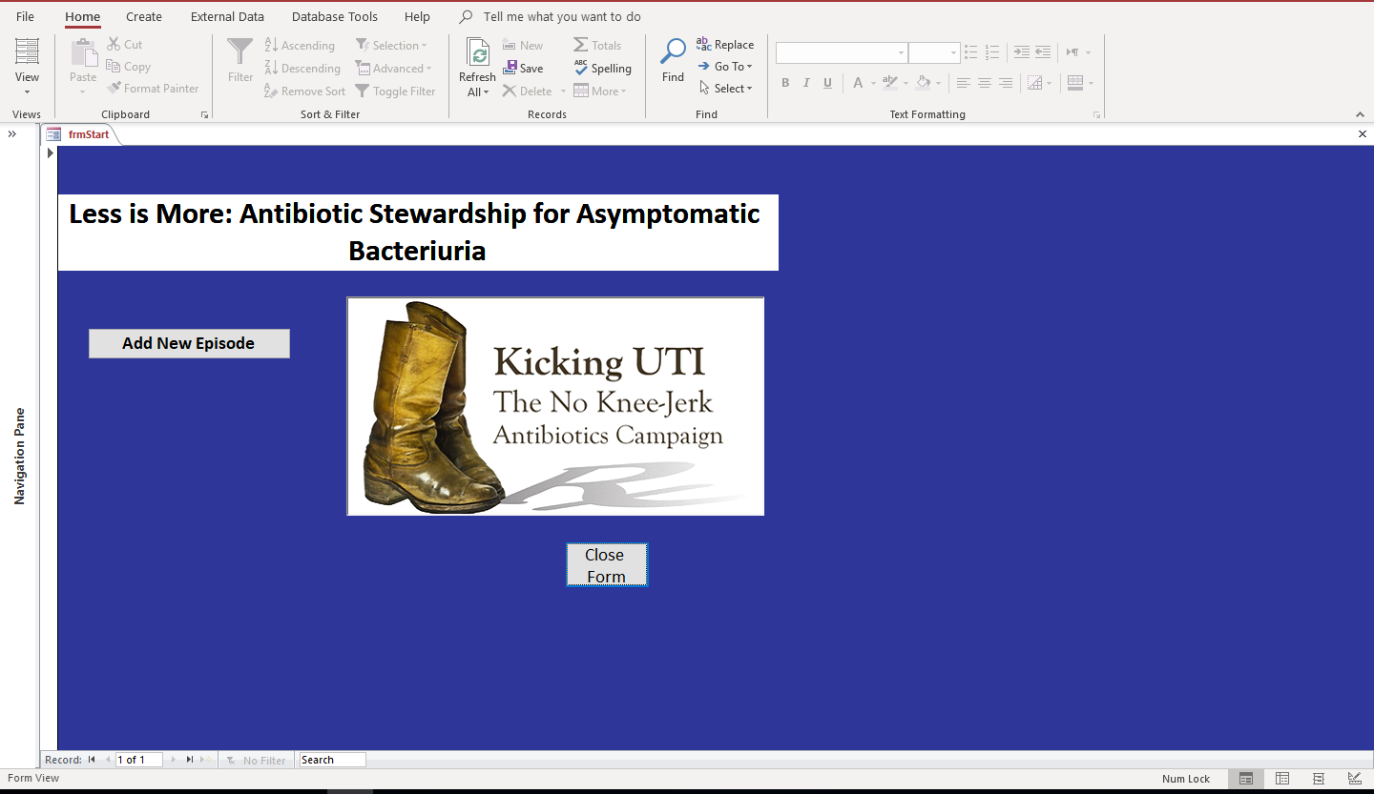
- Click on “Add New Episode”

Demographic Information:
- On the top of the new entry, enter the following information:
  - Surveillance ward: enter the ward where the patient is located.
  - Subject ID: enter the first, middle, and last initials plus final four SS numbers, without spaces.
  - Data Entered By: Enter your initials (choose 3) in the box.
  - Urinary catheter: Choose the option in the drop-down box.
    - Nursing notes are the best source of information about presence and type of catheter.
      - It may be useful to type “CATH” or, alternatively, “FOLEY” in the search window at the bottom right-hand side of the charting window. This filters all notes only for those than include mentions of catheter type.
    - We will follow NHSN rules about whether the patient is catheterized, except we include all catheter types.
      - In other words, the catheter needs to have been in place > 2 days prior to collection of the urine culture or removed <2 days prior to culture.
      - If the catheter type has changed during 2 days prior to urine culture, record the most invasive type of catheter (suprapubic > transurethral > intermittent > external).
      - If the urine was collected by an in and out catheterization, but the patient is not normally catheterized, the answer here is “no” catheter.
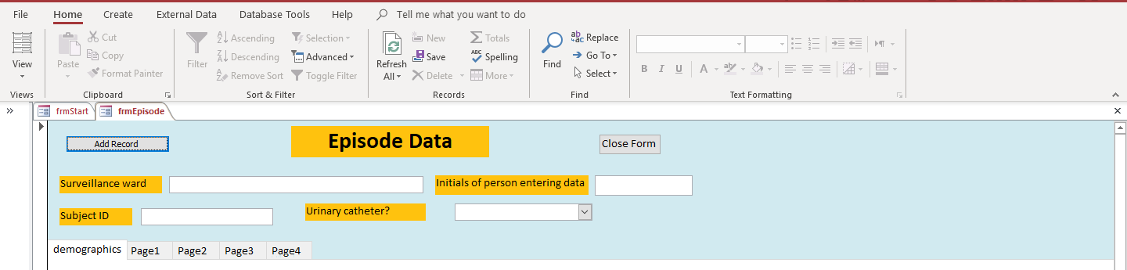
D.

C.

B.

A.

  - Enter basic patient demographics.
    - Gender, Race, Date of Birth
      - Some helpful hints on how to efficiently find this information within Capri/CPRS Charting is located after these Access file instructions.
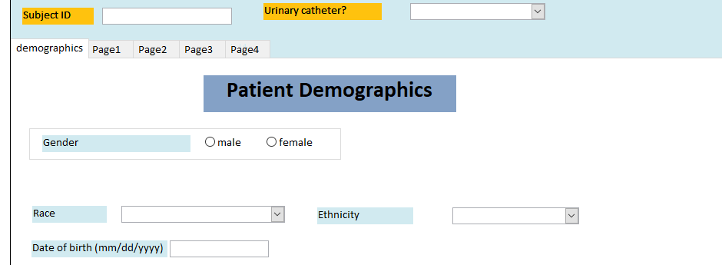
  - If the urine culture was collected for a pre-op evaluation, stop here.
    - In addition, patients who have received recent GU resection (TURP) or instrumentation would not make ideal intervention teaching cases, so exclude these patients in favor of more straightforward cases.
  - If the patient has other positive urine cultures within a 7-day period, either before or after (but in total spanning 7 days from first to last culture), record all of these, in order, starting on the next page. Use your own judgement on which of these episodes you will consider the index/primary culture, or the one you will review for symptoms and antibiotic use.
  - Click on the “Page 1” tab to get to the next page.
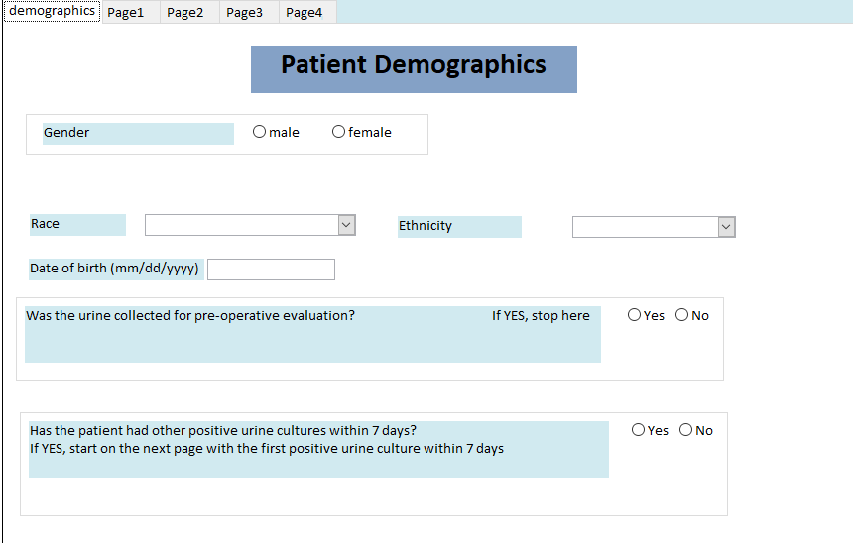
G.

F.

Page 1:
- Record urine culture organisms and quantity, up to 3 cultures.
  - Don’t forget to indicate where the urine specimen was collected.
    - It should be noted if urine specimens are collected in the ER, an inpatient ward, or outpatient clinic.
  - Check the box to the left of the culture that you consider the index culture for this case—whichever one in your opinion is related to the provider’s initial suspicion of UTI.

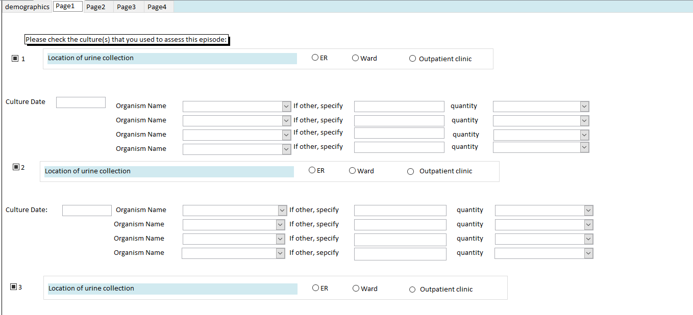

Page 2
- Record information about any blood cultures within 24 hours before/after the index urine culture. If no growth, type “none” in the box for organism. You can interpret 24 hours as the day prior to and after the urine culture collection (in other words, a three-day window).
- If a urinalysis was done within two days before/after the urine culture, record the information here. Leave blank if no urinalysis was performed. To find urinalysis, go to the lab results tab and use “selected tests by date.” Enter urinalysis and check the 1-month time frame.
- Check vital signs on the face page in CPRS and record the maximum temperature in Fahrenheit within 24 hours before/after the index urine culture. Sometimes cultures are sent when patients start to exhibit symptoms, and then the fever occurs. So, we want to catch both the pre- and post-culture fevers.
  - Add one-degree Fahrenheit to unadjusted axillary (armpit) temperatures—which are one-degree lower than oral temperatures, on average.
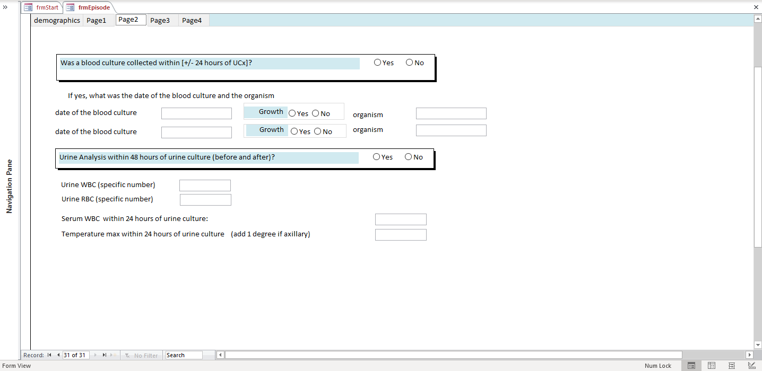
7.

6.

5.

Page 3
- Look for symptoms in the notes 72 hours before and after the urine sample collection. You can interpret 72 hours as three calendar days before and after.
- Record any and all symptoms documented as related to genitourinary condition. We have grouped these into evidence-based signs and symptoms of UTI (the upper set) and misleading signs and symptoms of UTI (the lower set). The evidence-based signs and symptoms are evidence-based symptoms of UTI drawn from the IDSA clinical practice guidelines. The misleading signs and symptoms are the commonly documented reasons for sending a urine culture that are not evidence-based symptoms of UTI.
  - A note on fever as a symptom: If a number is provided for a fever documented outside of hospital, it is acceptable to note fever as a symptom of UTI, even if the patient does not have a documented fever in the hospital.
    - For example:
      - Patients who are transferred may not have corresponding care notes with an original temperature recording, but it is permissible to record the symptom of fever if the patient is noted to have a fever (with an actual number recording) at another care facility.
      - If the patient records an at-home temperature using a thermometer and reports it to the care team (again, with an actual number recording), it is permissible to record the patient as febrile.
      - It is NOT permissible to record fever as a symptom if only subjective fevers are reported by the patient or the care team (with a verbal endorsement or the like, but without an actual number recording).
  - A note on hematuria: Record hematuria as a symptom if mentioned in the notes, but do not derive this info from the urinalysis (microscopic hematuria does not meet definition of UTI). Someone needs to have reported visibly bloody urine or hematuria in the notes.
  - If epididymitis (pain in the testicles) is mentioned, it indicates pelvic discomfort. This is considered a symptom of UTI.
  - Occasionally, the notes will mention pain related to irritation around the urinary catheter site, either from rubbing, friction, insertion, etc. Pain or irritation from mechanical issues with the catheter does not count as a symptom of UTI.
    - This may also be noted as Foley trauma in the notes.
  - Make sure evidence-based symptoms are current information, and not copy-pasted notes from a previous admission or from earlier in the admission, outside the 3-day window of the urine culture—watch for notes addendums.
    - Providers may often copy paste older notes showing apparent UTI symptoms into a current note within the time frame, so it would helpful to look back earlier to see if any notes were copy-pasted from older progress notes.
    - Example: Hematuria should not be noted in the access file if the patient had an episode of hematuria from admission 1 week prior, which has resolved >3 days before urine culture and has not re-emerged.
  - If an evidence-based symptom is documented to be connected to a non-urinary source, please continue to check its box in the Access database. However, please note the documented non-urinary cause in the comments and use this reasoning to help make your final clinical call.
    - Example: A patient is noted to be exhibiting symptoms of delirium, but a member of the care team documented corresponding behavior changes as a likely medication side effect, sign of acute progression of underlying dementia, etc.
      - In this case, check the Delirium checkbox on Page 3, but make a note of it as being due to a non-urinary source in the Comments box on Page 4.
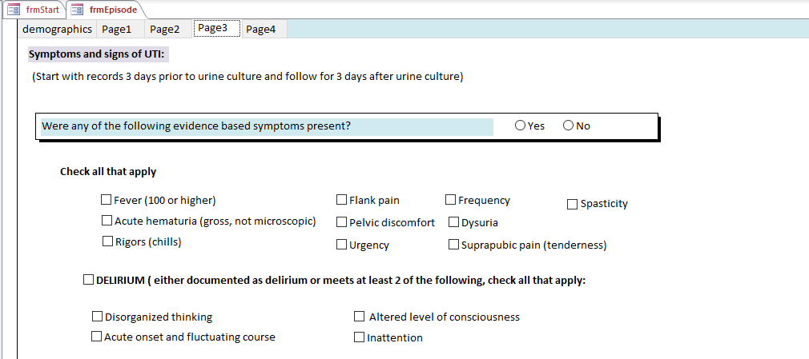
- A given case can have evidence-based symptoms and misleading symptoms.
- “Leukocytosis” on page 3 under “misleading symptoms” refers to an elevated serum WBC, or elevated white blood cell count in the blood—not urine.
- Also on page 3 under “misleading symptoms,” please check “pyuria/positive urinalysis” for any report of “dirty urine” or “dirty urinalysis”
- Delirium has a specific definition. For the patient to meet the definition of delirium, 2 of the 4 criteria must be met. However, these are rarely documented well in the chart. If you check any of the symptoms under delirium on page 3, please also check that delirium was present. Please note that the more general terms of “behavior changes” and “confusion” appear under the misleading symptoms. Demented patients are generally confused; delirium represents an acute change from baseline mental status. If the Site RA has trouble interpreting delirium in a challenging case, please have your Site PI review the notes, and help you make your call.
  - Acute/Fluctuating: The patient’s mental status has changed more than normal (no longer at baseline), or is continuously changing as the case progresses.
  - Disorganized thinking: Documented “altered mental status” meets this criterion.
  - Inattention: reference to confusion, lack of focus.
  - Altered level of consciousness: somnolence or hyper-alert state.
  - Check the overall box for delirium as “Yes” if you think delirium was present regardless of the number of delirium symptoms documented.
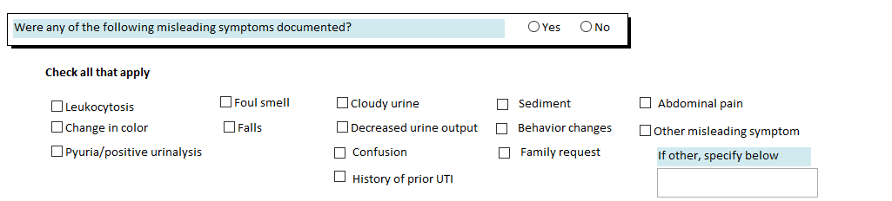
- Determine whether antimicrobial agents were given to treat the urine by the medicine or long-term care team. Please note that fluconazole is included on this list, as treatment of urinary Candida is common (and often unnecessary). Some notes about how to determine whether antibiotics were given to treat a possible UTI:
  - If an antibiotic is being used to treat another illness but is recorded as being broad spectrum to include a possible UTI, this is considered treatment of the UTI.
  - However, if the antibiotics are being used to target a different illness, and are not mentioned to include the UTI, do not record this as treatment of the UTI.
    - Example: “On pip/tazo (Zosyn) for fever of unclear origin, urine and sputum cultures sent” means that you would record that the patient received piperacillin/tazobactam to treat a possible UTI.
  - You can record up to 3 antibiotics given to treat the urine, over the course of seven days after the culture was sent.
  - Please note: when recording antibiotics, you record what a given patient’s care team decided to treat—that is, regardless if you as the classifier think the patient had UTI or ASB, if the care team records a diagnosis of UTI and prescribes antibiotics to treat the urine, you record those antibiotics here. If the patient clearly has ASB, you will be able to record that on the next page of the Access file.
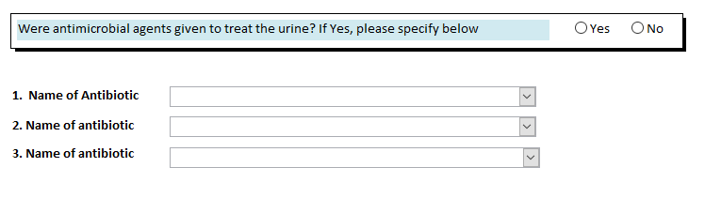

Page 4
- If the patient was being treated for a non-urinary infection, please note this. If not a respiratory, cellulitis, intraabdominal infection, or bloodstream infection, choose “Other Infection” and then use the text box to document what other type of infection occurred.
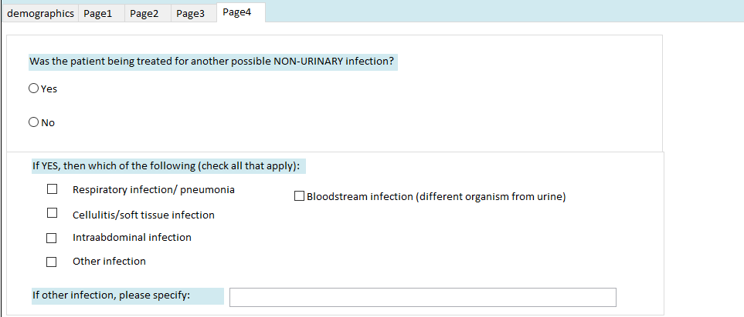
- Your Case Classification: This is the key item to document! Use the algorithm.
  - Please document ASB or UTI and treated with antibiotics (A) or not treated with antibiotics (U). Treated means the team decided to treat with antibiotics as if for UTI.
    - This is your classification for two decision points: 1. ASB vs. UTI (your call) and 2. treated or not (whether the care team treated for UTI, according to their diagnostic decisions).
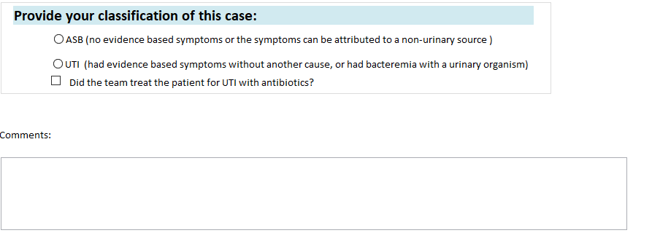
  - If the patient had any of the evidence-based symptoms of UTI, and there was not another obvious cause for the symptoms, document the case as UTI.
  - If the patient had evidence-based symptoms of UTI BUT there was another obvious cause, this is ASB. For example, if a patient has a fever and delirium after a seizure with possible aspiration, the symptoms can be attributed to a non-urinary cause, so this case would be ASB.
  - If the patient had bacteremia (an organism in a blood culture) that matches the urine culture, document this as UTI, regardless of whether any symptoms of UTI were present. Bacteremia with a urinary organism equals UTI.
  - If the patient did not have any evidence-based symptoms of UTI, and did not have bacteremia from a urinary organism, then document this case as ASB (asymptomatic bacteriuria).
  - Your decision on treated (A) or untreated (U) is from the perspective of the medicine team or CLC team and whether they thought they were treating for UTI or not.
    - For example, if the ER gave the patient a dose of pip/tazo to treat the urine but the medicine team did not continue this or decided to treat instead for cellulitis, not UTI, answer this question as “Untreated—U.” If the patient had ASB but was treated by the team for UTI, answer this question as “Treated—A”. If the treating team initially started the patient on antibiotics then decided to stop because they decided no UTI was present, answer this as Untreated—U.
  - If the only evidence-based symptom of UTI was fever, and the fever was clearly caused by something other than UTI, then record this case as ASB.
    - For example, if the patient was found to have a gangrenous, purulent sacral abscess shortly after the urine culture was sent, you can assume that the fever was caused by the sacral abscess, and the patient did not have a UTI. Or if the fever was caused by C. diff, this is a case of ASB.
  - Pneumonia is often difficult to diagnose in a hospitalized patient. If the patient is being evaluated for fever secondary either to pneumonia or UTI, we usually accept the team’s decision on ASB/UTI. In other words, if they decided to treat for both possible pneumonia and possible UTI, record this as a UTI. If they decided to treat for pneumonia and to assume that the urine culture represented colonization, record this as ASB.
  - A note about bacteremia and fever: If the patient has bacteremia (meaning has growth of bacteria in the bloodstream) and fever, the fever is most likely caused by the bacteremia.
    - If the same organism is in the blood and the urine, the patient should be classified as having UTI. On the other hand, if the blood cultures grow a different organism from the urine, the patient likely has non-urinary bacteremia as the cause for fever, and you can classify this case as ASB. One exception here: if the blood cultures have only growth of a coagulase negative staphylococcus and only in 1 bottle, this does not meet our definition of bacteremia.
  - A note about interpreting non-blood, non-urine cultures from the Lab report: Patients may occasionally have sputum cultures, or wound cultures with same organism as the urine culture. These results may be more suggestive of a systemic infection than a urinary-localized infection, so review the progress notes closely and reason your case classification along this route.
  - If the team says the urine is “colonized” this indicates that they are thinking it is ASB, not UTI.
  - You can use the comments box to document your thinking if the case was challenging, so it can be discussed later with others.
  - Special populations: We will include neutropenic patients and chemotherapy patients in this intervention, as they are populations no less likely to be treated inappropriately for UTI/bacteria in urine. Be sure to document neutropenic/chemotherapy patient cases as such, in the comments box.
    - We will exclude patients transitioning into or already in hospice care, since the patient’s own decision-making will potentially include stopping most or all medical treatment, which extends beyond the scope of this intervention. All CLC hospice wards have been excluded from Intervention areas for both Study and Control sites.
    - Others notes/definitions:
      - Patients with kidney stones and bacteriuria, or those being followed by Urology: We won’t exclude kidney stones/bacteriuric patients from our intervention if they are being followed by the Medicine team, as these patients may potentially receive unnecessary antibiotic treatment, but patients who are being exclusively followed by Urology (with no Medicine team involvement in management of their UTI/ASB) are outside of the scope of our intervention target group, as these patients may have a more complicated GU history and case presentation.
      - Spinal cord injury/paralyzed patients may often be placed on a Medicine ward as overflow patients. Include these patients in our classification if followed by the Medicine team; Exclude if these patients are only followed by the SCI Team.
      - Patients with nephrostomy tubes will be excluded from case classification and from teaching cases.
So, at a glance, this is how to approach completing a case classification. The first couple done, especially by a non-clinician will take some time, but efficiency improves the more you complete:

Sequence of Events for Case Classification
- Open the electronic medical record
- Look up the microbiology results and document the applicable urine culture results. Also, check any blood culture results occurring around the same time to see if the patient has bacteremia.
- Review and record relevant lab results and vital signs.
- Review progress notes:
  - You can include symptoms or signs documented within 3 days before/after urine culture, but your focus should be on the notes the day before and after.
  - Check ER notes and admission notes on recent admissions
  - The bottom of each note contains the provider’s thoughts and diagnoses.
  - Check for any mention of a documented fever in the admission note and ER notes
  - Review symptoms and possible other causes for symptoms
- Look for antibiotics in pharmacy records.
- Assign ASB vs. UTI according to algorithm.
- Follow-up for 2-3 days past UCx to verify that no further information comes to light.
Intervention Time Logs:
If you would like to track how much time you are spending on intervention-related activities, please use the following procedure:
The Time Log is organized in a weekly, Monday-Sunday format. Enter the number of minutes spent in intervention-related activities. These activities are listed as follows:
Local Project Administration, Meetings, and Logistics: This captures any local general administrative and logistics efforts around the Less is More intervention. Local team meetings that do not include any other sites or the Houston team should be captured here.
Chart Review and Case Classification: This primarily encompasses CPRS/CAPRI chart review and case classification of assigned cases.
Intervention Delivery: We will capture this information via your Intervention Delivery logs. No need to add this information to this table; please do keep completing and submitting your intervention development logs.
Time Log Screenshot:
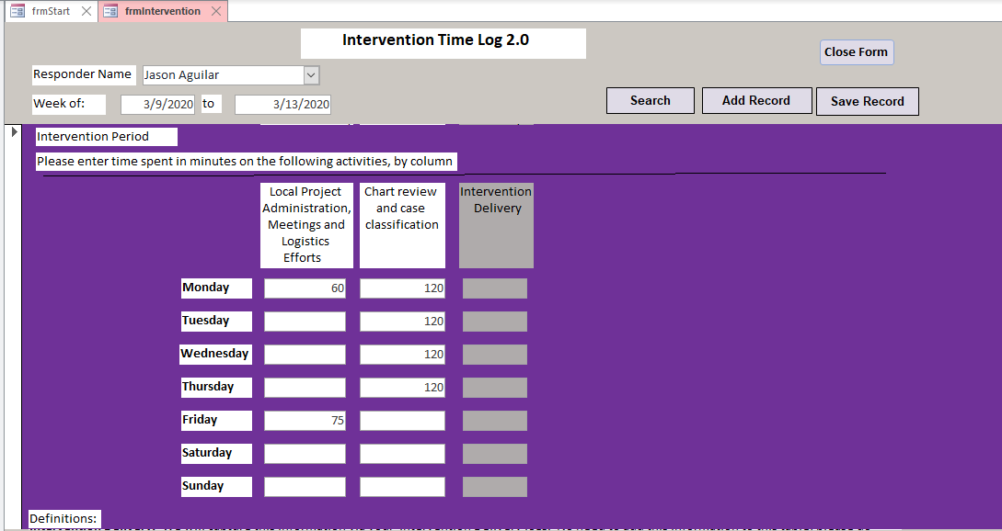
Please log all information about the Intervention delivery made:
Type of activity: Denotes the type of session where the intervention was delivered
Date of Activity: denotes the date of the delivery session
Number of participants in attendance: Denotes the number of people/providers reached with the intervention
Time spent in delivery in minutes: Denotes the number of minutes spent specifically speaking about and delivering the intervention
Composition of Audience: Denotes the type of health provider population(s) reached during the session
Intervention Delivery Log Screenshot:
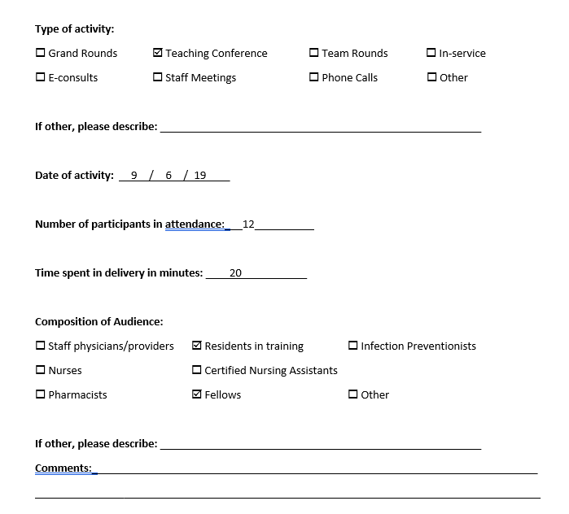

Need More Guidance?
Houston, we do not have a problem!
Please contact a member of our research team, located at the Center for Innovations in Quality, Effectiveness and Safety (IQuEST), an affiliate of Baylor College of Medicine and the Michael E. DeBakey VA Medical Center located in Houston, Texas.
Research Coordinator: Casey Hines-Munson – Casey.HinesMunson@va.gov
Research Coordinator: John Van – John.Van@va.gov
Research Coordinator: Laura Dillon – Laura.Dillon@va.gov
Principal Investigator: Barbara W. Trautner, MD, PhD - trautner@bcm.edu

Appendix:
- In-person Instructions for Introduction of Intervention through case presentation library
  - Template script items are included in italics; Presenters of case presentations should adjust or re-write the script so it feels natural to them.

- Give intervention participants Kicking UTI pocket cards.
- Introduce basic intervention concepts and background of the presentation:
  - Our team has prepared a visual aide for a case managed by a medicine [or CLC] team in the past few months that I would like to go over with you step-by-step. This teaching is based on the IDSA guidelines for effective management of UTI and asymptomatic bacteriuria. You can keep your copy of the algorithm when we are finished. As part of this project, we review cases of positive urine cultures. Our emphasis is on test stewardship—whether a urine culture needed or not, as well as antibiotic stewardship.
- Walk through the first slide, providing the background of the case.
  - [Show Slide 1] This is an interesting case from the medicine/long-term care wards at the [insert name of facility] VA.
- Before continuing to Page 1 of the presentation, provide a brief description of the Kicking UTI pocket card algorithm.
  - Our algorithm has two sides. The front side addresses whether you should send a urine culture. The back side addresses what to do when you get the urine culture results.
On the front side, you need to ask yourself two questions before you send a urine culture on a patient suspected of UTI. The Houston-based development team calls this “doing the Texas two-step.” Let’s see how this works with an actual case.
- Continue on to Slide 2.
  - [Show Slide 2] Please follow along with me as I review how this patient’s case unfolded. These cases were created through chart review, so it is always possible that the providers were working from additional information not documented in the charts. If you have any questions please feel free to ask them.
- Be sure to ask for participant input and answer any questions. If you can’t knowledgably answer a question, let them know you'll pass the question on to the site Champion.
  - Let’s begin at Start. The first diamond asks whether the patient shows symptoms. Please select either YES or NO, using the evidence-based symptoms on the algorithm. [STEP the participant through side 1].
- Introduce the back side of the pocket card.
  - The back side (page 2) of the algorithm is focused on antibiotic choice and treatment duration. Let’s see how it works when applied to this case. [STEP the participant through side 2].
- Proceed to the “Final Call” slide introduce the key takeaways, circling back to the main intervention goals.
- End the presentation and thank participants for their time. Be sure to ask for feedback and questions.
  - Thank you for your time and attention. Do you have any questions about the feedback we provided you with or treatment of UTI in-general?
    - If the participants have any questions, write them down and inform the participant you will relay them to the site Champion who will answer them personally. Be sure to follow-up to insure this happens.
- Before ending the interaction, double check to make sure everyone has a Kicking UTI pocket card. Distribute additional cards when necessary.
  - Do you have a copy of our UTI diagnostic algorithm?
- Follow-up with any questions that arise!

- Additional Helpful Tips Sheet
Helpful Tips and Points when Case Classifying UTI vs. ASB:
- Look for the provider who ordered the urine culture, as their progress note can often provide a clue as to why it was sent, if the reason is not entirely clear

- Look for the main chief complaint that brought the patient into the hospital, often if urinary-related issues are not among one of the main problems, then it may be likely to be something else. Use your discretion.

- Our goal of case classifying is not really to discern whether the patient truly had a UTI to be treated, but really we’re checking to see whether the providers’ thinking and decision making followed the UTI guidelines. Were they justified in treating? i.e., did they look for evidence-based symptoms of UTI that were not attributable to another cause? Or did they clearly fall for only misleading symptoms when they opted to treat?

- If developing your own Teaching Cases, having a complete Access file is important, as it is used to analyze data to find correlations in certain signs and symptoms with the provider’s decision to treat. Please fill out the Access table as carefully and completely as you can! Use the comment box to document any interesting provider notes you may have found.

- Always remember to check the Blood cultures to see if they grew the same organism in the urine within ~24 hours. If both the urine and blood grew the same organism, then this is always considered a UTI (bacteremia with the same organism), even if the patient is showing no symptoms of UTI.

- Look at the discharge note to see if there was anything not covered in the progress notes.

- We tend to be inclusive and we allow the med team some leeway in making our case classification, in that we give the providers the benefit of the doubt if they clearly document their intent, and if their intent was to treat for evidence-based symptoms that were present.

- Remember that ASB-A means they are clearly not following the guidelines. So, when you classify ASB-A, look back into the notes to see if something is clearly not following the guidelines.

Example: Patient has a fall and urinalysis showed pyuria. The urine culture is positive; the care team also notes some urinary retention, but the patient has no other urinary symptoms. Provider treats immediately for UTI with antibiotics. This is ASB-A.

2nd Example: Patient has a positive culture and urinary retention, but the provider opts to watch and wait for symptoms before treating. Patient starts to get a fever and dysuria. Provider then treats with antibiotics. This is UTI-A

3rd Example: A patient in the CLC has an abnormal UA (high WBC, high RBC) with no other symptoms. Provider treats anyway without watching and waiting for symptoms. This is ASB-A

- Helpful keywords to search for in the CPRS progress notes:

- UTI
- Asymptomatic
- Symptomatic
- Dysuria
- Antibiotics
- Abx
- Urination
- Urinary
- Urine
- Cath
- Catheter
- Foley
- Suprapubic
- Flank
- Pain
- Fever
- Febrile
- Chills
- Rigors
- Temp
- Temperature
- Tmax
- Retention
- Delirium
- AMS
- Behavior
- Colonization
- Infection
- Bacteriuria

Helpful Definitions:

Evidence-Based Symptoms:

- Flank pain – pain in the side body

- Acute hematuria – defined as visible blood in the urine, and not simply microscopic findings of blood in urine from urinalysis.

- Delirium – defined as marked change from baseline mental functioning, or acute onset of altered mental status. Sub symptoms of delirium: disorganized thinking, acute onset and fluctuating course, altered level of consciousness, inattention

- Rigors – defined as shivering/chills. It often is documented along with fever as “fever and chills”

- Fever – defined as elevated body temperature, above 100 degrees F

  - With UTI, fevers are typically persistent until antibiotics are given

- Pelvic Discomfort – pain or discomfort in the pelvic area

- Urgency – urgent need to void

- Frequency – defined as frequent need to void. Not to be confused with incontinence

- Dysuria – defined as pain or burning sensation during urination. Dysuria may often be confused pain/friction associated with Foley catheter trauma

- Suprapubic pain – defined as pain, tenderness or sensitivity in the suprapubic/lower abdominal area where the bladder, kidney, other organs reside

Misleading, Non-specific Symptoms of UTI:
- Leukocytosis – defined as an elevated white blood cell count in the blood

- Change in color – often can be expressed as dark-colored urine

- Pyuria/positive urinalysis – pyuria is defined as an elevated white blood cell count in the urine. A positive urinalysis may be referred to in the progress note as a “dirty UA,” “positive UA,” “UA suggestive of infection,” with references to “large leukocyte esterase (LE),” “many bacteria”

- Foul smell – a bad odor in the urine; often drives testing for UTI and unnecessary antibiotic starts for UTI

- Falls – indicates incidents of falling to floor—not an indicator for UTI

- Cloudy urine – marked by cloudy or murky appearance in the urine, and also often drives testing and unnecessary antibiotic starts for UTI

- Decreased urine output – the patient is retaining urine in the bladder, and obstructed urine may lead to concentration of bacteria in the urinary tract
  - Can lead to UTI, but not a symptom of existing UTI

- Confusion – marked by confused behavior, but not to the level of delirium; that is, may be a precursor to delirium but alone does not meet the definition of delirium; in order for a patient to be considered delirious, there needs to be an acute onset of altered mentation with fluctuation

- History of UTI –the patient may have had prior incidents of UTI (with an organism in the urine) that was treated by antibiotics. This is another driver of unnecessary antibiotic starts

- Sediment – defined by sedimentation or particles observed in the urine, found in the urine collection bag

- Behavior changes – behavior or changes in the patient’s personality from baseline, but not acute and not to the level of delirium

- Family request – a family members is requesting a urine workup or treatment with antibiotics

- Abdominal pain – generalized pain or discomfort in the abdomen

- Other misleading symptoms – urinary retention, incontinence, passing a kidney stone, etc.

Case Classification Definitions:
UTI-A: Means that this case was classified as a UTI by the medicine team and treated with antibiotics. There were evidence-based symptoms present, which were not entirely caused by any other source.
UTI-U: Means that this case was regarded as UTI, with evidence-based symptoms present and no other clear source, but the medicine team did not start the patient on any antibiotics.
ASB-U: Means that this case was regarded as asymptomatic bacteriuria, or colonization, by the medicine team. The medicine team did not start the patient on any antibiotics for UTI, but could have started the patient on antibiotics for another clear source of infection, such as pneumonia, intraabdominal infection, cellulitis (skin or wound infection), etc.
ASB-A: Means that the medicine treated this case as a UTI, with antibiotics, but the patient did not have any evidence-based symptoms of UTI. The antibiotic treatment was likely driven by misleading symptoms of UTI.

https://www.ncbi.nlm.nih.gov/pmc/articles/PMC3535479/

